

Republic of the Philippines

COMMISSION ON AUDIT
Commonwealth Ave., Quezon City

ANNUAL AUDIT REPORT

ON THE

MUNICIPALITY OF HERNANI

PROVINCE OF EASTERN SAMAR

For the Year Ended December 31, 2011

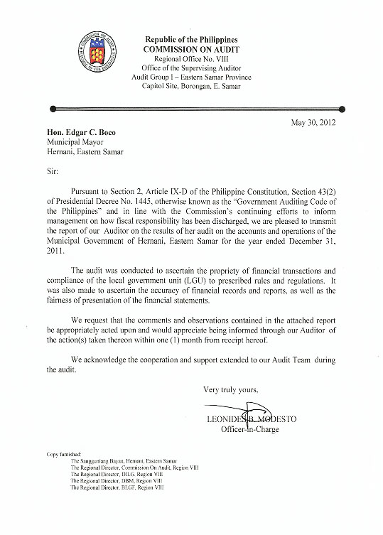

EXECUTIVE SUMMARY

Introduction

Hernani was founded around the year 1850 by a settler from Guiuan, Eastern Samar name Miguel “Totoy Yadawon” Candido. Formerly called NAG-AS (derived from the named of the river located southeast of the town proper), the settlement is nestled in a flat coastal terrain facing the vast Pacific Ocean.

NAG-AS reach the epochal point of its development when it was made a regular and independent municipality as embodied in a Royal Decree issued by Spanish Governor-General Rafael Echague on the 4th of January 1864. The royal fiat also mandated the change the old name NAG-AS to HERNANI.

Right after the Philippine-American War, the political status of Hernani was reduced into a barrio under the jurisdiction of Lanang (now Llorente). In 1912, its status as a Municipality was restored but the seat of local government was transferred to Pambujan (now Gen. MacArthur). However, in 1926 the Municipality of Hernani regained back the township by virtue of an Executive Order issued by the American Governor-General Leonard Wood.

Hernani is classified as a 5th Class Municipality headed by Honorable Edgar C. Boco. He is supported by his Vice Mayor and nine Members of the Sangguniang Bayan.
Highlights of Financial Operation

Sources and Application of Funds

Income

The municipality collected a total income of P35,932,341.05 from various sources. This year’s collection represented an increase of P7,137,000.80 or 19.86% from that of 2010, as follows:

 |  |  |  |  | Increase/ |  | Decrease
Income Sources | 2011 |  | 2010 |  | Amount |  | %
Local Income | 648,689.92 |  | 361,295.53 |  | 287,394.39 |  | 44.30
Permits & Licenses | 225,990.22 |  | 212,302.60 |  | 13,687.62 |  | 06.05
Service Income | 16,706.75 |  | 30,531.20 |  | (13,824.45) |  | (82.74)
Business Income | 3,876,416.00 |  | 140,556.25 |  | 57,209.14 |  | 96.37
Other Income | 31,164,538.16 |  | 28,050,654.67 |  | 3,113,883.49 |  | 09.99
Total | 35,932,341.05 |  | 28,795,340.25 |  | 7,137,000.80 |  | 19.86

Appropriations

The municipality appropriated P26,873,410.18 for the current year. There was a decrease of P2,380,283.63 or 08.85% from that of last year’s appropriations of P29,253,423.81 as presented below.
 |  |  |  |  | Increase/ |  | Decrease
Allotment Class | 2011 |  | 2010 |  | Amount |  | %
Personal Services | 16,485,554.68 |  | 16,317,132.29 |  | 168,422.39 |  | 01.02
Main. And Other  Operating Services | 10,372,855.50 |  | 11,414,883.39 |  | (1,042.027.89) |  | (10.05)
Capital Outlay | -0- |  | 497,260.00 |  | (497,260.00) |  | -
Financial Expenses __ 15,000.00 _1,024,418.13 (1,009,418.13) (67.29)
Total 26,873,410.18 29,253,693.81 (2,380,013.63) (08.85)

Expenditures

Expenditures incurred from current appropriations amounted to P30,048,646.85 There was an increase of P3,264,073.76 or 10.86% over that of last year, as shown below:
 |  |  |  |  | Increase/ |  | Decrease
Programs/Projects | 2011 |  | 2010 |  | Amount |  | %
Gen. Public Services | 18,694,720.13 |  | 16,117,765.18 |  | 2,576,954.95 |  | 13.78
Educ,Culture,Sports
& Manpower Dev. | 3,000.00 |  | 58,500.00 |  | (55,500.00) |  | (18.50)
Health Services | 1,989,351.46 |  | 1,944,659.39 |  | 44,692.07 |  | 02.24
Social Welfare Serv. | 394,644.60 |  | 376,655.96 |  | 17,988.64 |  | 04.55
Economic Services | 1,555,986.08 |  | 2,334,501.54 |  | (778,515.46) |  | (50.03)
Other Purposes | 7,410,944.58 |  | 5,952,491.02 |  | 1,458,453.56 |  | 19.67
Total | 30,048,646.85 |  | 26,784,573.09 |  | 3,264,073.76 |  | 10.86

Scope of Audit

An audit was conducted on the accounts and operations of the Municipality of Hernani, Eastern Samar for the year 2011. The audit was aimed to ascertain the propriety and validity of disbursements and receipts as well as the reliability of the accounts as presented in the financial statements.

This year’s audit was focused on revenues and receipts and various disbursements. Disbursement vouchers and official receipts from January to December 2011 were verified and examined.

State Auditor’s Report on the Financial Statements

The Auditor rendered a qualified opinion on the financial statements as the accuracy of the Property, Plant and Equipment accounts valued at P23,113,363.24 could not be ascertained due to management’s failure to maintain appropriate ledgers and property cards, and their existence could not be established because physical inventory was not conducted. The inadequacy of the property records did not permit us to apply alternative procedures to determine the accuracy of the account. Likewise, the current portion of the long-term indebtedness amounting to P882,954.60 was not transferred to current liabilities, resulting in the overstatement of the Loans Payable, Long-Term Domestic account and understatement of the Loans Payable-Current account by the same amount.

Summary of Significant Findings and Recommendations

1. The Municipal Accountant and Municipal Treasurer did not maintain appropriate ledger cards and property cards, respectively, and that no physical inventory was conducted on the LGU’s property plant, and equipment valued at P23,113,363.24, contrary to Sections 114 and 124 of the NGAS Manual for LGU’s Volume I, thus the accuracy of the recorded assets was not ascertained and their existence was not established.

We recommended that the Municipal Accountant and the Municipal Treasurer be required to maintain appropriate ledger cards, and property cards, respectively. Likewise the Local Chief Executive should ensure that physical inventory taking is conducted periodically.

2. The Municipal Accountant did not submit for audit paid disbursement vouchers and its supporting documents totaling P1,149,357.81 contrary to Section 107 of PD 1445, Section 347 of RA 7160, and Section 7.2.1(a) of COA Circular No.2009-006 dated September 15, 2009, thus, casted doubt on the propriety of the recorded check disbursements that resulted in audit suspension by the same amount.

We recommended that the Municipal Accountant be required to submit the disbursement vouchers, with the supporting documents for the recorded check disbursements amounting to P1,149,357.81. This recommendation is without prejudice to the results of the post audit. Henceforth, ensure, that the required financial reports are submitted within the period prescribed under Section 7.2.1(a) of COA Circular No. 2009-006 dated September 15, 2009.

3. Completed infrastructure projects in prior year’s amounting to P5,639,273.74 were not transferred to the Registry of Public Infrastructure account contrary to Section 4(n) of NGAS Manual, Volume I.

We recommended that the Municipal Accountant be directed to draw a journal entry voucher to drop the Public Infrastructure account from the books and transfer the same to the respective registry.

4. The current portion of the long-term indebtedness from the Development Bank of the Philippines amounting to P882,954.60 was inadvertently not transferred to current liabilities, contrary to paragraph 69 of the Philippines Accounting Standards (PAS) No. 1 and Section 143 of NGAS Manual, Volume III, resulting in the overstatement of the Loans Payable, Long-Term Domestic account, and understatement of the Loans Payable – Current, Domestic account by the same amount.

We recommended that the Municipal Accountant be directed draw a journal entry voucher to record the transfer of the current portion of the long-term indebtedness to current liabilities.

Compliance with Tax Laws

During the CY 2011, management implemented BIR Revenue Regulation No. 10-2008 dated July 8, 2008 and remitted all taxes withheld from compensation, expanded final and government money payments.

Statement of Audit Suspension, Disallowances and Charges (SASDC)

The total audit suspensions, disallowances and charges found in the audit of various transactions of the Municipality of Hernani, Province of Eastern Samar as of December 31, 2011 is P123,947.79 based on the NS/ND/NC issued by the Audit Team.

Status of Implementation of Prior Years’ Audit Recommendations

Of the five (5) audit recommendations embodied in the CY 2010 Annual Audit Report, one (1) was implemented, one (1) was partially implemented and three (3) were not implemented by management.

TABLE OF CONTENTS
Part I |  | Audited Financial Statements
 |  | * State Auditor's Report on the Financial Statement | 1
 |  | * Statement of Management Responsibility for Financial Statements | 2
 |  | * Consolidated Comparative Balance Sheet | 3
 |  | * Consolidated Comparative Statement of Income and Expenses | 4
 |  | * Consolidated Comparative Statement of Cash Flows | 5
 |  | * Notes to Consolidated Financial Statements | 6-13
Part II |  | Detailed Findings and Recommendations | 14-18
Part III |  | Status of Implementation of Prior Years'
 |  | Audit Recommendations | 19-20
Part IV |  | Annexes
A. Schedule of Unsubmitted Disbursement Vouchers |  |  | 21
B. Balance Sheet
 | * B-1 General Fund |  | 22
 | * B-2 Special Education Fund |  | 23
 | * B-3 Trust Fund |  | 24
 | * B-4 Coco Oil Mill |  | 25
C. Statement of Income and Expenses
 | * C-1 General Fund |  | 26
 | * C-2 Special Education Fund |  | 27
 | * C-3 Coco Oil Mill |  | 28
D. Statement of Cash Flows
 | * D-1 General Fund |  | 29
 | * D-2 Special Education Fund |  | 30
 | * D-3 Trust Fund |  | 31
 | * D-4 Coco Oil Mill |  | 32
E. Status of Appropriation, Allotments, Obligations and Balances |  |  | 33-35

PART I – AUDITED FINANCIAL STATEMENT

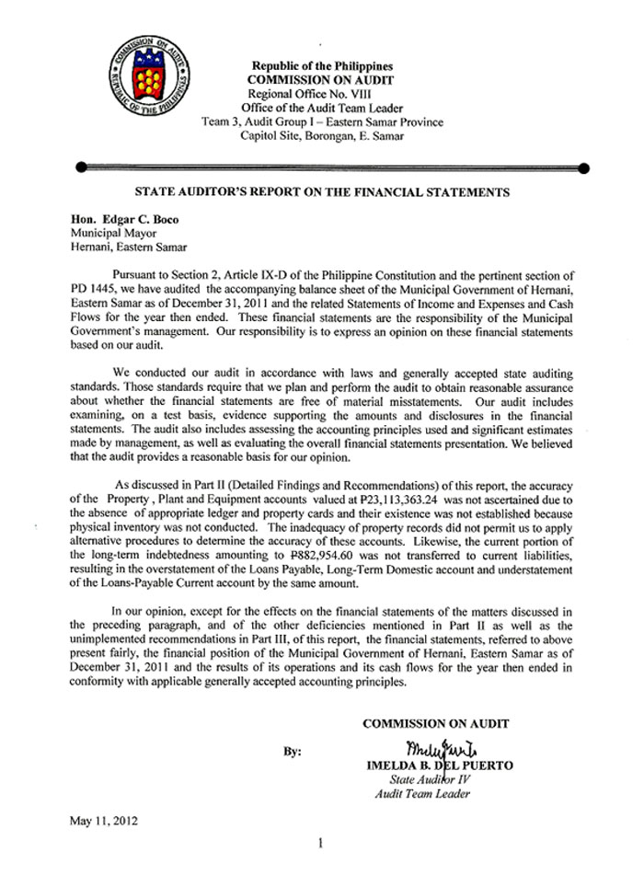

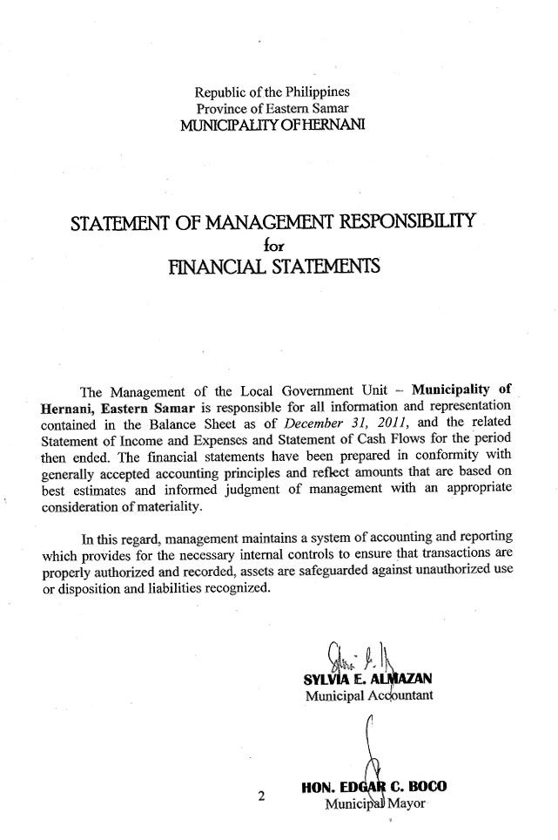

Consolidated Balance Sheet
As of December 31, 2011
Hernani, Eastern Samar

Consolidated Statement of Income and Expenses
For the Year Ended December 31, 2011
Hernani, Eastern Samar

Consolidated Statement of Cash Flows
For the Year Ended December 31, 2011
Hernani, Eastern Samar

Republic of the Philippines
Province of Eastern Samar
Municipality of Hernani

NOTES TO CONSOLIDATED FINANCIAL STATEMENTS

Note 1. General Agency Profile

HERNANI was founded around the year 1850 by a settler from Guiuan, Eastern Eastern Samar named Miguel “Totoy Yadawon” Candido. Formerly called NAG-AS (derived from the named of the river located southeast of the town proper), the settlement is nestled in a flat coastal terrain facing the vast Pacific Ocean.

NAG-AS reach the epochal point of its development when it was made a regular and independent municipality as embodied in a Royal Decree issued by Spanish Governor-General Rafael Echague on the 4th of January 1864, the royal fiat also mandate to change the old name NAG-AS to HERNANI.

Right after the Philippine-American War, the political status of Hernani was reduced into a barrio under the jurisdiction of Lanang (now Llorente). In 1912, its status as a Municipality was restored but the seat of local government was transferred to Pambujan (now Gen. MacArthur). However, in 1926 the Municipality of Hernani regained back the township by virtue of an Executive Order issued by the American Governor-General Leonard Wood.

Hernani was classified as 5th Class Municipality headed by Honorable Edgar C. Boco. He is supported by his Vice Mayor and nine Members of the Sangguniang Bayan and maintains three (3) funds General Fund, Special Education Fund and Trust Fund.

Among the major accomplishments for CY 2011 are as follows:

1. Construction of 2M x 190LM Concrete Pathwalk at Brgy. 02 Poblacion
2. Brgy. Base Reforestation at Brgy. Cacatmonan
3. Construction of 1 classroom Elem School Building at Brgy. Nagaja 4.Construction of 259LM Drainage Canal at Brgy San Miguel
5. Construction of 1 classroom Elem. School Building at Brgy. Batang
6. Construction of 2M x 272LM Concrete Pathwalk at Brgy. Padang
7. Construction of 2M x 256 at Brgy. Garawon
8. Construction of 256LM Drainage System at Brgy 03 Poblacion
9. Construction of 414LM Drainage Canal at Brgy. Cancilides
10. Construction of 21 units Sanitary Toilet at Brgy. 01 Poblacion
11. Construction of 259LM Drainage Canal at Brgy. 04 Poblacion

Note 2. Basis of Financial Statements Presentation

The consolidated financial statements have been prepared in accordance with generally accepted state accounting principles and standards.

Note 3. Significant Accounting Policies

1. Cost of inventories were based on perpetual inventory method and priced following the moving average method.

2. Plant , Property and Equipment are carried at historical cost. Infrastructures under construction in – progress are valued following the construction period theory.

3. The straight line method of depreciation is followed. For equipment, vehicles and other assets subject to depreciation, depreciation is computed on the month following the purchase date.

4. Share from Internal Revenue Collections was accounted for under the accrual method of accounting. All other taxes, fees, charges and other revenues are accounted using the cash method of accounting.

Note 4. Correction of Fundamental Errors

Fundamental errors of prior year’s are corrected using the Prior Year’s Adjustment account, while errors affecting the current year’s operations are effected to the current year accounts.

Note 5. Cash

The composition of the Cash account is as follows:

CY 2011 CY 2010
General Fund:
Cash on Hand P 231,884.87 P 285,290.21
Cash in Banks – Local Currency 2,255,587.48 1,874,622.58
Cash in Bank – Foreign Currency _____-_____ _____-_____
Sub-total 2,487,472.35 2,159,912.79

Special Education Fund
Cash on Hand - -
Cash in Banks Local Currency 59,805.36 49,045.36
Cash in Bank – Foreign Currency ___ -_ _____-____
Sub-total _59,805.36 __49,045.36

 |  | Trust Fund
 |  |  |  | Cash on Hand |  |  |  |  |  |  |  |  | - |  |  |  |  |  | -
 |  |  |  | Cash in Banks-Local Currency |  |  |  |  |  |  |  |  | 822,780.90 |  |  |  |  |  | 2,282,649.92
 |  |  |  | Cash in Bank-Foreign Currency |  |  |  |  |  |  |  |  | - |  |  |  |  |  | -
 |  |  |  | Sub-total |  |  |  |  |  |  |  |  | 822,780.90 |  |  |  |  |  | 2,282,649.92
 | Grand Total |  |  |  |  |  |  |  |  |  |  | 3,370,058.61 |  |  |  |  |  | 4,491,608.07
Note 6. Receivables
General Fund
 |  |  | Receivable Accounts-
 |  |  | Accounts Receivables |  |  |  |  |  |  |  | 848,987.00 |  |  |  |  |  | 284,687.00
 |  |  | Inter-Agency Receivables-
 |  |  | Due to LGUs |  |  |  |  |  |  |  | 802.35 |  |  |  |  |  | 802.35
 |  |  | Advances to Officers & Employees |  |  |  |  |  |  |  | 3,577.30 |  |  |  |  |  | 3,415.00
 |  |  | Due from Officers & Employees |  |  |  |  |  |  |  | 1,208,386.97 |  |  |  |  |  | 1,208,386.97
 |  |  | Intra-Agency Receivables-
 |  |  | Due from Other Funds |  |  |  |  |  |  |  | 672,928.57 |  |  |  |  |  | 19,559,541.61
 |  |  | Other Receivables-
 |  |  | Receivables-Disallowances/Charges |  |  |  |  |  |  |  | - |  |  |  |  |  | -
 |  |  | Other Receivables |  |  |  |  |  |  |  | 2,077.60 |  |  |  |  |  | 2,077.60
 |  |  | Sub-Total |  |  |  |  |  |  |  | 2,736,759.79 |  |  |  |  |  | 21,058,910.53
Special Education Fund
 |  |  | Intra-Agency Receivables-
 |  |  | Due from Other Funds |  |  |  |  |  |  |  | 256,875.01 |  |  |  |  |  | 139,075.41
Trust Fund
 |  |  | Receivable Accounts-
 |  |  | Due from Officers and Employees |  |  |  |  |  |  |  | 8,710.00 |  |  |  |  |  | 8,710.00
 |  |  | Intra-Agency Receivables-
 |  |  | Due from Other Funds |  |  |  |  |  |  |  | 215,528.83 |  |  |  |  |  | 1,288,615.38
 |  |  | Other Receivables |  |  |  |  |  |  |  | 87,000.00 |  |  |  |  |  | 87,000.00
 |  |  | Sub-Total |  |  |  |  |  |  |  | 311,238.83 |  |  |  |  |  | 1,384,325.38
Grand Total |  |  |  |  |  |  |  |  |  |  | 3,304,873.63 |  |  |  |  |  | 22,582,311.32
 |  | Note 7. Inventories
 |  | General Fund
 |  |  |  | Merchandise Inventory (Bagsakan) |  |  |  |  |  |  |  |  | 72,000.00 |  |  |  |  |  | 47,000.00
 |  |  |  | Raw Materials Inventory |  |  |  |  |  |  |  |  | 700,000.00 |  |  |  |  |  | 430,000.00
 |  |  |  | Finished Goods Inventory |  |  |  |  |  |  |  |  | 788,250.00 |  |  |  |  |  | 452,410.00
 |  |  |  | Total |  |  |  |  |  |  |  |  | 1,560,250.00 |  |  |  |  |  | 929,410.00

Note 8. Property, Plant and Equipment
8.1 Land and Land Improvement
Land |  |  |  |  | 454,795.70 |  | 374,795.70
Land Improvements |  |  |  |  | 3,501,198.91 |  | 3,501,198.91
Accumulated Depreciation-Land Improvements |  |  |  |  | - |  | -
Net Book Value |  |  |  |  | 3,955,994.61 |  | 3,875,994.61
8.2 Building
Office Buildings |  |  |  |  | 5,714,028.42 |  | 5,714,028.42
Accumulated Depreciation-Office Buildings |  |  |  |  | 829,979.82 |  | 566,137.19
Net Book Value |  |  |  |  | 4,884,048.60 |  | 5,147,891.23
Hospitals & Health Centers |  |  |  |  | 199,916.29 |  | 199,916.29
Accumulated Depreciation-Hospital & Health Centers |  |  |  |  | - |  | -
Net Book Value |  |  |  |  | 199,916.29 |  | 199,916.29
Market and Slaughterhouses |  |  |  |  | 2,045,402.24 |  | 2,045,402.24
Accumulated Depreciation-Market & Slaughterhouses |  |  |  |  | 1,073,836.16 |  | 971,566.05
Net Book Value |  |  |  |  | 971,566.08 |  | 1,073,836.19
Total Net Book Value-Building |  |  |  |  | 6,055,530.97 |  | 6,421,643.71
8.3 Office Equipment, Furniture and Fixtures
Office Equipment |  |  |  |  | 1,045,208.98 |  | 997,808.98
Accumulated Depreciation-Office Equipment |  |  |  |  | 913,892.62 |  | 913,892.62
Net Book Value |  |  |  |  | 131,316.36 |  | 83,916.36
Furniture and Fixtures |  |  |  |  | 825,035.00 |  | 813,999.00
Accumulated Depreciation-Furniture & Fixtures |  |  |  |  | 158,000.49 |  | 99,300.49
Net Book Value |  |  |  |  | 667,034.51 |  | 714,698.51
IT Equipment and Software |  |  |  |  | 1,160,546.83 |  | 1,084,671.83
Accumulated Depreciation-IT Eqpt. And Software |  |  |  |  | 145,137.75 |  | 46,300.75
Net Book Value |  |  |  |  | 1,015,409.08 |  | 1,038,371.08
Total Net Book Value- Office Eqpt, Furniture and Fixtures |  |  |  |  | 1,813,759.95 |  | 1,836,985.95
8.4 Machineries and Equipment
Machineries |  |  |  |  | 7,447,312.45 |  | 7,447,312.45
Accumulated Depreciation-Machineries |  |  |  |  | 3,035,422.48 |  | 2,594,157.42
Net Book Value |  |  |  |  | 4,411,889.97 |  | 4,853,155.03
Communication Equipment |  |  |  |  | 224,410.00 |  | 224,410.00
Accumulated Depreciation-Communication Eqpt. |  |  |  |  | 86,953.20 |  | 52,589.00
Net Book Value |  |  |  |  | 137,456.80 |  | 171,821.00
Medical, Dental & Laboratory Equipment |  |  |  |  | 18,400.00 |  | 18,400.00
Accumulated Depreciation-Med.,Dental & Lab. Eqpt |  |  |  |  | 13,650.00 |  | 13,650.00
Net Book Value |  |  |  |  | 4,750.00 |  | 4,750.00
Other Machineries and Equipment |  |  |  |  | 264,021.00 |  | 264,021.00
Accumulated Depreciation-Other Machineries & Eqpt. |  |  |  |  | - |  | -
Net Book Value |  |  |  |  | 264,021.00 |  | 264,021.00
Total Net Book Value -Machineries & Equipment |  |  |  |  | 4,818,117.77 |  | 5,293,747.03
8.5 Transportation Equipment
Motor Vehicles |  |  |  |  | 2,163,912.25 |  | 1,638,842.25
Accumulated Depreciation-Motor Vehicles |  |  |  |  | 1,407,721.00 |  | 1,387,721.00
Net Book Value |  |  |  |  | 756,191.25 |  | 251,121.25
8.6 Other Property Plant and Equipment
Other Property, Plant and Equipment |  |  |  |  | 329,647.20 |  | 319,450.20
Accumulated Depreciation-Other Property, Plant & Eqpt. |  |  |  |  | 255,152.25 |  | 211,469.21
Net Book Value |  |  |  |  | 74,494.95 |  | 107,980.99

Note 9. Current Liabilities
General Fund
 | Payable Accounts-
 | Accounts Payables |  |  |  | 248,871.82 |  | 401,537.65
 | Due to Officers & Employees |  |  |  | 380,619.38 |  | 205,988.10
 | Interest Payable |  |  |  | 82,321.81 |  | 876,418.07
 | Inter-Agency Payables-
 | Due to BIR |  |  |  | 110,166.50 |  | 163,278.56
 | Due to GSIS |  |  |  | 351,527.28 |  | 319,813.90
 | Due to PAG-IBIG |  |  |  | 104,317.22 |  | 66,926.90
 | Due to PHILHEALTH |  |  |  | 40,101.00 |  | 33,576.00
 | Due to Other NGAs |  |  |  | 831,819.48 |  | 735,891.19
 | Due to GOCCs |  |  |  | 12,013.03 |  | 7,213.07
 | Due to LGUs |  |  |  | 438,269.76 |  | 398,965.35
 | Intra-Agency Payables-
 | Due to Other Funds |  |  |  | 44,087.88 |  | 44,087.88
 | Other Liability Accounts-
 | Guaranty Deposits Payable |  |  |  | 140,300.00 |  | 140,300.00
 | Performance Bidders/Bail Bonds Payable |  |  |  | 15,158.50 |  | 25,158.50
 | Other Payables |  |  |  | (3,145.51) |  | (3,145.51)
 | Sub-Total |  |  |  | 2,796,428.15 |  | 3,416,009.66
Special Education Fund
 | Payable Accounts-
 | Accounts Payable |  |  |  | 3,084.75 |  | 3,084.75
 | Inter-Agency Payables-
 | Due to BIR |  |  |  | 2,854.99 |  | 2,854.99
 | Sub-Total |  |  |  | 5,939.74 |  | 5,939.74

Trust Fund
 | Inter-Agency Payables-
 | Due to BIR |  |  |  | 159,770.73 |  | 147,564.14
 | Due to GSIS |  |  |  | 6,774.76 |  | 6,774.76
 | Due to Other NGAs |  |  |  | 27,772.63 |  | 27,772.63
 | Due to PHILHEALTH |  |  |  | 410.70 |  | 410.70
 | Due to LGUs |  |  |  | 86,876.34 |  | 130,690.01
 | Intra-Agency Payables-
 | Due to Other Funds |  |  |  | 572,940.97 |  | 19,459,554.01
 | Other Liability Accounts-
 | Guaranty Deposit Payable |  |  |  | (28,769.37) |  | 1,039,664.72
 | Sub-Total |  |  |  | 825,776.76 |  | 20,812,430.97

Total Current Liabilities | 3,628,144.65 |  | 24,234,380.37

The decrease of P18,886,613.04 under Due to Other Funds account comprises the transfer of completed Public Infrastructure Project to the General Fund Account.
Note 10. Long-Term Liabilities
2011 2010

Loan Payable 10,458,131.85 11,939,666.00

Loans payable account refers to the long-term loan with 10.05% interest per annum availed by the municipality to finance the Construction/Rehabilitation of Carmen-San Isidro-Canciledes-Sitio Tutubigan Farm to Market Road by the Development Bank of the Philippines. It also include grants from Coconut Industry Investment Fund (CIIF) for the operational fund of Coco Mill amounting to P5,000,000.00, of which P64,334.00 had been debited to the account for the goods delivered to GRANEX per memorandum of agreement entered by the Oil Mill to CIIF. The balance of the loans as of December 31, 2011 are as follows:

Creditor | Proposal/Project | LA Due Date | Loan Amount | Outstanding Balance, December 2011
Development Bank of the Philippines | Construction/Rehabilitation of Carmen-San Isidro-  Canciledes-Sitio Tutubigan FMR | 03/07/2018 | 6,475,000.000 | 5,518,465.85
Coconut Industry Investment Fund | To augment operational fund of Coco Oil Mill | - | 5,000,000.00 | 4,939,666.00
 | TOTAL |  | 11,475,000.00 | 10,458,131.85

Note 11. Government Equity-

General Fund 12,481,124.30 28,057,143.86
Special Education Fund 325,740.63 197,181.03
Trust Fund _4,417,916.80 15,911,727.93
Total 17,224,781.73 44,166,052.82

Note 12. Income Accounts

Local Taxes
Amusement Tax 795.00 1,260.00
Business Tax 197,765.39 140.153.89
Community Tax 58,366.76 57,399.02
Occupation Tax 98,333.02 300.00
Real Property Tax 212,039.29 61,465.35
Other Local Taxes _81,390.46 100,717.27
Total 648,689.92 361,295.53

General Income Accounts

Permits and Licenses
Fees on Weights and Measures 5,460.00 5,187.50
Permit Fees 149,265.22 139,105.10
Registration Fees _71,265.00 _68,010.00
Total 225,990.22 212,302.60

Service Income
Clearance and Certification Fees 16,706.75 30,531.20

Business Income
Income from Markets 3,000.00 2,955.00
Income from Slaughterhouse 6,000.00 13,885.00
Income from Waterworks System 33,290.00 60,898.50
Rent Income 33,434.00 62,817.75
Sales Income 5,773,789.00 1,797,113.38
Cost of Goods Sold (1,973,097.00) (673,232.75)
3,876,416.00 1,264,436.88

Internal Revenue Allotment 27,715,141.00 25,673,758.00

Other Income
Income from Grants and Donations 3,440,030.06 2,361,122.10
Interest Income 9,367.10 14,319.57
Share from National Wealth - 555.00
Miscellaneous Income ______-____ ____ 900.00
Total 3,449,397.16 2,376,896.67

PART II- DETAILED FINDINGS AND RECOMMENDATIONS

PART II- DETAILED FINDINGS AND RECOMMENDATIONS

Financial and Compliance

1. The Municipal Accountant and Municipal Treasurer did not maintain appropriate ledger cards, and property cards, respectively, and that no physical inventory was conducted on the LGU’s property plant, and equipment valued at P23,113,363.24, contrary to Section 114 and 124 of the NGAS Manual for LGU’s Volume I, thus the accuracy of the recorded assets was not ascertained and their existence was not established.

Section 114 of the NGAS Manual, Volume I provides that the Chief Accountant shall maintain the perpetual inventory records comprising of the Property, Plant and Equipment Ledger Card (PPELC) for each of plant, property and equipment. Such ledger cards shall contain the details of property, plant and equipment account in the inventory control account in the general ledger. The General Services Officer or the Municipal Treasurer, as the case may be, shall likewise maintain property cards for property, plant and equipment to account for the receipt and disposition of the same. The balance per property cards should always reconcile with the ledger cards of the accounting unit. They should reconcile with other property records like Acknowledgement Receipt for Equipment (ARE)

Section 124 of the same Manual states that “The Local Chief Executive shall require periodic physical inventory of supplies or property. Physical count of property, plant and equipment by type shall be made annually and reported on the Report of Physical Count of Property, Plant and Equipment (RPCPPE). This shall be submitted to the Auditor concerned not later than January 31 of each year.”

The Consolidated Balance Sheet at year-end reported a balance for the property, plant and equipment account totaling P23,113,363.24. Verification of accounting and property records disclosed that the Municipal Accountant and the Municipal Treasurer did not conduct an inventory reconciliation because ledger cards and property cards were not maintained, thus the accuracy of the recorded assets was not ascertained. Likewise, no physical inventory was conducted on the LGU’s assets, thus their existence was not established.

In reply to our audit observation, the concerned municipal officials commented that they will designate a supply officer/property custodian to take/handle the responsibility of physical count and custody of property, plant and equipment to ensure compliance and that they will try to submit the Report of Physical Count of Plant, Property and Equipment (RPCPPE) in the ensuing year.

We recommended that the Municipal Accountant and he Municipal Treasurer be required to maintain appropriate ledger cards, and property cards, respectively. Likewise, the Local Chief Executive should ensure that physical inventory taking is conducted periodically.

2. The Municipal Accountant did not submit for audit paid disbursement vouchers and its supporting documents totaling P1,149,357.81 contrary to Section 107 of PD 1445, Section 347 of RA 7160, and Section 7.2.1(a) of COA Circular No. 2009-006 dated September 15, 2009, thus, casted doubt on the propriety of the recorded check disbursements that resulted in audit suspensions by the same.

Section 107, of PD 1445 states that “In the absence of specific provisions of law, all accountable officer shall render their accounts, submit their vouchers, and make deposits of money collected or held by them in such times and in such manner as shall be prescribed in the regulations of the Commission (underscoring supplied).

While Section 347 of RA 7160 provides that local treasurers, accountants and other local accountable officers shall render their accounts within such time in such form, style, and content and under such regulations as the Commission on Audit may prescribe.

Corollary to this, Section 7.2.1(a) of COA Circular No. 20009-006 dated September 15, 2009 provides that the Chief Accountant, Bookkeeper or other authorized official performing accounting and/or bookkeeping functions of the audited agency shall ensure, among others, that the reports and supporting documents submitted by the accountable officers are immediately recorded in the books of accounts and submitted to the Auditor within the first ten (10) days of the ensuing month.

Noted in the verification of the Report of Checks Issued (RCIs) is the absence of disbursement vouchers, with the supporting documents on recorded check disbursements totaling P1,149,357.81, broken down as follows: (See Annex A for details)

Month | Particulars | No. of DVs | Amount Involved
January | Telephone bill | 1 | P 667.98
February | Prepayment of travel expenses | 2 | 43,620.00
March | Reimbursements | 1 | 7,000.00
April | Prepayment of travel expenses, electric and telephone bills, supplies | 9 | 40,883.92
May | Prepayment of travel expenses | 1 | 3,640.00
June | Prepayment of telephone and electric bills | 2 | 1,926.33
July | Prepayment of telephone and electric bills and TEVs | 4 | 5,302.93
August | Payment of electric bill and amortization | 2 | 986,789.06
October | Prepayment of travel expenses | 2 | 25,100.00
November | Payment of labor, travel expenses and prizes | 3 | 30,970.00
December | Payment of supplies and reimbursement for travel | 2 | 3,457.58
GRAND TOTAL p 1,149,357.81

The absence of the subject disbursement vouchers casted doubt on the reliability of the recorded disbursements that resulted in audit suspensions by the same amount and have deprived management on the prompt communications of the audit results.

Management commented that paid disbursement vouchers and its supporting documents were not submitted for audit because the vouchers were still unclaimed at the time of submission date.

We maintain our stand that all accountable officers shall render their accounts and submit their vouchers within the reglementary period.

We recommended that the Municipal Accountant be required to submit the disbursement vouchers, with the supporting documents for the recorded check disbursements amounting to P1,149,357.81. This recommendation is without prejudice to the result of post-audit. Henceforth, ensure, that the required financial reports are submitted within the period prescribed under Section 7.2.1(a) of COA Circular No 2009-006 dated September 15, 2009.

3. Completed infrastructure projects in prior year’s amounting to P5,639,273.74 were not transferred to the Registry of Public Infrastructure account contrary to Section 4(n) of NGAS Manual, Volume I.

Section 4(n) of NGAS Manual, Volume I states: “Public infrastructures are assets for use of the general public, such as roads, bridges, waterways, railways, plazas, monuments, etc. A Registry of Public Infrastructures (RPI) shall be maintained according to classification to record all infrastructures for use of the general public. During construction these infrastructures shall be recorded in the books under the account “Construction in Progress”. Upon completion, the completed asset shall be transferred to the account “Public Infrastructure”. At the end of the year, completed assets under “Public Infrastructure” shall be transferred to the respective registry.”

Record showed that during the year, various completed projects that were recorded in the Public Infrastructure account of the General Fund and Trust Fund amounting to P21,926,643.10 and P11,493,821.12, respectively, were transferred to the Registry of Public Infrastructure, however, the balance of P5,639,273.74 was retained in the account at year-end.

The Municipal Accountant alleged that she inadvertently forgot to transfer the completed infrastructure projects to the Registry of Public Infrastructure since it was completed ad turn-over in 2009. She promised that she will make the necessary correcting entry in the following year.

We recommended that the Municipal Accountant be directed to draw a journal entry voucher to drop the Public Infrastructure account from the books and transfer the same to the respective registry.
4. The current portion of the long-term indebtedness from the Development Bank of the Philippines amounting to P882,954.60 was inadvertently not transferred to current liabilities, contrary to paragraph 69 of the Philippines Accounting Standards (PAS) No. 1 and Section 143 of NGAS Manual, Volume III, resulting in the overstatement of the Loans Payable, Long-Term Domestic account, an understatement of the Loans Payable – Current account by the same amount.

Paragraph 69 of Philippines Accounting Standards (PAS) No. 1, states that a liability shall be classified as current when it satisfies one of the conditions below. All other liabilities shall be classified as non-current.

- it is expected to be settled in the entity’s normal operating cycle;
- it is held primarily for the purpose of being traded;
- it is due to be settled within twelve months after the balance sheet date; or
- the entity does not have an unconditional right to defer settlement of the liability or at least twelve months after the balance sheet date.

Section 143, NGAS Manual, Vol. III, provides for the use of Loans Payable – Current, Domestic account to record short term loans and current portion of long-term indebtedness from domestic creditors. While Section 162 of the same Manual also provides for the use of Loans Payable, Long-Term Domestic account to record long-term indebtedness in cash or in kind, from domestic creditors and transfer of the current portion of loan to Current Liabilities.

Records disclosed tat the Loans Payable, Long-Term, Domestic account has a balance at year end amounting to P10,458,131.85. Of this amount P5,518,465.85 represent the outstanding balance of loans secured from DBP for the construction/rehabilitation of Carmen-San Isidro-Cancilides-Sitio Tutubigan farm to market road. Analysis of the outstanding balance, further disclosed that the amount of P882,954.60 is due to be settled within twelve months after balance sheet date, however the current portion of the long-term indebtedness was not reclassified/transferred to current liabilities, resulting the overstatement of Loans Payable, Long-Tem Domestic account and understatement of Loans Payable-Current, Domestic account by the same amount.

Creditor | Proposal/Project | LA Due Date | Loan Amount | Outstanding Balance December 31, 2011 | Current Portion of Loan Payable (Due on 2012)
Development Bank of the Philippines | Construction/Rehabilitation of Carmen-San Isidro-Canciledes-Sitio Tutubigan FMR | 03/07/2018 | 6,475,000.00 | 5,518,465.85 | 882,957.60

The Municipal Accountant in her reply to our observation averred that she maintain only one ledger account for the DBP loans payable and thus forgot to transfer the current portion of the long term liability amounting to P882,954.60. However, a journal entry voucher was made already as of January 2012 to correct it.

We recommended that the Municipal Accountant be directed to draw a journal entry voucher to record the transfer of the current portion of the long-term indebtedness to current liabilities.

5. Compliance with Tax Laws

During the CY 2011, management implemented BIR Revenue Regulation No. 10-2008 dated July 8, 2008 and remitted all taxes withheld from compensation, expanded, final and government money payments together with a copy of the Summary of Tax Withheld (STW) as support to the Tax Remittance Advice (TRA) duly certified by the Accountant and approved by the Head of the Agency or his duly authorized representative.

6. Statement of Audit Suspensions, Disallowances and Charges (SASDC)

The total audit suspensions, disallowances and charges found in the audit of various transactions of the Municipality of Hernani, Province of Eastern Samar as of December 31, 2011 is zero, as summarized hereunder:

Particulars | Beg. Balance (As of Dec. 31, 2010 | Issued this period  (NS/ND/NC)  Jan. 1 to Dec. 31, 2011 | Settled this period (NSSDC) Jan. 1 to Dec. 31, 2011 | Ending Balance (As of Dec. 31, 2011
Notice of Suspension | P 0.00 | P123,947.79 | P123,947.79 | P0.00
Notice of Disallowance | 0.00 | 0.00 | 0.00 | 0.00
Notice of Charge | 0.00 | 0.00 | 0.00 | 0.00
Total | P 0.00 | P123,947.79 | P123,947.79 | P0.00

Moreover, there was a suspension pertaining to CY 2011 transactions totaling P268,470.00 that was issued after the preparation of SASDC for the year ended December 31, 2011. This will be reported in the SASDC for the first quarter of CY 2012.

PART III – STATUS OF IMPLEMENTATION OF PRIOR YEARS’ AUDIT RECOMMENDATIONS

STATUS OF IMPLEMENTATION OF PRIOR YEARS’ AUDIT RECOMMENDATIONS

Of the five (5) audit recommendations embodied in the CY 2010 Annual Audit Report, one (1) was implemented, one (1) was partially implemented and three (3) were not implemented by management.

Audit  Observation | Recommendation | Ref | Management  Action | Status of  Implementation | Reason for  Partial/Non-  Implementation
The Municipal Treasurer and the Accountant did not submit the paid vouchers (DVs), with supporting documents within the first 10 days of the ensuing months or for a period ranging from 22 to 156 days after they became due, contrary to Section 347 of RA 7160 Section 6 of COA Circular No. 95-006 and Section 7.2.1 paragraph (a) of COA Circular No.2009-006. | We recommend that the Municipal Treasurer and the Accountant be required strictly observe the timely submission of the paid disbursement vouchers with the supporting documents as provided for in Section 347 of RA 7160, Section 6 of COA Circular No. 95-006 and Section 7.2.1 paragraph (a) of COA Circular No. 2009-06. | AAR 2010-  01 | The Municipal Accountant alleged that the delay in the submission of the disbursement vouchers was due to the failure to the Municipal Treasurer to submit them since they remained unclaimed. Hence, she cannot submit them within the reglementary period. | Partially Implemented
The municipality did not release the shares of the barangays from the collection of real property taxes amounting to P301,214.76, contrary to Article 362 of IRR of RA 7160, thus depriving the barangays concerned of much needed funds for its various development programs/projects. | We recommended that the Municipal Treasurer be directed to immediately release the funds due to barangays in accordance with the provisions of Article 362 of the IRR o RA 7160. | AAR 2010-02 | The share of the barangays from real property taxes to P301,214.76 was release on March 30, 2011 | Implemented.
The total appropriation for personal services exceeded the budgetary limitations by P3,456,603.90 or 18.09% in violation of adequate budget for maintenance and other operating expenses and needed development project. | The Local Chief Executive should limit the appropriations for personal services to 55% of the total annual income from regular sources of the next the municipality and the community as a whole. | AAR 2009-02 | Management commented that its excess in Personal Services was largely due to the LGU’s adoption of the Salary Standardization Law and the provision of benefits for Public Health Workers and other devolved functions. | Not Implemented
Management failed to submit approved copies of contracts/purchase order, and notices of deliveries for additional review and evaluation contrary to the mandates of COA Circular No. 2009-001 | Copies of the perfected contracts/purchase orders should be submitted within five (5) days after their execution/issuance | AAR 2009-03 | Management did not justify the non-implementation of this recommendation | Not Implemented
The validity of Land, Land Improvements and Building account valued P9,872,463.10 could not be ascertained due to lack of property cards, subsidiary ledgers and certificate of title contrary to Section 23(2), Title I, Book V, 1987 Administrative Code | We recommended strict compliance to Section 23(2), Title I, Book V, 1987 Administrative Code. | AAR 2008-01 | No action was taken by management on the recommendation | Not Implemented | No explanation was submitted by management for the non-implementation of audit recommendation

PART IV – ANNEXES

A. Schedule of Unsubmitted Disbursement Vouchers

B. Balance Sheet by Fund

- B-1 General Fund
- B-2 Special Education Fund
- B-3 Trust Fund
- B-4 Coco Oil Mill

C. Statement of Income and Expenses

- C-1 General Fund
- C-2 Special Education Fund
- C-3 Coco Oil Mill

D. Statement of Cash Flows

- D-1 General Fund
- D-2 Special Education Fund
- D-3 Trust Fund
- D-4 Coco Oil Mill

E. Status of Appropriations, Allotments, Obligations and Balances

CY 2011 AAR Annexes
Hernani, Eastern Samar

