

Republic of the Philippines
COMMISSION ON AUDIT
Commonwealth Avenue, Quezon City

ANNUAL AUDIT REPORT

on the

MUNICIPALITY OF HERNANI

PROVINCE OF EASTERN SAMAR

For the Period Ended December 31, 2009

Republic of the Philippines
COMMISSION ON AUDIT
Regional Office No. VIII
Candahug, Palo, Leyte

July 21, 2010

Hon. Cesar G. Tagon, Sr.
Municipal Mayor
Hernani, Eastern Samar

Sir:

Pursuant to Section 2, Article IX-D of the Philippine Constitution, Section 43(2) of Presidential Decree No. 1445, otherwise known as the “Government Auditing Code of the Philippines” and in line with the Commission’s continuing efforts to inform management on how fiscal responsibility has been discharged, we are pleased to transmit the report of our Auditor on the results of her audit on the accounts and operations of the Municipal Government of Hernani, Eastern Samar for the year ended December 31, 2009.

The audit was conducted to ascertain the propriety of financial transactions and compliance of the local government unit (LGU) to prescribed rules and regulations. It was also made to ascertain the accuracy of financial records and reports, as well as the fairness of presentation of the financial statements.

We request that the comments and observations contained in the attached report be appropriately acted upon and would appreciate being informed through our audit team of the action(s) taken thereon within one (1) month from receipt hereof.

We acknowledge the cooperation and support extended to our auditor by you and your staff during the audit.
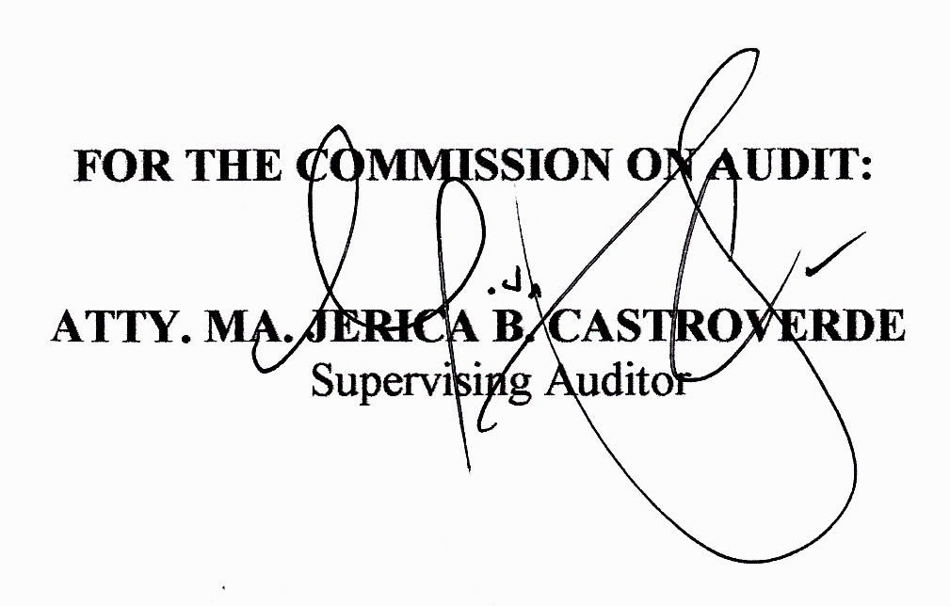
Very truly yours,

Copy furnished:
The Sangguniang Bayan, Hernani, Eastern Samar
The Regional Director, Commission On Audit, Region VIII
The Regional Director, Department of Interior
and Local Government, Region VIII
The Regional Director, Department of Budget
and Management, Region VIII
The Regional Director, Bureau of Local Government
Finance, Region VIII

EXECUTIVE SUMMARY

Highlights of Financial Operation

Sources and Application of Funds

Income
`
The municipality collected a total income of P27,515,069.20 from various sources. This year’s collection represented a decrease of P8,303,118.42 or 23.18% from that of 2008, as follows:

 |  |  |  |  | Increase/ |  | Decrease
Income Sources | 2009 |  | 2008 |  | Amount |  | %
Local Income | 436,930.36 |  | 423,719.50 |  | 13,210.86 |  | 3.12
Permits & Licenses | 179,796.39 |  | 197,632.10 |  | (17,357.71) |  | (8.78)
Service Income | 4,400.00 |  | 13,166.25 |  | (8,766.25) |  | (66.58)
Business Income | 156,072.00 |  | 718,848.95 |  | (562,776.95) |  | (78.29)
Other Income | 26,737,870.45 |  | 34,464,820.82 |  | (7,726,950.37) |  | (22.42)
Total | 27,515,069.20 |  | 35,818,187.62 |  | (8,303,118.42) |  | (23.18)

Appropriations

The municipality appropriated P27,265,943.66 for the current year and had continuing appropriations in the amount of P100,000.00 There was an increase of P3,814,745.33 or 16.27% from that of last year’s appropriations of P23,451,198.33 as presented below.
 |  |  |  |  | Increase/ |  | Decrease
Allotment Class | 2009 |  | 2008 |  | Amount |  | %
Personal Services | 15,242,810.96 |  | 10,264,408.50 |  | 5,030,047.46 |  | 49.00
Maint and Other
Operating Expenses | 11,514,822.70 |  | 6,946,579.78 |  | 4,516,597.92 |  | 65.02
Capital Outlay | 508,310.00 |  | 6,240,210.05 |  | (5,731,900.05) |  | (91.85)
Total | 27,265,943.66 |  | 23,451,198.33 |  | 3,814,745.33 |  | 16.27

Expenditures

Expenditures incurred from current appropriations amounted to P25,044,385.73. There was an increase of P2,707,172.27 or 12.12% over that of last year, as shown below:
 |  |  |  |  | Increase/ |  | Decrease
Programs/Projects | 2009 |  | 2008 |  | Amount |  | %
Gen. Public Services | 16,331,035.79 |  | 12,353,822.91 |  | 3,977,212.88 |  | 32.19
Educ,Culture,Sports
& Manpower Dev. | 63,142.00 |  | 83,940.22 |  | (20,798.22) |  | (24.78)
Health Services | 1,503,452.66 |  | 1,828,050.20 |  | (324,597.54) |  | (17.76)
Social Welfare Serv. | 350,871.08 |  | 353,105.58 |  | (2,234.50) |  | (0.632)
Economic Services | 6,795,884.20 |  | 7,718,294.55 |  | (922,410.35) |  | (11.95)
Other Purposes | - |  | - |  | - |  | -
Total | 25,044,385.73 |  | 22,337,213.46 |  | 2,707,172.27 |  | 12.12

Scope of Audit

An audit was conducted on the accounts and operations of the Municipality of Hernani, Eastern Samar for the year 2009. The audit was aimed to ascertain the propriety of disbursements and receipts as well as the reliability of the accounts as presented in the financial statements. The audit also aimed to determine whether plans, programs, projects and activities were implemented in accordance with plans and specifications. This year’s audit was focused on revenues and receipts and various disbursements. Disbursement vouchers and official receipts from January to December 2009 were verified and examined.

Auditor’s Opinion on the Financial Statements

The auditor rendered a qualified opinion on the financial statements as the balance of Land, Land Improvements and Buildings valued at P10,663,751.06 could not be ascertained due to management’s failure to present proof of ownership.

Significant Findings and Recommendations

- The Municipal Accountant failed to submit the year-end financial statements to the Auditor within the period prescribed under COA Accounting Circular Letter 2007-003 dated January 19, 2007.

Strictly comply with the submission of financial statements and its supporting reports/schedules on time to preclude possible initiation of administrative disciplinary actions against erring accountant aside from rendering updated financial data whenever required by COA and other authorities.

- The total appropriations for personal services exceeded the budgetary limitation by P3,458,603.90 or 18.09% in violation of Section 325 of RA 7160 which deprived the agency to provide adequate budget for maintenance and other operating expenses and needed development projects.

The local chief executive should limit the appropriations for personal services to 55% of the total annual income from regular sources of the next preceding fiscal year so as not to prejudice the priority needs of the municipality and the community as a whole. Another corrective measure is to increase the local income in order to have a bigger basis for the computation of the allowable budget for personal services.

- Management failed to submit approved copies of contracts/purchase orders, and notices of deliveries for auditorial review and evaluation contrary to the mandates of COA Circular No. 2009-001, thus, precluding auditors from ascertaining the legality, propriety as well as completeness of documentations of all procurement transactions prior to payment.

Copies of the perfected contracts/purchase orders should be submitted within five (5) days after their execution/issuance. Copies to be furnished should be separate from those attached as supporting documents to vouchers. That the timely review of these documents will hasten the detection of deficiencies and deviations which need corrective action should primarily inspire concerned officials in faithfully observing to the pertinent COA rules. On the other hand, to avoid the presumptions of ghost or irregular deliveries, management has to comply with the requirement on notifying the auditor of such undertaking within 24 hours from its occurrence, regardless of the amount involved.

Status of Implementation of Prior Year’s Audit Recommendations

Of the six (6) recommendations contained in the prior year’s Annual Audit Report, two (2) were fully implemented, two (2) were partially implemented while two (2) were not acted upon by management.

TABLE OF CONTENTS

Part I Audited Financial Statements

- Audit Certificate 1
- Statement of Management Responsibility for Financial Statements 2
- Consolidated Balance Sheet 3

- Consolidated Statement of Income and Expenses 4
- Consolidated Statement of Cash Flows 5

- Notes to Financial Statements 6-11

Part II Detailed Findings and Recommendations

- Financial and Compliance Audit 12 - 15

Part III Status of Implementation of Prior Year’s Recommendations 16 - 18

Part IV Annexes
1- 11 Financial Statements by Fund 19 - 29
12 Status of Appropriations, Allotments, Obligations
and Balances 30 - 32

PART I – AUDITED FINANCIAL STATEMENTS

- Audit Certificate
- Statement of Management Responsibility for Financial Statements
- Comparative Consolidated Balance Sheet
- Comparative Consolidated Statement of Income and Expenses
- Comparative Consolidated Statement of Cash Flows
- Comparative Consolidated Notes to Financial Statements

Republic of the Philippines
COMMISSION ON AUDIT
Regional Office No. VIII
Candahug, Palo, Leyte

AUDIT CERTIFICATE

Hon. Cesar G. Tagon, Sr.
Municipal Mayor
Hernani, Eastern Samar

Our Audit Team audited the accompanying balance sheet of the Municipal Government of Hernani, Eastern Samar as of December 31, 2009 and the related Statements of Income and Expenses and Cash Flows for the year then ended. These financial statements are the responsibility of the Municipal Government’s management. Our responsibility is to express an opinion on these financial statements based on our audit.

Accordingly, the audit was conducted in accordance with laws, COA and INTOSAI standards and applicable generally accepted auditing standards. Those standards require that we plan and perform the audit to obtain reasonable assurance about whether the financial statements are free of material misstatements. An audit includes examining, on a test basis, evidence supporting the amounts and disclosures in the financial statements. This also includes assessing the accounting principles used and significant estimates made by management, as well as evaluating the overall financial statements presentation. It is believed that the audit provides a reasonable basis for our opinion.

As discussed in Part III (Status of Implementation of Prior Year’s Audit Recommendations) of this report, the validity and accuracy of the Land, Land Improvements and Buildings with a total valuation of P10,663,751.06 could not be ascertained due to management’s failure to present the certificates of ownership. The inadequacy of property records did not permit us to apply alternative procedures to determine the validity of these accounts.

In our opinion, except for the effect on the financial statements of the matters discussed in the preceding paragraph, or had the records allowed the application of alternative audit procedures, the financial statements, referred to above present fairly, the financial position of the Municipal Government of Hernani, Eastern Samar as of December 31, 2009 and the results of its operations and its cash flows for the year then ended in conformity with applicable generally accepted accounting principles.

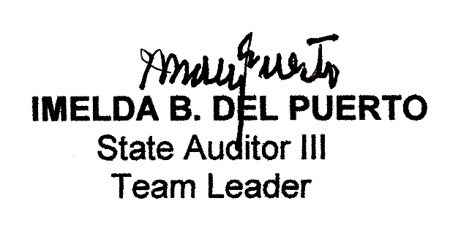
COMMISSION ON AUDIT

IMELDA B. DEL PUERTO
State Auditor III
Team Leader
March 25, 2010

Republic of the Philippines
Province of Eastern Samar
Municipality of Hernani

STATEMENT OF MANAGEMENT RESPONSIBILITY
FOR FINANCIAL STATEMENTS

The management of the Local Government of Hernani Eastern Samar is responsible for all information and representation contained in the accompanying Balance Sheet as of December 31, 2009 and the related Statement of Income and Expenses and Statement of Cash Flows for the period then ended. The financial statements have been prepared in conformity with generally accepted state accounting principles and reflect amounts that are based on best estimates and informed judgment of management with an appropriate consideration of materiality.

In this regard, management maintains a system of accounting and reporting which provides for the necessary internal controls to ensure that transactions are properly authorized and recorded, assets are safeguarded against unauthorized use or disposition and liabilities recognized.

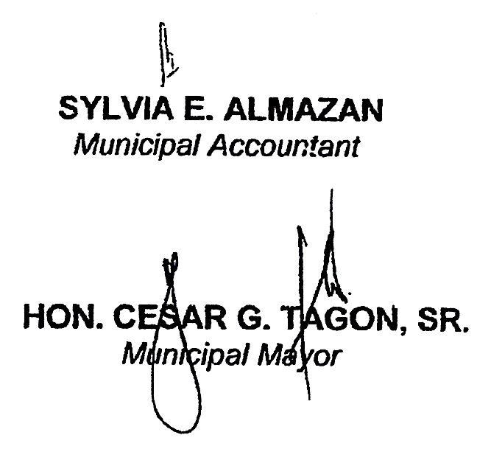
SYLVIA E. ALMAZAN, CPA
Municipal Accountant

HON. CESAR G. TAGON. SR.
Municipal Mayor

Consolidated Balance Sheet
As of December 31, 2009
Hernani, Eastern Samar

Consolidated Statement of Income and Expenses
For the Year Ended December 31, 2009
Hernani, Eastern Samar

Consolidated Statement of Cash Flows
For the Year Ended December 31, 2009
Hernani, Eastern Samar

NOTES TO FINANCIAL STATEMENTS

General Agency Profile

The Municipality of Hernani was formerly known as “Nag-as” derived from the name of the river located southeast of the town proper. The history of Hernani accounted the periodic visits of Chinese traders, which greatly influenced the rapid growth of business in the locality. During the Spanish regime, under the governorship of General Rafael Echague, the name Nag-as was changed to Hernani and by virtue of a Royal Decree issued on January 4, 1864, the place became a regular and an independent municipality.

Hernani, a fifth class municipality, is located between the municipalities of Gen. MacArthur and Llorente along the coastline of Eastern Samar facing the vast Pacific Ocean. The Municipality is bounded on the north by the municipality of Llorente, on the east by the Philippine Sea, on the south by the municipality of Gen. MacArthur, and on the west by the mountain ranges of the municipality of Llorente. It has a total land area of 49,429,728.99 sq. meters, 47.30% of which is timberland, and the remaining 52.70% consists of residential, commercial, institutional and public roads.

The municipal government of Hernani has been headed for almost nine years by Mayor Cesar G. Tagon, Jr. He is supported by his Vice-Mayor and nine Members of the Sangguniang Bayan.

During the middle part of 2005, the municipality ventured into an income-generating project which uses coconut as its raw material. The project is named as Hernani Integrated Coconut Processing Plant and Agribusiness Livelihood Center (HICPPALC). Its operations was funded initially through a loan from CIIF in the amount of P5,000,000.00. Some of the products sold in the market are cooking oil, crude oil, virgin coconut oil, hair and body lotion, coco charcoal, coco fiber, coco peat, geotextile net, and copra as its major product.

` The Municipality of Hernani has continuously implemented development projects particularly the rehabilitation of various farm to market roads granted by DAR/ADB. For the past three years, the municipality was able to acquire funds from INFRES for the construction and rehabilitation of farm to market roads from Carmen to San Isidro-Canciledes-Sitio Tubigan and for the rehabilitation of Barangay 03-Lingsad-San Isidro farm to market roads.

Basis of Financial Statements Presentation

The consolidated financial statements have been prepared in accordance with generally accepted state accounting principles and standards.

Significant Accounting Policies

- The agency uses accrual basis of accounting. All expenses are recognized when incurred and reported in the financial statements in the period to which they relate. Income is on accrual basis except for transactions where it is impractical or when other methods are required by law.

2. Cost of inventories are based on perpetual inventory method and priced
following the moving average method.

- Depreciation is computed using the straight line method. No depreciation is charged to Public Infrastructures. For current acquisitions, it is computed beginning on the month following the purchase date, net of 10% salvage value.

- Property, Plant and Equipment are carried at historical cost, acquisition cost less the applicable accumulated depreciation.

- The cost of Public Infrastructures, such as roads, highways and bridges are not carried in the books.

- Fundamental errors are charged to Prior Years’ Adjustments account. Errors
affecting current year’s operations are charged to current year’s accounts.

- Share from Internal Revenue Collections is accounted for under the accrual
method and real property taxes, fees, charges and other revenues are accounted using the cash method of accounting.

Note 1. Cash
Composition
 |  |  |  | 2009 |  |  |  | 2008
Cash in Vault |  |  |  | 596,074.85 |  |  |  | 841,890.69
Petty Cash Fund |  |  |  | 9,041.09 |  |  |  | 98,665.86
Payroll Fund |  |  |  | 97,933.86 |  |  |  | -
Cash in Bank-LCCA |  |  |  | 5,574,167.40 |  |  |  | 10,265,663.38
Total |  |  |  | 6,277,217.20 |  |  |  | 11,206,219.93
Note 2. Receivables
Composition
 |  |  |  | 2009 |  |  |  | 2008
Accounts Receivables |  |  |  | 294,207.00 |  |  |  | 553,337.00
Real Property Tax Receivable |  |  |  | 62,400.41 |  |  |  | 249,216.81
Due from Officers & Employees |  |  |  | 1,217,096.97 |  |  |  | 1,220,511.97
Due from LGUs |  |  |  | 157,062.58 |  |  |  | 148,972.28
Due from Other Funds |  |  |  | 17,121,261.70 |  |  |  | -
Advances to Contractors |  |  |  | 3,415.00 |  |  |  | 504,876.14
Other Receivables |  |  |  | 89,077.60 |  |  |  | 89,077.60
Total |  |  |  | 18,944,521.26 |  |  |  | 2,765,991.80
Note 3. Property Plant & Equipment
This account is composed of:
 |  |  |  | Balance |  | Net Addition/ |  | Balance
 |  |  |  | Dec.31,2008 |  | (Reduction) |  | Dec.31, 2009
Land |  |  |  | 2,574,359.25 |  |  |  | 2,574,359.25
Land Improvements |  |  |  | 333,135.36 |  | 968,500.00 |  | 1,301,635.36
Office Buildings |  |  |  | 9,577,283.78 |  | (2,056,417.83) |  | 7,520,865.95
School Buildings |  |  |  | - |  |  |  | -
Hospitals & Health Centers |  |  |  |  |  | 199,916.29 |  | 199,916.29
Markets & Slaughterhouses |  |  |  |  |  | 2,045,402.24 |  | 2,045,402.24
Office Equipment |  |  |  | 1,848,136.55 |  | (915,327.57) |  | 932,808.98
Furnitures & Fixtures |  |  |  | 104,428.00 |  | 592,529.00 |  | 696,957.00
Machineries |  |  |  | 7,711,333.45 |  | (264,021.00) |  | 7,447,312.45
Communication Equipment |  |  |  | 52,589.00 |  | 171,821.00 |  | 224,410.00
Laboratory Equipment |  |  |  | 1,350.00 |  | 17,050.00 |  | 18,400.00
Other Machineries & Equipment |  |  |  |  |  | 264,021.00 |  | 264,021.00
Motor Vehicles |  |  |  | 1,538,842.25 |  | - |  | 1,538,842.25
Other Property Plant & Equipment |  |  |  | 319,450.20 |  | (30,000.00) |  | 289,450.20
Construction in Progress-Roads, Highways
& Bridges |  |  |  | 11,530,145.67 |  | 3,977,701.19 |  | 15,507,846.86
Public Infrastructure-Roads, Highways |  |  |  |  |  |  |  | -
& Bridges |  |  |  | 11,728,018.87 |  | 4,995,000.00 |  | 16,723,018.87
Work Animals |  |  |  | 30,000.00 |  | - |  | 30,000.00
Total |  |  |  | 47,395,373.13 |  | 10,688,464.40 |  | 58,083,837.53
Less Accumulated Depreciation |  |  |  | (6,090,728.89) |  | (1,315,103.53) |  | (7,405,832.42)
Total Property Plant & Equipment(net) |  |  | 41,304,644.24 |  |  | 9,373,360.87 |  | 50,678,005.11
Note 4. Current Liabilites
Composition
 |  |  |  | 2009 |  |  |  | 2008
Accounts Payable |  |  |  | 1,442,334.36 |  |  |  | 646,179.10
Due to Officers & Employees |  |  |  | 524,036.74 |  |  |  | 178,806.01
Due to BIR |  |  |  | 395,873.36 |  |  |  | 376,727.20
Due to GSIS |  |  |  | 279,725.33 |  |  |  | 277,614.62
Due to PAGIBIG |  |  |  | 93,332.33 |  |  |  | 85,294.87
Due to PHILHEALTH |  |  |  | 29,649.20 |  |  |  | 4,488.50
Due to Other NGAs |  |  |  | 834,289.90 |  |  |  | 1,750,549.49
Due to GOCCs |  |  |  | 13,198.16 |  |  |  | (2,136.72)
Due to LGUs |  |  |  | 504,646.49 |  |  |  | 1,490,259.13
Due to Other Funds |  |  |  | 16,542,519.79 |  |  |  | 450.00
Guaranty Deposits Payable |  |  |  | 2,042,993.71 |  |  |  | 140,300.00
Performance /Bidders/Bail Bonds Payable |  |  | 27,158.50 |  |  |  |  | 1,557,899.09
Other Payables |  |  |  | 92.17 |  |  |  | 912.17
 |  |  |  | 22,729,850.04 |  |  |  | 6,507,343.46
Note 5. Long-Term Liabilities
Loans Payable,Domestic |  |  |  | 11,239,666.00 |  |  |  | 9,839,666.00
Note 6. Government Equity
 |  |  |  | 2009 |  |  |  | 2008
Government Equity, Beginning |  |  |  | 39,324,528.85 |  |  |  | 26,741,429.80
Add:
Retained Earnings |  |  |  | 2,772,219.08 |  |  |  | 12,587,520.30
Prior Year's Adjustments |  |  |  | 361,553.34 |  |  |  | (4,421.25)
Other Adjustments |  |  |  | - |  |  |  | -
Government Equity,End |  |  |  | 42,458,307.27 |  |  |  | 39,324,528.85
Note 7. Income Accounts
Composition: |  |  |  | 2009 |  |  |  | 2008
Amusement Tax |  |  |  | 1,929.60 |  |  |  | 960.00
Professional Tax |  |  |  | 1,250.00
Business Tax |  |  |  | 147,584.60 |  |  |  | 161,306.40
Community Tax |  |  |  | 49,568.06 |  |  |  | 47,084.21
Occupation Tax |  |  |  | 29,785.00 |  |  |  | 37,231.70
Real Property Tax |  |  |  | 144,696.30 |  |  |  | 133,067.19
Peddlers Tax |  |  |  | 595.00
Other Local Taxes |  |  |  | 59,681.95 |  |  |  | 44,070.00
Fees on Weights & Measures |  |  |  | 4,512.50 |  |  |  | 4,650.00
Permit Fees |  |  |  | 116,828.89 |  |  |  | 105,802.10
Registration Fees |  |  |  | 57,860.00 |  |  |  | 87,180.00
Clearance/Certfication Fees |  |  |  | 4,400.00 |  |  |  | 13,166.25
Income from Markets |  |  |  | 6,430.00 |  |  |  | 4,930.00
Income from Slaughterhouse |  |  |  | 1,710.00 |  |  |  | 2,690.00
Income from Waterworks |  |  |  | 79,277.00 |  |  |  | 77,127.00
Rent Income |  |  |  | 2,900.00 |  |  |  | 4,300.00
Sales Income |  |  |  | 65,755.00 |  |  |  | 629,801.95
Fines & Penalties-Business Income |  |  |  | 2,434.85
Income from Grants & Donations |  |  |  | 2,432,073.61 |  |  |  | 12,766,358.30
Interest Income |  |  |  | 28,127.04 |  |  |  | 16,525.97
Internal Revenue Allotment |  |  |  | 24,247,276.00 |  |  |  | 21,570,621.81
Share from National Wealth |  |  |  | - |  |  |  | 54,000.00
Miscellaneous Income |  |  |  | 30,393.80 |  |  |  | 57,314.74
Total |  |  |  | 27,515,069.20 |  |  |  | 35,818,187.62

PART II – DETAILED FINDINGS AND RECOMMENDATIONS

PART II - DETAILED FINDINGS AND RECOMMENDATIONS

- The Municipal Accountant failed to submit the year-end financial statements to the Auditor within the period prescribed under COA Accounting Circular Letter 2007-003 dated January 19, 2007.

COA Circular Letter 2007-003 mandates the Chief Accountant/Head of Accounting Unit to submit to the Audit Team Leader (ATL)/Auditor concerned, year-end financial statements and reports/schedules before February 14 of each year. Accordingly, failure of the officials/employees concerned to comply with the requirements of this Accounting Circular Letter shall cause the automatic suspension of the payment of their salaries and other emoluments until they have complied therewith. It also provides that violation for at least three (3) times shall subject offender to administrative disciplinary action imposed under Section 55, Chapter 10, Title 1.B Book V of Executive Order No. 292, the Administrative.

It was noted that the Municipal Accountant failed to submit the year-end financial statements and reports/schedules on the legal deadline. Hence, review and verification of the required statements and schedules could not be undertaken.

The delayed submission of financial statements and its supporting schedules or reports caused delays as well in the preparation of the agency’s Annual Audit Report as the absence of said renditions hinders the issuance of accurate audit opinion on their fairness as well as reliability. On the other hand, tolerated omission in adhering to the requirements may result to other adverse effects, among which, are failure to respond urgently in case of need by other authorities of the statements or inaccurate presentations due to hasty preparations. Moreover, the omission shall subject the concerned accountant to disciplinary actions.

The Municipal Accountant in her reply to the observation averred that the lack of the accounting staff was the main reason why she failed to submit the year-end financial statements to the auditor within the prescribed period. The hiring of additional staff is impossible considering the Personal Services limitation requirement.

We have to contend that the lack of staff could be remedied once such limitation is conveyed to the Mayor being himself equally liable for the defect as head of the agency. One recourse could be that of detailing a permanent staff to the accounting office in case the available appropriations for personal services cannot assure the required hiring of additional personnel. On such premise the given justification has to be rendered unacceptable, the required prompt submission insisted.

Recommendation:

Strictly comply with the submission of financial statements and its supporting reports/schedules on time to preclude possible initiation of administrative disciplinary actions against erring accountant aside from rendering updated financial data whenever required by COA and other authorities.

- The total appropriations for personal services exceeded the budgetary limitation by P3,458,603.90 or 18.09% in violation of Section 325 of RA 7160 which deprived the agency to provide adequate budget for maintenance and other operating expenses and needed development projects.

Section 325 of RA 7160 provides that the total appropriations, whether annual or supplemental, for personal services of a local government for one (1) fiscal year shall not exceed forty-five (45%) in the case of first to third class provinces, cities and municipalities, and fifty-five (55%) in the case of fourth class or lower, of the total annual income from regular sources realized in the next preceding fiscal year.

Review of the financial records revealed that the total appropriations for personal services during the current year exceeded the budgetary requirements, which should not be more than forty-five per cent of the total annual income realized during the year 2007. The agency’s total appropriations for personal services amounted to P13,972,325.62 which amount represents 73.09% of the total annual income from regular sources realized during the year 2007 totaling P19,115,857.67. The total appropriations exceeded by P3,458,603.90 or 18.09% from the allowable budget of P10,513,721.72. The excess amount of P3,458,603.90 should have been appropriated for maintenance and other operating expenses, capital outlay, or other development projects most needed by the constituents.

The excessive budgetary allocations is a disclosure of intended hiring of personnel at a level beyond the municipality’s needs to the disadvantage of appropriations required to carry out the incurrence of essential maintenance & other operating expenses as well as capital outlays. Moreover, with this incorrect budgeting, actual personal services incurred is anticipated as exceeding the legal limits thus may be proper subjects of disallowances for reason of having contradicted the pertinent provisions of RA 7160 as above cited.

Management commented that the main reasons why personal services appropriations exceeded the budgeting limitation were due to the implementation of magna carta benefits for devolved DOH personnel particularly Hazard Pay; the continued adoption of a salary schedule for higher income class which was approved by the Sangguniang Bayan considering their function per Section 468 of RA 7160; the hiring of additional casual and emergency employees and additional year-end benefits per Budget Circular 2009-5 (PEI).

We contend that hiring and all expenses for personal services have to be in accordance with the appropriation limits. This requirement cannot be set aside as those incurred in excess of such limitations shall be either suspended or disallowed in audit for being contrary to RA 7160.

Recommendation:

The local chief executive should limit the appropriations for personal services to 55% of the total annual income from regular sources of the next preceding fiscal year so as not to prejudice the priority needs of the municipality and the community as a whole. Another corrective measure is to increase the local income in order to have a bigger basis for the computation of the allowable budget for personal services.

- Management failed to submit approved copies of contracts/purchase orders, and notices of deliveries for auditorial review and evaluation contrary to the mandates of COA Circular No. 2009-001, thus, precluding auditors from ascertaining the legality, propriety as well as completeness of documentations of all procurement transactions prior to payment.

COA Circular No. 2009-001 mandates for agencies to furnish the Auditor a copy of purchase order/contracts irrespective of amount, together with supporting documents with in five (5) working days from issuance thereof. In addition, concerned agency personnel responsible for accepting deliveries of procured items are likewise required, within twenty-four (24) from such acceptance, to notify the Auditor of the time and date of the scheduled deliveries. In case of partial delivery of any item in the Purchase Order, the copy to be submitted shall indicate which items have been delivered and which have not.

It had been the practice of the municipality not to furnish the Auditor’s Office with copies of the approved contracts/purchase orders. Contracts executed by the LGU for public works projects as well as purchase orders issued for the furnishing of supplies, materials and equipment were not submitted within five (5) days after execution/issuance. Instead, these documents were appended to the corresponding vouchers, together with the other supporting documents.

Management’s failure to furnish the audit team with copies of contracts/purchase orders and its necessary supporting documents as prescribed above prevented the conduct of review and verification of the transactions at the most appropriate time and manner. Likewise, ocular validation and inspection could not be undertaken at the most proximate period where the evidence of its accomplishment or its delivery is still fresh and verifiable. Furthermore, the omitted act of having the contemplated transactions subjected to auditorial as well as technical review generally endangers the questioned dealings to possible suspension or disallowance during post audit in cases of disbursement errors, with the concerned officials open to risks of legal consequences on ground of neglect in conforming with the mandates of the pertinent COA rule.

Management took note of our observation which we shall be monitoring in the subsequent operations..

Recommendation:

Copies of the perfected contracts/purchase orders should be submitted within five (5) days after their execution/issuance. Copies to be furnished should be separate from those attached as supporting documents to vouchers. That the timely review of these documents will hasten the detection of deficiencies and deviations which need corrective action should primarily inspire concerned officials in faithfully observing to the pertinent COA rules. On the other hand, to avoid the presumptions of ghost or irregular deliveries, management has to comply with the requirement on notifying the auditor of such undertaking within 24 hours from its occurrence, regardless of the amount involved.

PART III - STATUS OF IMPLEMENTATION OF PRIOR YEAR’S RECOMMENDATIONS

STATUS OF IMPLEMENTATION OF PRIOR YEAR’S RECOMMENDATIONS

Audit  Observation | Recommendation | Ref | Management  Action | Status of  Implementation | Reason for  Partial/Non-  Implementation
The validity of Land, Land Improvements and Building account valued at P9,872,463.10 could not be ascertained due to lack of property cards, subsidiary ledgers and certificates of title contrary to Section 23(2), Title I, Book V, 1987 Administrative Code. | We recommend strict compliance to Section, NGAS Manual of LGUs and Section 23(2), Title I-B, Book V, 1987 Administrative Code. | AAR 2008-01 | Management had not taken action on the recommendation. | Not Implemented | Management did not justify the non-implementation of the audit recommendation.
Collections were not deposited intact in violation of Section 32, NGAS Manual for LGUs resulting in the accumulation of the Cash in Vault account to P841,890.69 which exposes the cash to risks of loss either due to theft or misappropriation. | Require the Municipal Treasurer to comply with Section 32, NGAS Manual for LGUs. | AAR 2008-02 | The custodianship of the locally sourced revenues including the deposit function was transferred from the Municipal Treasurer to a Revenue Collecting Officer. | Partially Implemented
Real property taxes amounting to P249,216.81 or 80.82% of the total real property tax receivables remain uncollected as of year end contrary to Sec. 247, RA 7160 thereby depriving the local government unit to generate more income from local sources. | Require the Municipal Treasurer to exert more effort to intensify the collection from real property taxes to augment the meager income of the municipality in compliance with Section 247 of RA 7160. | AAR 2008-03 | The municipality set up a lower real property tax receivable. For the year 2009, it collected fifty (50%) per cent of the total RPT receivable. | Implemented.
Real Property and Special Education Tax Receivable were not recorded in the books of the municipality due to the failure of the Municipal Treasurer to furnish the Accountant an updated listing of Real Property in the Assessment Roll, which resulted in the understatement of the receivables and Deferred Income accounts. | Require the Municipal Treasurer to strictly comply with Section 20 of the NGAS Manual for LGUs, Volume I. | AAR 2008-04 | The RPT Receivable was set up in the books of accounts of the municipality. | Implemented.
Failure of the municipality to cover the government properties with a comprehensive fire insurance with the Government Service Insurance System exposes these properties to natural and man-made calamities which is contrary to Section 5 of Republic Act 656 and Presidential Decree 245. | The Municipal Mayor should see to it that the government properties should be provided with adequate protection from possible risk or calamities like fire, typhoon, earthquake or other calamities by securing comprehensive fire insurance | AAR 2008-5 | The municipality did not implement the audit recommendation, | Not Implemented. | The municipality failed to provide the appropriation for the program/project.
Copies of contract/purchase orders were not submitted for audit and verification within five days from issuance ion violation of COA Circular Nos. 87-278, 89-299 and 96-010, which prevented the auditor from conducting review and evaluation of the terms and conditions of the contract at the most appropriate time. | We recommend that copies of the perfected contracts/purchase orders be submitted within five (5) after approval. We further suggest that copies to be furnished should be separate from the copies attached as supporting documents to the corresponding vouchers. | AAR 2008-06 | Copies of perfected contracts were submitted to the office of the auditor but the copies of purchase orders were not submitted. | Partially Implemented. | Management did not present its justification for failure to submit the purchase order within five (5) days from issuance.

PART IV - ANNEXES

2009 AAR Annexes
Hernani, Eastern Samar

