

Republic of the Philippines

**COMMISSION ON AUDIT**

Commonwealth Avenue

Quezon City

#### **ANNUAL AUDIT REPORT**

**ON THE**

**MUNICIPALITY OF HERNANI**

**Province of Eastern Samar**

For the Year Ended December 31, 2012

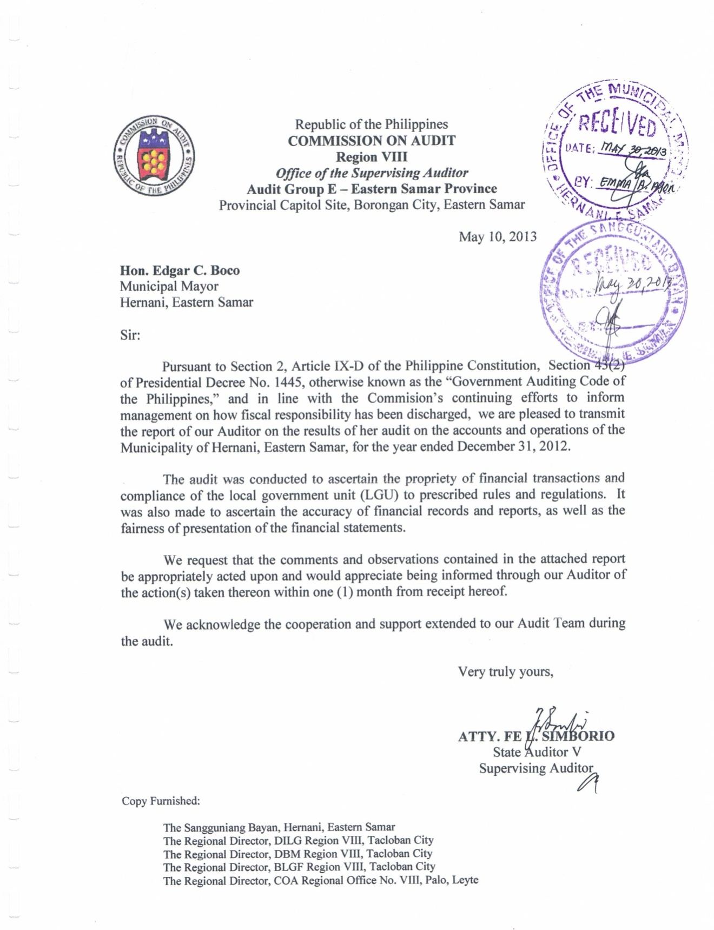

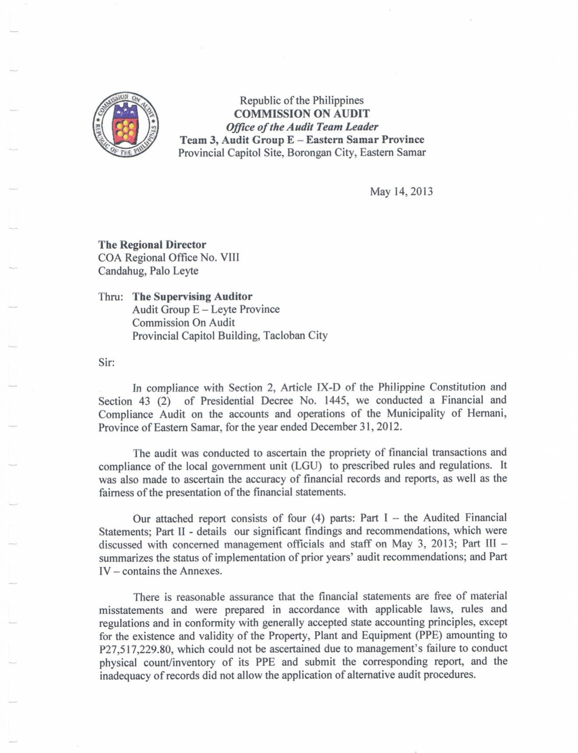

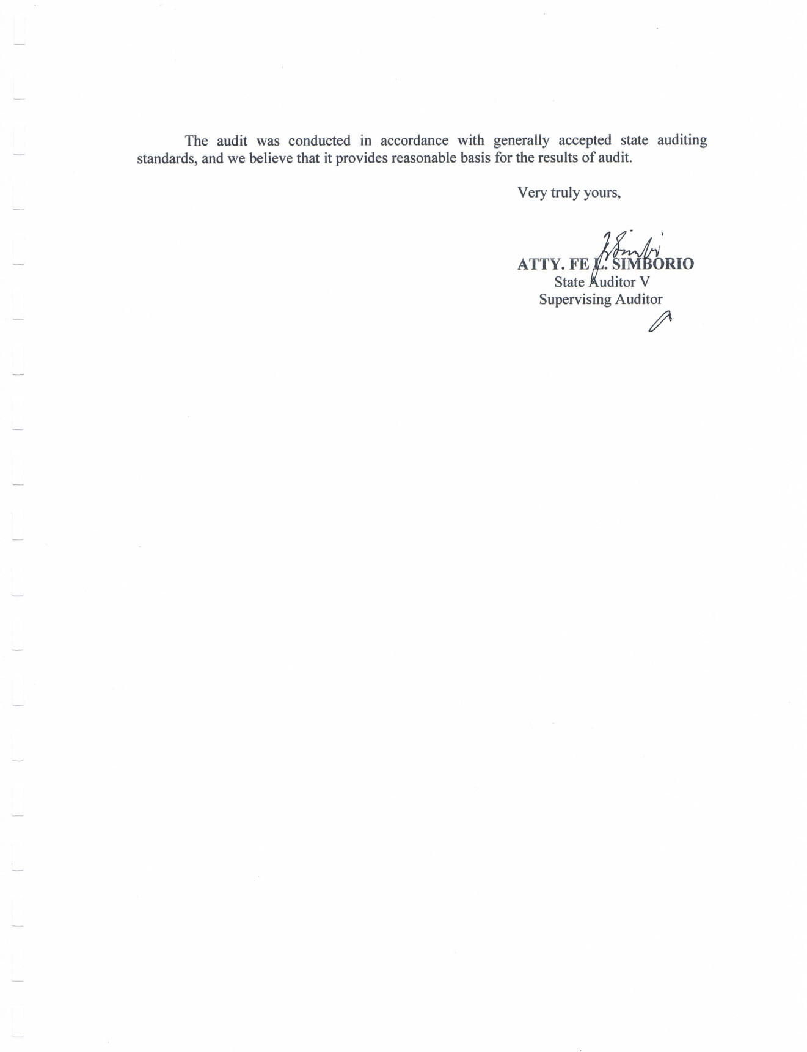



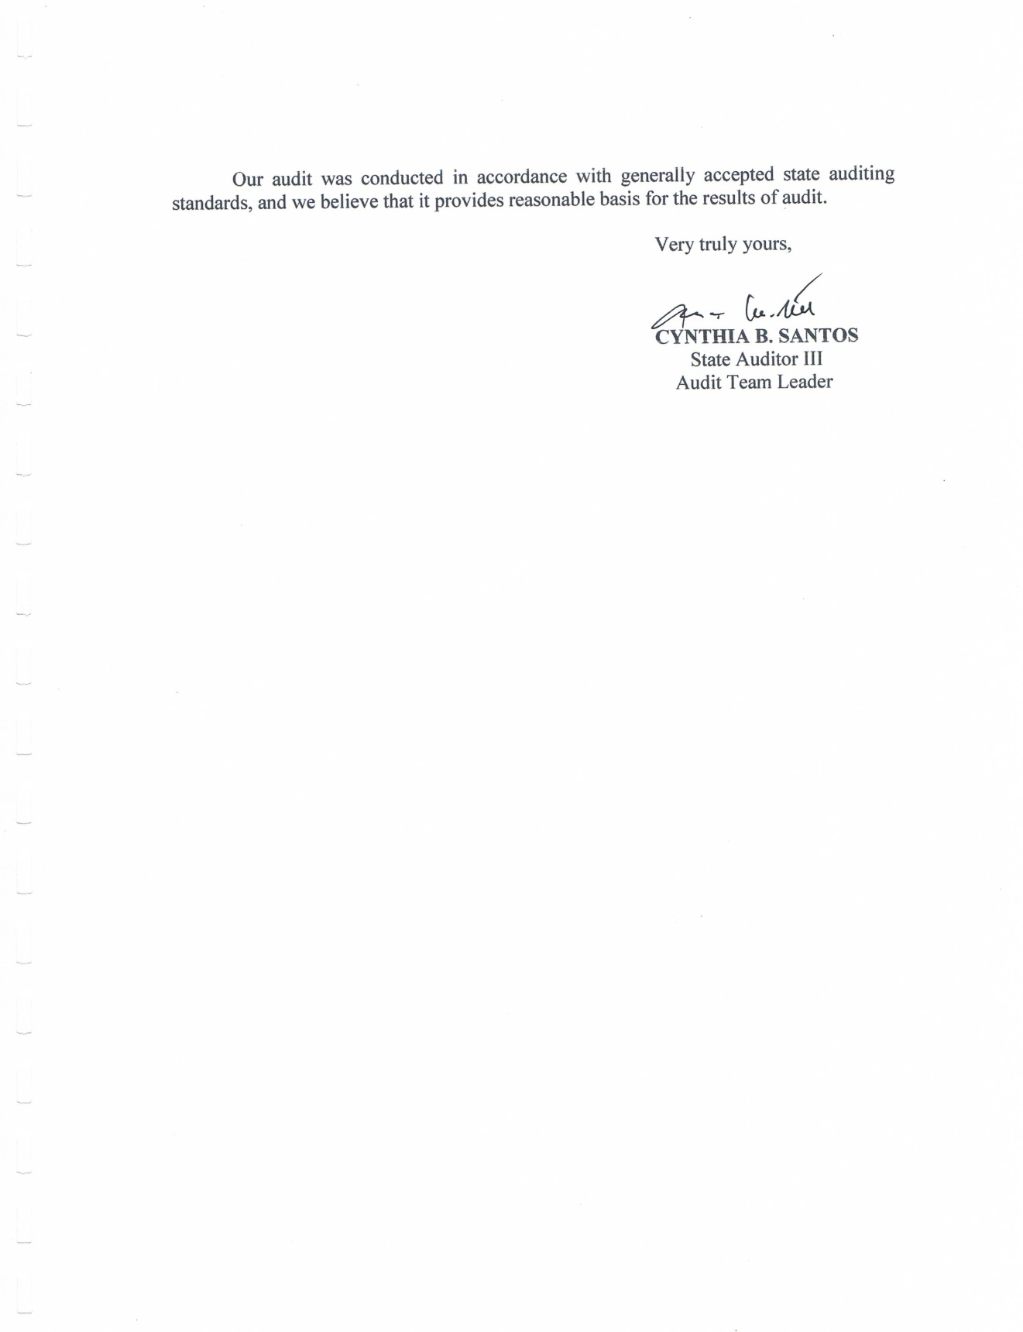

**EXECUTIVE SUMMARY**

**Introduction**

The Municipality of Hernani was founded around the year 1850 by Miguel “Totoy Yadawon” Candido, a settler from Guiuan, Eastern Samar. Formerly called NAG-AS (derived from the name of the river located southeast of the town proper), the settlement is nestled in a flat coastal terrain facing the vast Pacific Ocean.

NAG-AS reached the epochal point of its development when it was made a regular and independent municipality as embodied in a Royal Decree issued by Spanish Governor-General Rafael Echague on the 4th of January, 1864. The royal fiat also mandated the change of the old name NAG-AS to HERNANI.

Right after the Philippine-American War, the political status of Hernani was reduced into a barrio under the jurisdiction of Lanag (now Llorente). In 1912, its status as a Municipality was restored but the seat of local government was transferred to Pambujan (now Gen. MacArthur). However, in 1926, the Municipality of Hernani regained back the township by virtue of an Executive Order issued by the American Governor-General Leonard Wood.

Hernani is a 5th class municipality with thirteen (13) barangays. Its vision - “*A prosperous community characterized by enlightened and self-sufficient citizens engaged in diversified livelihood undertakings in an ecologically balanced environment and inspired by a just and efficient local government leadership*”.

**Highlights of Financial Operation**

The Municipality’s assets, liabilities and equity as of December 31, 2012 in comparison with 2011 are as follows:

|  |  |  |  |  |
| --- | --- | --- | --- | --- |
|  | **2012** | **2011** | **Increase (Decrease)** | |
| **Amount** | **%** |
| **Assets** | 27,475,422.02 | 31,398,058.23 | (3,922,636.21) | (12.40) |
| **Liabilities** | 13,446,684.83 | 14,173,276.50 | (726,591.67) | (5.13) |
| **Equity** | 14,028,737.19 | 17,224,781.73 | (3,196,044.54) | (18.55) |

**A.1 Income**

The Municipality collected a total income of P33,235,000.59from various sources. This year’s collection show a reduction by P2,697,340.46 or 7.21% from that of 2011, as follows:

|  |  |  |  |  |
| --- | --- | --- | --- | --- |
| **Sources of Fund** | **2012** | **2011** | **Increase(Decrease)** | |
| **Amount** | **%** |
| Local Income | 459,511.47 | 648,689.92 | (189,178.45) | (29.16) |
| IRA share | 26,804,904.00 | 27,715,141.00 | (910,237.00) | (3.28) |
| Permits and Licenses | 262,573.00 | 225,990.22 | 36,582.78 | 16.19 |
| Service Income | 115,523.10 | 16,706.75 | 98,816.35 | 591.48 |
| Business Income | 5,586,676.15 | 3,876,416.00 | 1,710,260.15 | 44.12 |
| Other Income | 5,812.87 | 3,449,397.16 | (3,443,584.29) | (99.83) |
| **Total** | **33,235,000.59** | **35,932,341.05** | **(2,697,340.46)** | **(7.51)** |

**A.2 Appropriations and Expenditures**

Appropriations for the current year amounted to P28,636,553.52 which decreased by 3.65% compared to that of last year’s appropriations of P29,722,059.71 as herein presented:

Appropriations per Program/Project

|  |  |  |  |  |
| --- | --- | --- | --- | --- |
| **Program/Projects** | **2012** | **2011** | **Increase(Decrease)** | |
| **Amount** | **%** |
| General Public Services | 16,462,847.70 | 16,488,701.15 | (25,853.45) | (0.16) |
| Education, Culture, Sports & Manpower Devt. | 74,177.00 | 3,000.00 | 71,177.00 | 2,372.57 |
| Health Services | 2,085,234.48 | 1,991,663.48 | 93,571.00 | 4.70 |
| Social Welfare Services | 428,270.00 | 402,351.60 | 25,918.40 | 6.44 |
| Economic Services | 8,104,224.34 | 9,451,221.18 | (1,346,996.84) | (14.25) |
| Other Purposes | 1,481,800.00 | 1,385,122.30 | 96,677.70 | 6.98 |
| **Total** | **28,636,553.52** | **29,722,059.71** | **(1,085,506.19)** | **(3.65)** |

Appropriations per Expense Classification

|  |  |  |  |  |
| --- | --- | --- | --- | --- |
| **Program/Projects** | **2012** | **2011** | **Increase(Decrease)** | |
| **Amount** | **%** |
| Personal Services | 17,977,606.50 | 15,005,253.17 | 2,972,353.33 | 19.81 |
| MOOE | 9,143,527.02 | 11,614,329.98 | (2,470,802.96) | (21.27) |
| Capital Outlay | 1,515,420.00 | 1,468,870.50 | 46,549.50 | 3.17 |
| Financial Expenses |  | 1,633,606.06 | (1,633,606.06) | (100.00) |
| **Total** | **28,636,553.52** | **29,722,059.71** | **(1,085,506.19)** | **(3.65)** |

Total expenditures incurred from current appropriations amounted to P35,966,063.52. There was an increase of P3,301,774.61 or 10.11% over that of CY 2011 as tabulated below:

Expenditures per Program/Project

|  |  |  |  |  |
| --- | --- | --- | --- | --- |
| **Program/Projects** | **2012** | **2011** | **Increase(Decrease)** | |
| **Amount** | **%** |
| General Public Services | 19,675,760.48 | 20,402,605.48 | (726,845.00) | 3.56 |
| Education, Culture, Sports & Manpower Devt. | 74,177.00 | 3,000.00 | 71,177.00 | 2,372.57 |
| Health Services | 2,936,978.03 | 2,970,239.46 | (33,261.43) | (1.12) |
| Social Welfare Services | 1,010,202.00 | 1,030,804.60 | (20,602.60) | (2.00) |
| Economic Services | 12,013,146.01 | 7,793,899.37 | 4,219,246.64 | 54.14 |
| Other Purposes | 255,800.00 | 463,740.00 | (207,940.00) | (44.84) |
| **Total** | **35,966,063.52** | **32,664,288.91** | **3,301,774.61** | **10.11** |

Expenditures per Expense Classification

|  |  |  |  |  |
| --- | --- | --- | --- | --- |
| **Program/Projects** | **2012** | **2011** | **Increase(Decrease)** | |
| **Amount** | **%** |
| Personal Services | 20,251,927.60 | 18,694,720.13 | 1,557,207.47 | 8.33 |
| MOOE | 7,866,016.99 | 8,679,981.54 | (813,964.55) | (9.38) |
| Cost of Goods Sold (Coco Oil Mill) | 5,139,566.29 | 1,973,097.00 | 3,166,469.29 | 160.48 |
| Subsidiaries and Donations | 1,039,801.87 | 907,303.18 | 132,498.69 | 14.60 |
| Capital Outlay | 346,554.00 | 749,581.00 | (403,027.00) | (53.77) |
| Financial Expenses | 1,322,196.77 | 1,634,606.06 | (312,409.29) | (19.11) |
| Inventory (Bagsakan) |  | 25,000.00 | (25,000.00) | (100.00) |
| **Total** | **35,966,063.52** | **32,664,288.91** | **3,301,774.61** | **10.11** |

**SCOPE OF AUDIT**

The audit was conducted on the accounts and operations of the Municipality of Hernani, Eastern Samar, for the period from January to December 31, 2012. The audit was aimed to ascertain the propriety and validity of disbursements and receipts as well as the reliability of the accounts as presented in the financial statements. The audit consisted of review of operating procedures, verification and analysis of accounts, interview with concerned municipal officials and employees, and such other audit procedures considered necessary in the circumstances.

**STATE AUDITOR’S REPORT ON THE FINANCIAL STATEMENTS**

The auditor rendered a qualified opinion on the financial statements because the existence and validity of Property, Plant and Equipment (PPE) amounting to P27,517,229.80could not be established due to management’s failure to conduct annual physical count/inventory of its PPE and submit the corresponding report, and the accuracy and reliability of the balance of the Cash in Bank – Local Currency, Current Account (LCCA) in the amount of P5,712,482.08 could not be ascertained due to the non-preparation of the Bank Reconciliation Statements. The other deficiencies mentioned in Part II and the unimplemented recommendations shown in Part III, of this Report, were also considered in the audit opinion.

**SUMMARY OF SIGNIFICANT FINDINGS AND RECOMMENDATIONS**

1. The existence and validity of Property, Plant & Equipment (PPE) accounts totalling ₱P27,517,229.80 as of December 31, 2012, could not be established due to the failure of management to conduct the annual physical count of its properties, contrary to Section 124 of the NGAS Manual for LGU, Volume 1, and the possible inclusion in the asset account of unserviceable properties subject for disposal.

**Create a committee to conduct the annual physical count of all PPE and to prepare and submit the RPCPPE;**

**Direct the Municipal Accountant to reconcile the recording of the PPE accounts as against that of the RPCPPE; and**

**Direct the Municipal Accountant and/or Property Officer to prepare the I & I Report of Unserviceable Properties prior to the conduct of disposal, if any.**

1. The accuracy and reliability of the balance of the Cash in Bank – Local Currency, Current Account (LCCA) in the amount of P5,712,482.08 could not be ascertained due to the non-preparation of the Bank Reconciliation Statements, contrary to Sections 3.2, 3.3 and 3.4 of COA Circular No. 96-011 dated October 2, 1996.

**Instruct the Municipal Accountant to prepare and submit bank reconciliation statements.**

1. Intelligence and Confidential Funds granted to Mayor Edgar C. Boco, totaling P76,000.00, were immediately taken up as Intelligence Expenses (882), instead of recording it as Advances to Officers and Employees (148), contrary to COA Circular No. 2003-003 dated July 30, 2003, thus monitoring the utilization of the funds could not be made and may expose the funds to possible misuse.

**Instruct the Municipal Accountant to reclassify the accounts and make necessary adjusting entry to record the same as Advances to Officers and Employees.**

**In the liquidation of the cash advance, adhere strictly to the provisions of COA Circular No. 2003-003 dated July 30, 2003.**

1. Management failed to formulate a Gender and Development (GAD) Plan duly approved by the Commission On Women and allocate at least 5% of their budget for Calendar Year 2012 contrary to R.A. No. 7192, Executive Order 273, Joint Circular No. 2004-1 dated April 5, 2004, and the General Appropriations Act (GAA) for FY 2012 (R.A. 10155), thus gender issues and concerns affecting the full development of women may not have been addressed.

**Instruct all concerned LGU officials to formulate and prepare the GAD Plan and Budget to insure that funds are allocated for the implementation of Gender and Development programs/projects.**

The above findings and recommendations, including the unimplemented and the partially implemented recommendations of prior years, were discussed with concerned officials of the Municipality during the audit exit conference. Management comments were considered in the report, where appropriate.

**Compliance with Tax Laws**

For CY 2012, the Municipality withheld taxes from claims for payment of suppliers/contractors and compensation of employees and remitted the same. The balance of P481,976.26 as of December 31, 2012 are taxes withheld for the month of December and remitted on January 10, 2013 and February 1, 2013.

**SUMMARY OF AUDIT SUSPENSIONS, DISALLOWANCES AND CHARGES**

|  |  |  |  |  |
| --- | --- | --- | --- | --- |
| Notices | Beg. Balance  (As of  January 1, 2012) | This Period  Jan. 1 to Dec. 31, 2012 | | Ending Balance  (As of Dec. 31, 2012) |
| NS/ND/NC NSSDC | |
| Notice of Suspension  Notice of Disallowance  Notice of Charge  Total | P 0.00  0.00  0.00  -------------  P 0.00  ======= | P268,470.00  0.00  0.00  ---------------  P268,470.00  ========= | P268,470.00  0.00  0.00  ---------------  P268,470.00  ========= | P 0.00  0.00  0.00  ------------------  P 0.00  ========== |

**STATUS OF IMPLEMENTATION OF PRIOR YEARS’AUDIT RECOMMENDATIONS**

Of the four (4) recommendations in CY 2011, three (3) were fully implemented while one (1) was partially implemented. The lone recommendation in CY 2010 was fully implemented, while the two (2) in CY 2009 and one (1) in CY 2008 were not implemented.

**TABLE OF CONTENTS**

**Page**

**Part I – Audited Financial Statements**

* State Auditor’s Report on the Financial Statement 1
* Statement of Management Responsibility for

Financial Statement 2

* Consolidated Balance Sheet 3
* Consolidated Statement of Income and Expenses 4
* Consolidated Statement of Cash Flow 5
* Notes to Financial Statements 7

**Part II – Detailed Findings and Recommendations** 19

**Part III – Status of Implementation of Prior Years’ Audit** 27

**Recommendations**

**Part IV – Annexes**

**FS-General Fund**

A - Detailed Balance Sheet

B - Detailed Statement of Income & Expenses

C - Detailed Statement of Cash Flow

**FS-SEF**

D - Detailed Balance Sheet

E - Detailed Statement of Income & Expenses

F - Detailed Statement of Cash Flow

**FS-Trust Fund**

G - Detailed Balance Sheet

H - Detailed Statement of Cash Flow

I - Statement of Appropriations, Allotment and Obligations

(General Fund)

J - Statement of Appropriations, Allotment and Obligations

(Special Education Fund)

K - Statement of Appropriations, Allotment and Obligations

(Continuing Appropriation)

L – Summary of Public Infrastructures

**PART I- Financial Statements**

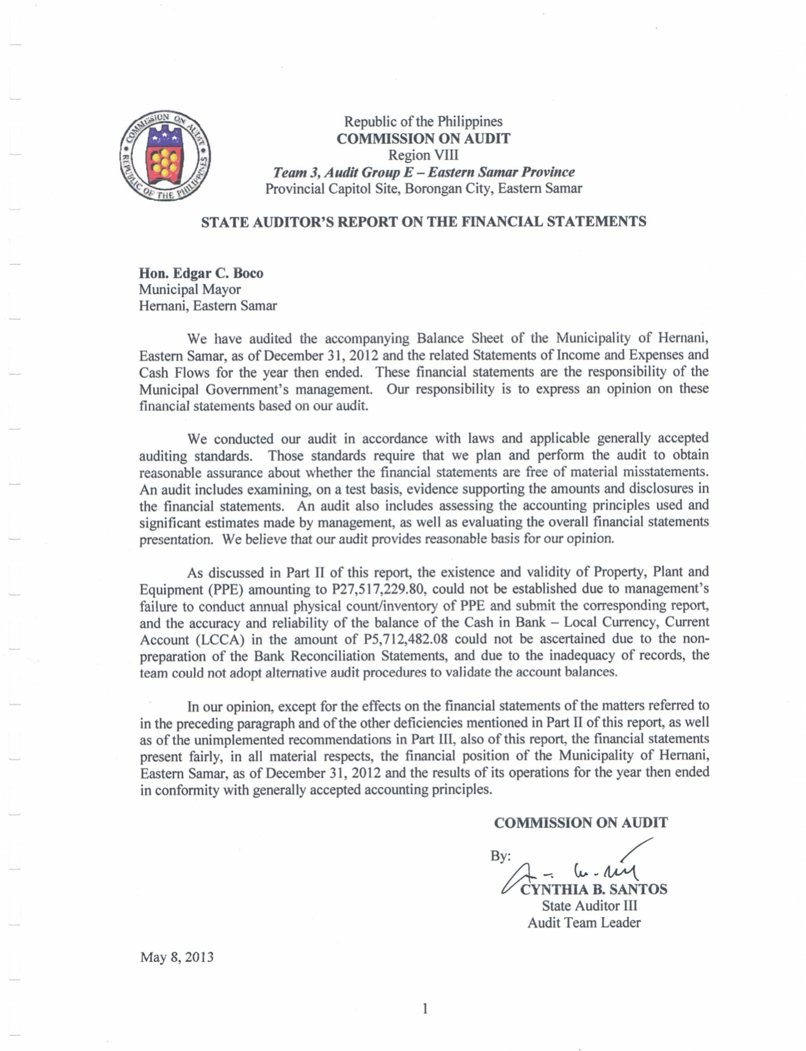

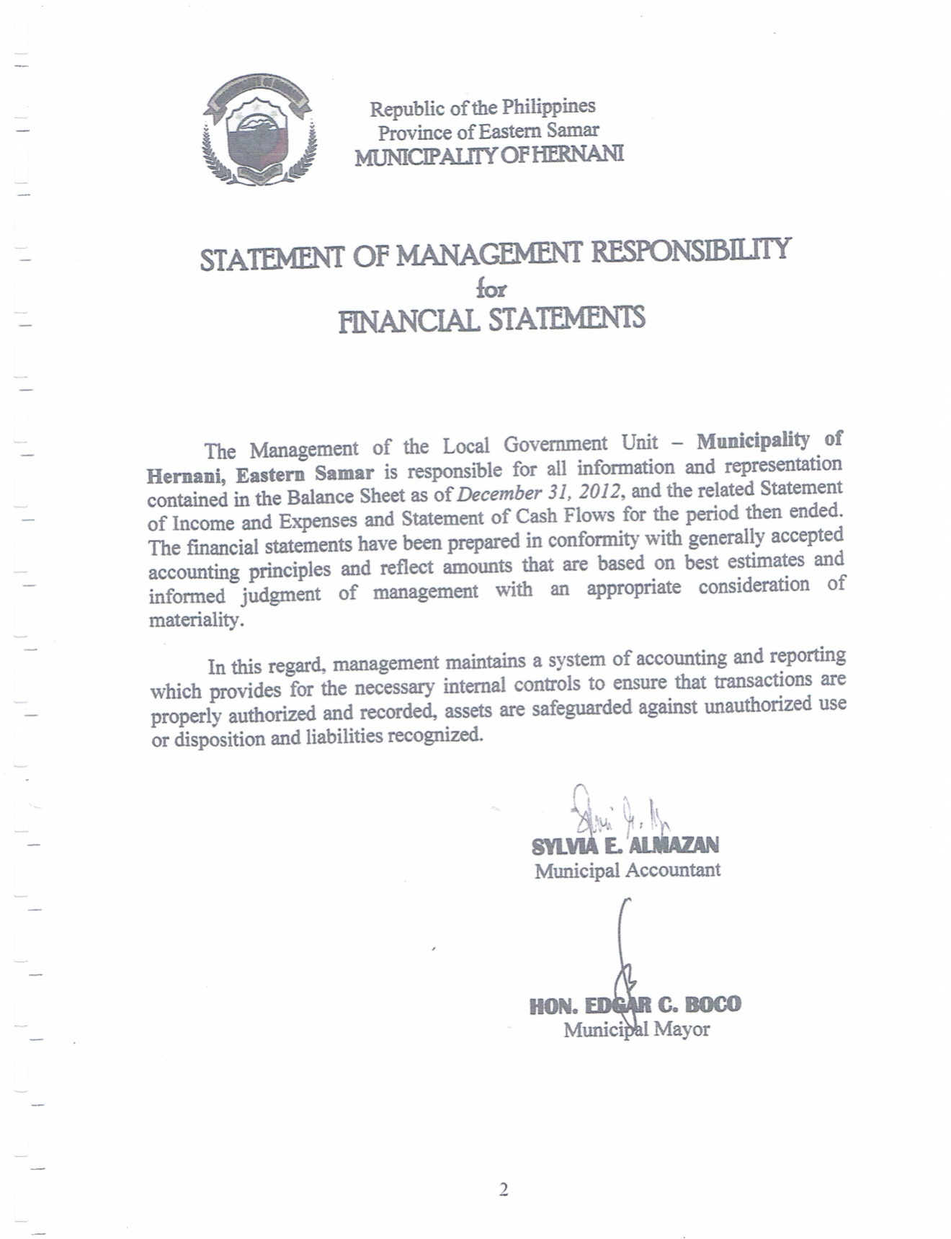

|  |  |  |  |  |
| --- | --- | --- | --- | --- |
| MUNICIPALITY OF HERNANI | | | | |
| **CONSOLIDATED BALANCE SHEET** | | | | |
| As of December 31, 2012 | | | | |
| (With Comparative Figures for CY 2011) | | | | |
|  |  |  |  |  |
| ASSETS | | **2012** |  | **2011** |
| CURRENT ASSETS | |  |  |  |
|  | Cash (Note 3) | 6,019,202.72 |  | 3,370,058.61 |
|  | Receivables (Note 4) | 3,457,008.81 |  | 3,304,873.63 |
|  | Inventories (Note 5) | 1,298,792.00 |  | 1,560,250.00 |
|  | Prepayments | 0.00 |  | 0.00 |
|  | Other Current Assets | 0.00 |  | 0.00 |
|  | Total Current Assets | 10,775,003.53 |  | 8,235,182.24 |
| INVESTMENTS | | 0.00 |  | 0.00 |
| PROPERTY, PLANT AND EQUIPMENT (Net of Depreciation-Note 6) | | |  |  |
|  | Land and Land Improvements | 4,129,994.61 |  | 3,955,994.61 |
|  | Buildings | 5,733,473.43 |  | 6,055,530.97 |
|  | Office Equipment, Furniture and Fixtures | 1,744,964.79 |  | 1,813,759.95 |
|  | Machineries and Equipment | 4,342,488.51 |  | 4,818,117.77 |
|  | Transportation Equipment | 659,674.45 |  | 756,191.25 |
|  | Other Property, Plant and Equipment | 40,309.95 |  | 74,494.95 |
|  | Public Infrastructures |  |  | 5,639,273.74 |
|  | Total Property, Plant and Equipment | 16,650,905.74 |  | 23,113,363.24 |
| OTHER ASSETS | | 49,512.75 |  | 49,512.75 |
| TOTAL ASSETS | | **27,475,422.02** |  | **31,398,058.23** |
| LIABILITIES AND EQUITY | |  |  |  |
| CURRENT LIABILITIES (Note 8) | |  |  |  |
|  | Payable Accounts | 447,572.05 |  | 714,897.76 |
|  | Inter-Agency Payables | 2,544,338.94 |  | 2,172,674.42 |
|  | Intra-Agency Payables | 657,478.32 |  | 617,028.85 |
|  | Other Liability Accounts | 1,018,072.87 |  | 123,543.62 |
|  | Total Current Liabilities | 4,667,462.18 |  | 3,628,144.65 |
| LONG-TERM LIABILITIES (Note 9) | |  |  |  |
|  | Mortgage/Bonds/Loans Payable | 8,692,222.65 |  | 10,458,131.85 |
| DEFERRED CREDITS (Note 10) | | 87,000.00 |  | 87,000.00 |
| TOTAL LIABILITIES | | 13,446,684.83 |  | 14,173,276.50 |
| EQUITY | |  |  |  |
|  | Government Equity (Note 11) | 14,028,737.19 |  | 17,224,781.73 |
| TOTAL LIABILITIES AND EQUITY | | **27,475,422.02** |  | **31,398,058.23** |

|  |  |  |  |  |
| --- | --- | --- | --- | --- |
| MUNICIPALITY OF HERNANI | | | | |
| **STATEMENT OF INCOME AND EXPENSE** | | | | |
| As of December 31, 2012 | | | | |
| (With Comparative Figures for CY 2011) | | | | |
|  |  |  |  |  |
|  |  | **2012** |  | **2011** |
| TAX REVENUE | |  |  |  |
|  | Local Taxes | 459,511.47 |  | 648689.92 |
| GENERAL INCOME ACCOUNTS | |  |  |  |
|  | Internal Revenue Allotment | 26,804,904.00 |  | 27,715,141.00 |
|  | Permits and Licenses | 262,573.00 |  | 225,990.22 |
|  | Service Income | 115,523.10 |  | 16,706.75 |
|  | Business Income | 5,586,676.15 |  | 3,876,416.00 |
|  | Other Income | 5,812.87 |  | 3,449,397.16 |
|  | Total Operating Income | 33,235,000.59 |  | 35,932,341.05 |
| EXPENSES | |  |  |  |
|  | Personal Services | 20,251,927.60 |  | 18,694,720.13 |
|  | Maintenance and Other Operating Expenses | 9,018,224.75 |  | 9,742,946.58 |
|  | Total Operating Expenses | 29,270,152.35 |  | 28,437,666.71 |
| INCOME FROM OPERATIONS | | 3,964,848.24 |  | 7,494,674.34 |
| FINANCIAL EXPENSES | | 439,242.17 |  | 153,071.91 |
| Income before Subsidies, Donations and Extraordinary Items | | 3,525,606.07 |  | 7,341,602.43 |
| Add: Subsidy from Other National Government Agencies | | 0.00 |  | 0.00 |
| Less: Subsidies and Donations | | (1,039,801.87) |  | (907,303.18) |
| Income before Extraordinary Items | | 2,485,804.20 |  | 6,434,299.25 |
| Add (Less) Extraordinary Items | | 0.00 |  | 0.00 |
| NET INCOME | | **2,485,804.20** |  | **6,434,299.25** |

|  |  |  |  |  |  |  |
| --- | --- | --- | --- | --- | --- | --- |
| Municipality of Hernani | | | | | | |
| CONSOLIDATED STATEMENT OF CASH FLOW | | | | | | |
| As of December 31, 2012 | | | | | | |
| (With Comparative Figures C.Y 2011) | | | | | | |
|  |  |  |  |  |  |  |
|  | | | | **2012** |  | **2011** |
|  |  |  |  |  |  |  |
| Cash Flows From Operating Activities | | | |  |  |  |
|  | Cash Inflows | | |  |  |  |
|  |  | Share from Internal Revenue Allotment | | 26,804,904.00 |  | 27,715,141.00 |
|  |  | Collection from Taxpayers | | 1,201,539.67 |  | 773,587.29 |
|  |  | Receipts from sale of goods and services | | 10,416,440.20 |  | 5,285,213.00 |
|  |  | Interest Income | | 5,812.87 |  | 9,367.10 |
|  |  | Dividend Income | | 0.00 |  | 0.00 |
|  |  | Receipts In Trust | | 1,868,139.23 |  | 9,067,866.04 |
|  |  | Other Adjustment | | 0.00 |  | 13,760.00 |
|  |  | Other Receipts | | 97,295.25 |  | 387,687.60 |
|  |  | Total Cash Inflows | | **40,394,131.22** |  | **43,252,622.03** |
|  | Cash Outflows | | |  |  |  |
|  |  | Payments to - | |  |  |  |
|  |  |  | Suppliers/Creditors | 13,445,031.33 |  | 13,127,673.21 |
|  |  |  | Employees | 11,832,794.01 |  | 9,864,871.56 |
|  |  |  | Remittance (GSIS,BIR,Pag-ibig,Philhealth etc.) | 9,697,122.52 |  | 8,643,067.09 |
|  |  | To purchase Property,Plant and Equipment | | 0.00 |  | 0.00 |
|  |  | Interest Expenses | | 439,242.17 |  | 69,750.11 |
|  |  | Other Expenses | | 1,120,788.48 |  | 10,437,694.37 |
|  |  | Total Cash Outflows | | **36,534,978.51** |  | **42,143,056.34** |
|  | Cash Provided by (Used In) | | | **3,859,152.71** |  | **1,109,565.69** |
| Cash Flows From Investing Activities | | | |  |  |  |
|  | Cash Inflows | | |  |  |  |
|  |  | Sale of Property, Plant and Equipment | | 0.00 |  | 0.00 |
|  |  | Sale of Debt Securities of Other Entities | | 0.00 |  | 0.00 |
|  |  | Collection of Principal on Loans to Other Entities | | 0.00 |  | 0.00 |
|  |  | Total Cash Inflows | | **0.00** |  | **0.00** |
|  | Cash Outflows | | |  |  |  |
|  |  | Purchase of Property, Plant and Equipment and Public Infrastructures | | 327,054.00 |  | 749,581.00 |
|  |  | Purchase of Debt Securities of Other Entities | | 0.00 |  | 0.00 |
|  |  | Purchase of Public Infrastructure | | 0.00 |  | 0.00 |
|  |  | Grant/Loans to Other Entities | | 0.00 |  | 0.00 |
|  |  | Total Cash Outflows | | **327,054.00** |  | **749,581.00** |
|  | Cash Provided by (Used In) | | | **3,532,098.71** |  | **359,984.69** |
| Cash Flows From Financing Activities | | | |  |  |  |
|  | Cash Inflows | | |  |  |  |
|  |  | Issuance of Debt Securities | | 0.00 |  | 0.00 |
|  |  | Acquisition of Loan | | 0.00 |  | 0.00 |
|  |  | Total Cash Inflows | | **0.00** |  | **0.00** |
|  | Cash Outflows | | |  |  |  |
|  |  | Retirement/Redemption of Debt Securities | | 0.00 |  | 0.00 |
|  |  | Payment of Loan Amortization | | 882,954.60 |  | 1,481,534.15 |
|  |  | Total Cash Outflows | | **882,954.60** |  | **1,481,534.15** |
|  | Cash Provided by (Used In) | | | **2,649,144.11** |  | **(1,481,534.15)** |
| Net Cash Provided By (Used In) | | | | 2,649,144.11 |  | (1,121,549.46) |
| Cash at the Beginning of the Period | | | | 3,370,058.61 |  | 4,491,608.07 |
| Cash at the End of the Period | | | | **6,019,202.72** |  | **3,370,058.61** |

Republic of the Philippines

Province of Eastern Samar

Municipality of Hernani

**NOTES TO FINANCIAL STATEMENTS**

1. Agency Profile

1.1 Creation

**HERNANI** was founded around the year 1850 by a settler from Guiuan, Eastern Samar named *Miguel “TotoyYadawon” Candido*. Formerly called ***NAG-AS*** (derived from the named of the river located southeast of the town proper), the settlement is nestled in a flat coastal terrain facing the vast Pacific Ocean.

**NAG-AS** reach the epochal point of its development when it was made a regular and independent municipality as embodied in a Royal Decree issued by Spanish Governor-General Rafael Echague on the 4th of January 1864. the royal fiat also mandate to change the old name ***NAG-AS to HERNANI****.*

Right after the Philippine-American War, the political status of Hernani was reduced into a barrio under the jurisdiction of *Lanang*( nowLlorente). In 1912, its status as a Municipality was restored but the seat of local government was transferred to *Pambujan*(now Gen. MacArthur). However, in 1926 the Municipality of Hernani regained back the township by virtue of an Executive Order issued by the American Governor-General Leonard Wood.

* 1. Vision

A prosperous community characterized by enlightened and self

sufficient citizens engaged in diversified livelihood undertakings in an ecologically balanced environment and inspired by a just and efficient local government leadership.

1.3 Fund Composition

* + 1. General Fund (101)

1.3.2 Special Education Fund (221)

1.3.3 Trust Fund (401)

* 1. Economic Enterprises Operated

The municipality currently have one Economic Enterprises in operation; The Hernani Integrated Coconut Processing Plant and Agribusiness Livelihood Center. This account is consolidated as part of the General Fund.

2. Summary of Significant Accounting Policies

2.1 Basis of Preparation

The agency uses Accrual Basis of accounting. All expenses are recognized when incurred and reported in the financial statements in the period to which they relate. Income is on accrual basis except for transactions where it is impractical or when other methods are required by law. All figures are being presented using Philippine Peso (Php) as denomination.

* 1. Accounting Policy Observed for Each Account

2.2.1 Cash

Petty Cash Fund (PCF) account is maintained under the Imprest System. All replenishments are directly charged to the expense account. It is not used to purchased regular inventory items for stock.

2.2.2 Receivables

Includes advances from officers and employees which are mostly prepayments for local travels. Balances reflected represents the unliquidated portion. Individual accounts has its corresponding aging reports.

2.2.3 Inventories

Procured supplies and materials inventory are recorded using the Perpetual Inventory Method. Purchases out of the Petty Cash Fund (PCF) are directly charged to corresponding expense accounts.

2.2.4 Property, Plant and Equipment

These are carried at historical cost. Acquisition cost less the applicable accumulated depreciation. Cost of Public Infrastructures, such as roads, highways and bridges are not carried on the books.

2.2.7 Depreciation

Depreciation is computed using the straight line method. No depreciation is charged to Public Infrastructures. For current acquisitions, it is computed beginning on the month following the purchase date, net of estimated scrap value.

2.2.8 Other Property, Plant and Equipment

These are assets that could not be classified under any of the PPE accounts due to their unsubstantial amounts and do not bear their corresponding depreciation. Unserviceable assets are also part of this account.

2.2.9 Payable Accounts

Subsequent year’s principal amortization on Loans Payable is recognized under Other Payables. Obligated disbursements which are paid the following year are recognized as Accounts Payable or under the Due to Officers and Employees account.

2.2.10 Inter-Agency Payables

National and Provincial aids or financial assistance with a specified purpose are booked using Due to National or LGU’s account and are nominated as Trust Receipts. These are reduced as soon as the project or program starts its implementation.

2.2.11 Intra-Agency Payables

Due to Other Funds account are being used everytime bank interests are earned from bank accounts in the Trust Fund. This is also used as reciprocal account of funds transferred from other Fund.

2.2.12 Other Liability Accounts

Deductions to employees from their salaries which are due to creditors. Amounts are reduced when remittances and payments are recorded. This includes Performance/Bidders/Bail Bond Payable due to contractors.

2.2.13 Loans Payable

Recorded as soon as the loan contract is perfected. These are reduced thru a set-up of the succeeding year’s amortization. Balance represents the outstanding principal.

2.2.14 Deferred Credits

The Deferred Real Property Tax Income is used as a reciprocal account with the Real Property Tax Receivable.

2.2.15 Equity

Prior period adjustments, transfer of assets booking from other funds, cumulative retained earnings and assets bookedfunded by other agencies are reflected under the Government Equity Account.

3. CASH

|  |  |  |  |  |  |  |  |  |  |
| --- | --- | --- | --- | --- | --- | --- | --- | --- | --- |
| 3.1 Details (Composition) by Fund | | | | | |  | **2012** |  | **2011** |
|  | 3.1.1 General Fund | | |  |  |  |  |  |  |
|  |  | Cash in Vault | |  |  |  | 124,565.06 |  | 124,659.21 |
|  |  | Cash Disbursing Officer | | |  |  | 174,124.88 |  | 99,094.47 |
|  |  | Payroll Fund | |  |  |  | 8,030.70 |  | 8,131.19 |
|  |  | Cash in Bank-Local Currency,Current Account | | | | | 4,641,453.70 |  | 2,255,587.48 |
|  |  |  |  |  |  |  | **4,948,174.34** |  | **2,487,472.35** |
|  | 3.1.2 Special Education Fund | | | | |  |  |  |  |
|  |  | Cash in Bank-Local Currency, Current Account | | | | | 140,841.96 |  | 59,805.36 |
|  |  |  |  |  |  |  | **140,841.96** |  | **59,805.36** |
|  | 3.1.3 Trust Fund | | |  |  |  |  |  |  |
|  |  | Cash in Bank-Local Currency, Current Account | | | | | 930,186.42 |  | 822,780.90 |
|  |  |  |  |  |  |  | **930,186.42** |  | **822,780.90** |

3.2 Cash in Bank are maintained at the following banks with their corresponding account numbers and per book balances:

|  |  |  |  |  |  |  |  |  |
| --- | --- | --- | --- | --- | --- | --- | --- | --- |
| **GENERAL FUND** | | |  |  |  |  |  |  |
| 3.2.1 LBP Borongan (1202-1019-99) | | | | | | 1,711,751.92 |  | 569,333.24 |
| 3.2.2 LBP Borongan (1202-1042-46) | | | | | | 1,225,794.61 |  | 1,268,661.50 |
| 3.2.3 LBP Borongan (1202-1116-25) | | | | | | 57,954.14 |  | 57,954.14 |
| 3.2.4 LBP Borongan (1202-1109-12) | | | | | | 23,291.25 |  | 23,291.25 |
| 3.2.5 LBP Borongan (1202-1084-62) | | | | | | 85,968.10 |  | 85,968.10 |
| 3.2.6 LBP Borongan (1202-1081-20) | | | | | | 65,962.64 |  | 159,086.01 |
|  |  |  |  |  |  |  |  |  |
| **Oilmill** | |  |  |  |  |  |  |  |
| 3.2.7 LBP Borongan (1202-1092-48) | | | | | | 1,470,731.04 |  | 91,293.24 |
|  |  |  |  |  |  | 4,641,453.70 |  | 2,255,587.48 |
| **SEF** | |  |  |  |  |  |  |  |
| 3.2.8 LBP Borongan (1202-1022-19) | | | | | | 140,841.96 |  | 59,805.36 |
|  |  |  |  |  |  |  |  |  |
| **TRUST FUND** | | |  |  |  |  |  |  |
| 3.2.9 DBP Borongan (000-1439-720-3) | | | | | | 7,519.49 |  | 9,075.49 |
| 3.2.10 DBP Borongan (000-1440-720-1) | | | | | | 874,301.51 |  | 622,315.96 |
| 3.2.11 DBP Borongan (000-1438-720-7) | | | | | | 10,000.00 |  | 10,000.00 |
| 3.2.12 LBP Borongan (1202-1098-41) | | | | | | 5,714.41 |  | 8,714.41 |
| 3.2.13 LBP Borongan (1202-1098-76) | | | | | | - |  | 31,842.10 |
| 3.2.14 LBP Borongan (1202-1098-84) | | | | | | 4,944.39 |  | 106,489.12 |
| 3.2.15 LBP Borongan (1202-1098-68) | | | | | | - |  | 31,613.17 |
| 3.2.16 PNB Borongan (614-860-0250) | | | | | | 27,706.62 |  | 2,730.65 |
|  |  |  |  |  |  | 930,186.42 |  | 822,780.90 |
|  |  |  |  |  |  | **5,712,482.08** |  | **3,138,173.74** |

3.3 This account includes Cash in Vault, Cash Disbursing Officer, Payroll Fund and Cash in Bank Accounts. The balance reflected on Cash in Vault represents collection collected at the last day of the fiscal year but was deposited at the very first banking day of January 2013. Cash Disbursing Officer balance represents revolving fund for HICPPALC Operation. Cash in Bank Account with the Development Bank of the Philippines serves as a hold out deposit due to our loan with them.

1. RECEIVABLES
   1. Details (Composition) by Fund
      1. General Fund

|  |  |  |  |  |  |  |  |  |
| --- | --- | --- | --- | --- | --- | --- | --- | --- |
| Receivable Accounts | | |  |  |  |  |  |  |
|  | Accounts Receivable | | |  |  | 1,159,923.00 |  | 848,987.00 |
| Inter-Agency Receivable | | | |  |  |  |  |  |
|  | Due from LGU's | |  |  |  | 802.35 |  | 802.35 |
|  | Advances toOfficers and Employees | | | | | 3,415.00 |  | 3,577.30 |
|  | Due from Officers and Employees | | | | | 1,208,386.97 |  | 1,208,386.97 |
| Intra-Agency Receivable | | | |  |  |  |  |  |
|  | Due from Other Funds | | |  |  | 713,378.04 |  | 672,928.57 |
| Other Receivables | | |  |  |  |  |  |  |
|  | Receivables-Disallowances/Charges | | | | |  |  |  |
|  | Other Receivables | | |  |  | 2,077.60 |  | 2,077.60 |
|  |  |  |  |  |  | **3,087,982.96** |  | **2,736,759.79** |

This account Due from Officers and Employees comprises the total Cash Accountability of Luzviminda Mabasa, former OIC-Municipal Treasurer who was on AWOL since October 1999.

* + 1. Special Education Fund

|  |  |  |  |  |  |  |  |  |
| --- | --- | --- | --- | --- | --- | --- | --- | --- |
|  |  |  |  |  |  | **2012** |  | **2011** |
| Receivable Accounts | | | |  |  |  |  |  |
|  | Special Education Tax Receivable | | | | |  |  |  |
|  | Advances to Officers and Employees | | | | |  |  |  |
| Intra-Agency Receivables | | | |  |  |  |  |  |
|  | Due from Other Funds | | |  |  | 154,885.61 |  | 256,875.01 |
| Other Receivables | | |  |  |  |  |  |  |
|  | Other Receivables | | |  |  |  |  |  |
|  | Receivables-Disallowances/Charges | | | | |  |  |  |
|  |  |  |  |  |  | **154,885.61** |  | **256,875.01** |

* + 1. Trust Fund

|  |  |  |  |  |  |  |  |  |
| --- | --- | --- | --- | --- | --- | --- | --- | --- |
| Receivable Accounts | | | |  |  |  |  |  |
|  | Due from Officers and Employees | | | | | 8,710.00 |  | 8,710.00 |
| Inter-Agency Receivables | | | |  |  |  |  |  |
|  | Due from NGAs | |  |  |  |  |  |  |
| Intra-Agency Receivables | | | |  |  |  |  |  |
|  | Due from Other Funds | | |  |  | 118,430.24 |  | 215,528.83 |
| Other Receivables | | |  |  |  | 87,000.00 |  | 87,000.00 |
|  |  |  |  |  |  | **214,140.24** |  | **311,238.83** |

1. INVENTORIES
   1. Details (Composition) by Fund
      1. General Fund

|  |  |  |  |  |  |  |  |
| --- | --- | --- | --- | --- | --- | --- | --- |
| Merchandise Inventory (Bagsakan) | | | | | 72,000.00 |  | 72,000.00 |
| Raw Materials Inventory | | | |  | 900,000.00 |  | 700,000.00 |
| Finished Goods Inventory | | | |  | 326,792.00 |  | 788,250.00 |
|  |  |  |  |  | **1,298,792.00** |  | **1,560,250.00** |

1. PROPERTY, PLANT AND EQUIPMENT
   1. Details (Composition) by Fund
      1. General Fund

|  |  |  |  |  |  |  |  |
| --- | --- | --- | --- | --- | --- | --- | --- |
|  |  |  |  |  | **2012** |  | **2011** |
| Land | |  |  |  | 628,795.70 |  | 454,795.70 |
| Land Improvements | | | |  | 1,301,635.36 |  | 3,501,198.91 |
| Accumulated Depreciation-Land Improvements | | | | | - |  | - |
| Net Book Value | | | |  | **1,301,635.36** |  | **3,501,198.91** |
|  |  |  |  |  |  |  |  |
| Office Buildings | | |  |  | 5,763,656.42 |  | 5,714,028.42 |
| Accumulated Depreciation-Office Buildings | | | | | (2,906,232.78) |  | (829,979.82) |
| Net Book Value | | | |  | **2,857,423.64** |  | **4,884,048.60** |
|  |  |  |  |  |  |  |  |
| School Buildings | | | |  | - |  | - |
| Accumulated Depreciation-School Buildings | | | | | - |  | - |
| Net Book Value | | | |  | **-** |  | **-** |
|  |  |  |  |  |  |  |  |
| Hospitals and Health Centers | | | | | 199,916.29 |  | 199,916.29 |
| Accumulated Depreciation-Hospitals and Health Centers | | | | | - |  | - |
| Net Book Value | | | |  | **199,916.29** |  | **199,916.29** |
|  |  |  |  |  |  |  |  |
| Markets and Slaughterhouses | | | | | 2,045,402.24 |  | 2,045,402.24 |
| Accumulated Depreciation-Markets and Slaughterhouses | | | | | (1,176,106.27) |  | (1,073,836.16) |
| Net Book Value | | | |  | **869,295.97** |  | **971,566.08** |
|  |  |  |  |  |  |  |  |
| Other Structures | | | |  | - |  | - |
| Accumulated Depreciation-Other Structures | | | | | - |  | - |
| Net Book Value | | | |  | **-** |  | **-** |
|  |  |  |  |  |  |  |  |
| Office Equipment | | | |  | 991,708.98 |  | 1,045,208.98 |
| Accumulated Depreciation-Office Equipment | | | | | (913,892.62) |  | (913,892.62) |
| Net Book Value | | | |  | **77,816.36** |  | **131,316.36** |
|  |  |  |  |  |  |  |  |
| Furniture and Fixtures | | | |  | 758,235.00 |  | 825,035.00 |
| Accumulated Depreciation-Furniture and Fixtures | | | | | (219,430.49) |  | (158,000.49) |
| Net Book Value | | | |  | **538,804.51** |  | **667,034.51** |
|  |  |  |  |  |  |  |  |
|  |  |  |  |  |  |  |  |
| I.T Equipment and Software | | | | | 1,241,658.83 |  | 1,160,546.83 |
| Accumulated Depreciation-I.T Equipment | | | | | (258,574.91) |  | (145,137.75) |
| Net Book Value | | | |  | **983,083.92** |  | **1,015,409.08** |
|  |  |  |  |  |  |  |  |
| Machineries | | |  |  | 7,447,312.45 |  | 7,447,312.45 |
| Accumulated Depreciation-Machineries | | | | | (3,476,687.54) |  | (3,035,422.48) |
| Net Book Value | | | |  | **3,970,624.91** |  | **4,411,889.97** |
|  |  |  |  |  |  |  |  |
| Agricultural, Fishery and Forestry Equipment | | | | | **-** |  | **-** |
|  |  |  |  |  |  |  |  |
| Communication Equipment | | | | | 224,410.00 |  | 224,410.00 |
| Accumulated Depreciation-Communication Equipment | | | | | (121,317.40) |  | (86,953.20) |
| Net Book Value | | | |  | **103,092.60** |  | **137,456.80** |
|  |  |  |  |  |  |  |  |
| Firefighting Equipment and Accessories | | | | | - |  | - |
| Accumulated Depreciation-Firefighting Equipment | | | | | - |  | - |
| Net Book Value | | | |  | **-** |  | **-** |
|  |  |  |  |  |  |  |  |
| Medical, Dental and Laboratory Equipment | | | | | 18,400.00 |  | 18,400.00 |
| Accumulated Depreciation-Medical, Dental and Lab. Equip. | | | | | (13,650.00) |  | (13,650.00) |
| Net Book Value | | | |  | **4,750.00** |  | **4,750.00** |
|  |  |  |  |  |  |  |  |
| Other Machineries and Equipment | | | | | 264,021.00 |  | 264,021.00 |
| Accumulated Depreciation-Other Machineries & Equipment | | | | | - |  | - |
| Net Book Value | | | |  | **264,021.00** |  | **264,021.00** |
|  |  |  |  |  |  |  |  |
| Motor Vehicles | | |  |  | 2,180,766.25 |  | 2,163,912.25 |
| Accumulated Depreciation-Motor Vehicles | | | | | (1,521,091.80) |  | (1,407,721.00) |
| Net Book Value | | | |  | **659,674.45** |  | **756,191.25** |
|  |  |  |  |  |  |  |  |
| Watercrafts | | |  |  | - |  | - |
| Accumulated Depreciation-Watercrafts | | | | | - |  | - |
| Net Book Value | | | |  | **-** |  | **-** |
|  |  |  |  |  |  |  |  |
| Other Property, Plant and Equipment | | | | | 299,650.20 |  | 329,650.20 |
| Accumulated Depreciation-Other PPE | | | | | (259,340.25) |  | (255,152.25) |
| Net Book Value | | | |  | **40,309.95** |  | **74,497.95** |
|  |  |  |  |  |  |  |  |
| Construction in Progress- Flood Controls | | | | | **-** |  | **-** |
|  |  |  |  |  |  |  |  |
| Construction in Progress- Roads,Highways and Bridges | | | | | **-** |  | **-** |
|  |  |  |  |  |  |  |  |
| Construction in Progress- Other Public Infra. | | | | | **-** |  | **-** |

* + 1. Special Education Fund

|  |  |  |  |  |  |  |  |
| --- | --- | --- | --- | --- | --- | --- | --- |
| Office Equipment | | | |  | 15,000.00 |  | 15,000.00 |
| Accumulated Depreciation-Office Equipment | | | | | **-** |  | **-** |
| Net Book Value | | | |  | **15,000.00** |  | **15,000.00** |
|  |  |  |  |  |  |  |  |
| I.T Equipment and Software | | | | | 19,500.00 |  | **-** |
| Accumulated Depreciation-I.T Equipment | | | | | **-** |  | **-** |
| Net Book Value | | | |  | **19,500.00** |  | **-** |

* + 1. Trust Fund

|  |  |  |  |  |  |  |  |
| --- | --- | --- | --- | --- | --- | --- | --- |
| Land & Land Improvements | | | | | 2,199,563.55 |  | 2,199,563.55 |
| Accumulated Depreciation-Land Improvements | | | | | **-** |  | **-** |
| Net Book Value | | | |  | **2,199,563.55** |  | **2,199,563.55** |
|  |  |  |  |  |  |  |  |
| Office Buildings | | |  |  | 1,806,837.53 |  | 1,806,837.53 |
| Accumulated Depreciation-Office Buildings | | | | | **-** |  | **-** |
| Net Book Value | | | |  | **1,806,837.53** |  | **1,806,837.53** |
|  |  |  |  |  |  |  |  |
| Office Equipment | | | |  | 38,500.00 |  | 38,500.00 |
| Accumulated Depreciation-Office Equipment | | | | | **-** |  | **-** |
| Net Book Value | | | |  | **38,500.00** |  | **38,500.00** |
|  |  |  |  |  |  |  |  |
| Furniture and Fixtures | | | |  | 72,260.00 |  | 72,260.00 |
| Accumulated Depreciation-Furniture and Fixtures | | | | | **-** |  | **-** |
| Net Book Value | | | |  | **72,260.00** |  | **72,260.00** |
|  |  |  |  |  |  |  |  |
| Other Assets | | |  |  | **49,512.75** |  | **49,512.75** |

PUBLIC INFRASTRUCTURE

|  |  |  |  |  |  |
| --- | --- | --- | --- | --- | --- |
| Roads, Highways and Bridges | | | |  | 5,639,273.74 |
| Parks, Plazas and Monuments | | | |  |  |
| Ports, Lighthouses and harbors | | | |  |  |
| Artesian Wells, Reservoirs, Pumping Stations | | | |  |  |
| and Conduits | |  |  |  |  |
| Irrigation, Canals and Laterals | | | |  |  |
| Flood Controls |  |  |  |  |  |
| Waterways, Aquaducts, Seawalls, Riverwalls | | | |  |  |
| and Others | |  |  |  |  |
| Other Public Infrastructure | | |  |  |  |
| Total Public Infrastructure | | | **-** |  | **5,639,273.74** |

* 1. Cost of Public Infrastructures transferred to Registry of Public Infrastructures (RPI) for the year 2012 totaled **P5,639,273.74** which consisted of the following:

|  |  |
| --- | --- |
| 6.2.1 Roads, Highways and Bridges | 5,639,273.74 |
| 6.2.2 Flood Controls | - |
| 6.2.3 Ports, Lighthouses and Harbors | - |
| 6.2.4 Other Public Infrastructure | - |

1. OTHER ASSETS

|  |  |  |  |  |  |  |  |  |  |
| --- | --- | --- | --- | --- | --- | --- | --- | --- | --- |
|  |  |  |  |  |  |  | **2012** |  | **2011** |
| 7.1 Trust Fund | | | |  |  |  | 49,512.75 |  | 49,512.75 |

1. CURRENT LIABILITIES
   1. Details (Composition) by Fund

|  |  |  |  |  |  |  |  |  |  |  |  |  |
| --- | --- | --- | --- | --- | --- | --- | --- | --- | --- | --- | --- | --- |
| 8.1.1 General Fund | | | | |  | |  | |  | |  | |
|  |  |  |  |  |  | | **2012** | |  | | **2011** | |
| Payable Accounts | | | |  |  | |  | |  | |  | |
|  | Accounts Payable | | | |  | | 221,402.99 | |  | | 103,706.03 | |
|  | Due to Officers and Employees | | | | | 223,084.31 | |  | | 380,611.38 | |
|  | Interest Payable | | | |  | |  | |  | | 82,321.81 | |
| Inter-Agency Payables | | | | |  | |  | |  | |  | |
|  | Due to National Treasury | | | | |  | |  | | - | |
|  | Due to BIR | | |  |  | | 316,038.99 | |  | | 50,786.41 | |
|  | Due to GSIS | | |  |  | | 382,492.67 | |  | | 351,527.28 | |
|  | Due to PAG-IBIG | | | |  | | 103,934.51 | |  | | 104,317.22 | |
|  | Due to PHILHEALTH | | | |  | | 104,626.00 | |  | | 40,101.00 | |
|  | Due to Other NGAs | | | |  | | 1,130,171.00 | |  | | 831,819.48 | |
|  | Due to Other GOCCs | | | |  | | 12,013.03 | |  | | 12,013.03 | |
|  | Due to LGUs | | |  |  | | 274,787.34 | |  | | 438,269.76 | |
| Intra-Agency Payables | | | | |  | |  | |  | |  | |
|  | Due to Other Funds | | | |  | | 6,734.12 | |  | | 236.00 | |
| Other Liability Accounts | | | | |  | |  | |  | |  | |
|  | Performance/Bidders/Bail Bonds Payable | | | | | 26,733.15 | |  | | 15,158.50 | |
|  | Other Payables | | |  |  | | 879,809.09 | |  | | (3,145.51) | |
|  |  |  |  |  |  | | **3,681,827.20** | |  | | **2,407,722.39** | |
|  |  |  |  |  |  | |  | |  | |  | |
| 8.1.2 Special Education Fund | | | | | |  | |  | |  | |
| Payable Accounts | | | |  |  | |  | |  | |  | |
|  | Accounts Payable | | | |  | | 3,084.75 | |  | | 3,084.75 | |
| Inter-Agency Payables | | | | |  | |  | |  | |  | |
|  | Due to BIR | | |  |  | | 6,166.54 | |  | | 2,854.99 | |
|  | Due to Other GOCCs | | | |  | | - | |  | | - | |
|  | Due to LGUs | | |  |  | | - | |  | | - | |
| Intra-Agency Payables | | | | |  | |  | |  | |  | |
|  | Due to Other Funds | | | |  | | - | |  | | - | |
|  |  |  |  |  |  | | **9,251.29** | |  | | **5,939.74** | |
|  |  |  |  |  |  | |  | |  | |  | |
| 8.1.3 Trust Fund | | | |  |  | |  | |  | |  | |
| Inter-Agency Payables | | | | |  | |  | |  | |  | |
|  | Due to National Treasury | | | | | - | |  | | - | |
|  | Due to BIR | | |  |  | | 159,770.73 | |  | | 159,770.73 | |
|  | Due to GSIS | | |  |  | | 6,774.76 | |  | | 6,774.76 | |
|  | Due to Other NGAs | | | |  | | 27,772.63 | |  | | 27,772.63 | |
|  | Due to PHILHEALTH | | | |  | | 410.70 | |  | | 410.70 | |
|  | Due to Other GOCCs | | | |  | | - | |  | | - | |
|  | Due to LGUs | | |  |  | | 19,380.04 | |  | | 86,876.34 | |
| Intra-Agency Payables | | | | |  | |  | |  | |  | |
|  | Due to Other Funds | | | |  | | 650,744.20 | |  | | 572,940.97 | |
| Other Liability Accounts | | | | |  | |  | |  | |  | |
|  | Performance/Bidders/Bail Bonds Payable | | | | | (28,769.37) | |  | | (28,769.37) | |
|  | Other Payables | | |  |  | | - | |  | | - | |
|  |  |  |  |  |  | | **836,083.69** | |  | | **825,776.76** | |

* 1. Due to BIR balance were remitted Jan. 10, 2013 under OR# 04369942 and Feb. 01, 2012 under OR# 05096407.
  2. The significant increase of the Due to Other NGAs account under General Fund was attributable to financial assistance/grants from the DSWD for the supplemental feeding, Financial Assistance to Kalahi Projects and Financial Assistance to BHWs.
  3. Loan Amortizations amounting P882,954.60 which is due CY 2013 is included under the Other Payable accounts. Salary loans with the RBG GuiuanMacarthur Branch and Employees COOP are also part of the Other Payables account.

1. LONG-TERM LIABILITIES

|  |  |  |  |  |  |  |  |  |  |
| --- | --- | --- | --- | --- | --- | --- | --- | --- | --- |
|  |  |  |  |  |  |  | **2012** |  | **2011** |
| 9.1 Loans Payable | | | | |  |  | **3,752,556.65** |  | **5,518,465.85** |

9.2 Succeeding years’ amortization are being booked under the Other Payables account. A total amount of P882,954.60 was booked under the Other Payables account representing amortization of CY 2013 of a loan with the DBP. This loan is payable on a 7 years and 4 months period with a 2 year grace period on principal payments.

9.3 Details of Loan:

Name of Loan: Term Loan DBP for the Construction/Rehabilitation of 8.1412KM Carmen – San Isidro – Canciledes – SitioTutubigan Farm to Market Road (FMR).

Type of Loan: Term Loan 7 years & 4 months period with a 2-year grace period.

Kind of Indebtedness: Domestic

Purpose of Loan: Construction/Rehabilitation of 8.1412KM Carmen – San Isidro – Canciledes – SitioTutubigan Farm to Market Road (FMR).

Authority of Loan: SANGGUNIANG Bayan Resolution No. 20 Series of 2007

Bank/Lending Institution: Development Bank of the Philippines

Amount: Php 6,475,000.00

Date OF loan was Granted/Approved: March 07, 2008

Maturity Date: March 07, 2018

Interest Rate: 9.00%

Contract Reference No. 5625002281-001-005-9

|  |  |  |  |  |  |  |  |  |  |  |  |  |  |  |  |  |  |  |  |
| --- | --- | --- | --- | --- | --- | --- | --- | --- | --- | --- | --- | --- | --- | --- | --- | --- | --- | --- | --- |
|  |  |  | |  | | | |  | | | | **2012** | |  | **2011** | | | | |
| Oil Mill Fund | | |  | | |  | | |  | | |  |  | | | | |  |  | | |
| 9.4 Loans Payable | | | | |  | |  | | |  | **4,939,666.00** | | | | |  | **4,939,666.00** | | | |

This account represents the amount released by CIIF to augment the operational fund of Coco Oil Mill in the amount of P 5,000,000.00, P64,334.00 of which have been debited to the account for the goods delivered to GRANEX per memorandum of agreement entered into by OILMILL and CIIF. Payment of loan will be in form of goods/products produced by Oilmill to be delivered to CIIF.

|  |  |  |  |  |  |  |  |  |  |  |
| --- | --- | --- | --- | --- | --- | --- | --- | --- | --- | --- |
| 10. DEFERRED CREDITS | | | | |  |  |  | **2012** |  | **2011** |
|  | 10.1 Composition | | |  |  |  |  |  |  |  |
|  | Deferred Real Property Tax Income | | | | | |  |  |  |  |
|  | Other Deferred Credits | | | |  |  |  | **87,000.00** |  | **87,000.00** |
|  |  |  |  |  |  |  |  |  |  |  |
| 11. GOVERNMENT EQUITY | | | | | |  |  | **2012** |  | **2011** |
|  | 11.1 Details (Composition) by Fund | | | | | |  |  |  |  |
|  |  | 11.1.1 General Fund | | |  |  |  | 9,319,844.11 |  | 12,481,124.30 |
|  |  | 11.1.2 Special Education Fund | | | | |  | 320,976.28 |  | 325,740.63 |
|  |  | 11.1.3 Trust Fund | | |  |  |  | 4,387,916.80 |  | 4,417,916.80 |
|  |  |  |  |  |  |  |  | **14,028,737.19** |  | **17,224,781.73** |

11.2 Assets and Infrastructure projects funded under the Trust Fund are being transferred of by booking to the General Fund upon completion, thus reducing this account under the TF. This year a total amount of **P5,639,273.74**was transferred to Registry of Public Infrastructure. An amount of **P 2,485,804.20** was added to the Retained Earnings account representing the agency’s Net Income for CY 2012.

|  |  |  |  |  |  |  |  |  |  |
| --- | --- | --- | --- | --- | --- | --- | --- | --- | --- |
|  |  |  |  |  |  |  | **2012** |  | **2011** |
| 11.3 | |  |  |  |  |  |  |  |  |
|  | Government Equity, beginning balance | | | | | | 17,224,781.73 |  | 44,166,052.82 |
|  | Add: Retained Operating Surplus | | | | | | |  |  |
|  |  | Current Operations | | | |  | 2,485,804.20 |  | 6,434,299.25 |
|  | Public Infrastructure | | | | |  | (5,639,273.74) |  | (33,420,464.23) |
|  | Add/Deduct. | | | |  |  | (42,575.00) |  | 44,893.89 |
|  | Other Adjustments | | | |  |  |  |  |  |
|  | Government Equity, End | | | | |  | **14,028,737.19** |  | **17,224,781.73** |

**PART II - FINDINGS AND RECOMMENDATIONS**

1. **The existence and validity of Property, Plant & Equipment (PPE) accounts totalling ₱27,517,229.80 as of December 31, 2012, could not be established due to the failure of management to conduct the annual physical count of its properties, contrary to Section 124 of the NGAS Manual for LGU, Volume 1, and the possible inclusion in the asset account of unserviceable properties subject for disposal.**

Section 124 of the NGAS Manual for LGUs Vol. I states that:

“*xxx*

*The physical count of property, plant and equipment by type shall be make annually and reported on the Report of the Physical Count of Property, Plant & Equipment (RPCPPE). This shall be submitted to the Auditor not later than January of each year.”*

Our verification of the Property, Plant & Equipment (PPE) showed the following balances as of December 31, 2012:

|  |  |  |  |
| --- | --- | --- | --- |
| **Account Title** | **Balance**  **Dec. 31, 2011** | **Net Addition/**  **Reduction** | **Balance**  **Dec. 31, 2012** |
| Land | 454,795.70 | 174,000.00 | 628,795.70 |
| Land Improvement | 3,501,198.91 | 0.00 | 3,501,198.91 |
| Office Buildings | 5,714,028.42 | 1,856,465.53 | 7,570,493.95 |
| Hospital and Health Centers | 199,916.29 | 0.00 | 199,916.29 |
| Market and Slaughterhouse | 2,045,402.24 | 0.00 | 2,045,402.24 |
| Office Equipment | 1,045,208.98 | 0.00 | 1,045,208.98 |
| Furniture & Fixtures | 825,035.00 | 5,460.00 | 830,495.00 |
| IT Equipment & Software | 1,160,546.83 | 100,612.00 | 1,261,158.83 |
| Public Infra – Roads, Highways & Bridges | 5,639,273.74 | (5,639,273.74) | 0.00 |
| Machineries | 7,447,312.45 | 0.00 | 7,447,312.45 |
| Communication Equipment | 224,410.00 | 0.00 | 224,410.00 |
| Medical, Dental & Laboratory Equipments | 18,400.00 | 0.00 | 18,400.00 |
| Other Machineries and Equipment | 264,021.00 | 0.00 | 264,021.00 |
| Motor Vehicles | 2,163,912.25 | 16,854.00 | 2,180,766.25 |
| Other Property, Plant and Equipment | 329,650.20 | 30,000.00 | 299,650.20 |
| **TOTAL** | **31,033,112.01** | **(3,515,882.21)** | **27,517,229.80** |
| **Accumulated Depreciation** | **7,919,748.77** | **2,946,575.29** | **10,866,324.06** |
| **NET AMOUNT** | **23,113,363.24** | **(6,462,457.50)** | **16,650,905.74** |

The total book value of ₱27,517,229.80 as of December 31, 2012, was reduced by ₱3,515,882.21 upon the completion of the infrastructure project amounting to P5,639,273.74 which were subsequently transferred to the Registry of Public Infrastructures. Only the amount of P2,123,391.53represent improvements and procurements made during the year.

The recording of PPE in the books was made by the accountant based on her records/files and balances which include those that were carried over from previous Accountants.

The Agency did not conduct the annual physical count of all PPE of the Municipality.

Thus, valuation, and existence of the properties may not be correct andthe account balance may not be reliable as this may include unserviceable properties subject for disposal.

In our exit conference, the Municipal Mayor promised to comply with our recommendation.

**Create a committee to conduct the annual physical count of all PPE and to prepare and submit the RPCPPE;**

**Direct the Municipal Accountant to reconcile the PPE account ledger balances with that of the RPCPPE; and**

**Direct the Municipal Accountant and/or Property Officer to prepare the I & I report of all Unserviceable Properties prior to the conduct of disposal, if any.**

Notice of Suspension/Disallowance may not yet be possible at this time until the accountability for particular equipment or property has been sufficiently established and determined.

1. **The accuracy and reliability of the balance of the Cash in Bank – Local Currency, Current Account (LCCA) in the amount of P5,712,482.08 as of December 31, 2012 could not be ascertained due to the non-preparation of the Bank Reconciliation Statements, contrary to Sections 3.2, 3.3 and 3.4 of COA Circular No. 96-011 dated October 2, 1996.**

COA Circular No. 96-011 dated October 2, 1996 is the “*Modification of Provincial Circular No. 19 dated June 15, 1970 re: Bank Reconciliation Statements for Depository Accounts*”. Sections 3.2, 3.3 and 3.4, thereof, states that:

*“3.2* ***The Local Accountants shall within ten (10) days from receipt of the Bank Statements, reconcile the same (BS) with the General Ledgers (GL) and prepare the BRS in five (5) copies****, x xx*

*3.3 The accountant shall draw journal vouchers to record all valid reconciling items that require adjustment and correction in the GL.*

*3.4 The duplicate and quadruplicate copies of the BRS including the paid checks, original copies of debit/credit memos, shall be submitted to the Auditor concerned for verification within ten (10) days from receipt after the end of each month.”* (Emphasis Supplied)

It was disclosed during our verification of the Consolidated Balance Sheet, as of December 31, 2012, that the Cash in Bank – Local Currency, Current Account (LCCA), as disclosed in the Notes to Financial Statements, has a balance of P5,712,482.08. However, no reconciliation was made to validate the accuracy of the account balancesbecause bank reconciliation statements were not prepared nor submitted to us for review.

With the foregoing condition, the accuracy and reliability of the balance of Cash in Bank – LCCA account could not be ascertained.

The Municipal Accountant explained that bank statements of their LBP account maintained at Borongan Branch are sent to them at months later by LBP Catbalogan Branch. The latest bank reconciliation statement prepared is as of May 31, 2012 but this was not yet submitted to COA.

We advised the Municipal Accountant to submit the latest bank reconciliation statements prepared and to make representations with LBP to fast track the mailing of its bank statements.

**Instruct the Municipal Accountant to prepare and submit monthly bank reconciliation statements in order to present a reliable balance of the Cash in Bank – LCCA account.**

The above observation may not give rise to the issuance of the Notice of Suspension or Disallowance as it involves mere submission of financial reports only.

1. **Intelligence and Confidential Funds granted to Mayor Edgar C. Boco, totaling P76,000.00, were immediately taken up as Intelligence Expenses (882), instead of recording it as Advances to Officers and Employees (148), contrary to COA Circular No. 2003-003 dated July 30, 2003, thus monitoring the utilization of the funds could not be made and may expose the funds to possible misuse.**

COA Circular No. 2003-003 dated July 30, 2003 laid down the guidelines in the audit and liquidation of Intelligence and Confidential Funds of the Local Government Units. It states, among others, the following guidelines:

*“1. All cash advances chargeable against the intelligence and/or confidential funds of all local government units shall be liquidated within one (1) month from the date the purpose of the cash advance was accomplished. X XX*

*2. The liquidation report* ***shall not*** *be coursed through the Agency Auditor or Regional/Cluster Director, but shall be submitted in a sealed envelope with label “CONFIDENTIAL – For COA Chairman Only” directly to the Chairman’s Office, COA …*

*X XXX*

*6.* ***Subsequent cash advances shall be granted only after the issuance of credit advice from the Chairman or the submission of liquidation vouchers/reports for the previous cash advance to the COA chairman****. One copy of the transmittal letter, for the purpose, duly received by the Chairman or his authorized representative, must be forwarded to the Accountant of the local government unit and the auditor concerned for reference. X XX”* (Emphasis Supplied)

Intelligence and Confidential Funds are allotted exclusively for peace and order programs and activities of the local government units. Such intelligence and confidential operations are highly sensitive which cannot be divulged without posing a threat to the success of the mission/security of the LGU.

The use of such funds shall not be limited to:

1. Purchase of information;
2. Payment of rewards;
3. Rental and other incidental expenses relative to the maintenance of safe houses; and
4. Purchase of supplies and ammunition, provision of medical and food aid, as well as, payment of incentives or traveling expenses relative to the conduct of intelligence or confidential operations. (Source: DILG Website – Frequently Asked Questions)

Our audit of financial transactions and reports disclosed that, as of December 31, 2012, Intelligence and Confidential funds was granted to Mayor Boco on various dates, totaling P76,000.00. These are:

|  |  |  |  |
| --- | --- | --- | --- |
| Date | Check No. | Payee | Amount |
| February 3, 2012 | 0456085 | Edgar C. Boco | 20,000.00 |
| May 2, 2012 | 0464863 | -do- | 20,000.00 |
| July 19, 2012 | 0487747 | -do- | 20,000.00 |
| December | (DV not yet submitted. Data based on GL) | -do- | 16,000.00 |
| TOTAL |  |  | 76,000.00 |

The Intelligence and Confidential funds were immediately taken up as expense under the Intelligence Expenses (882) account instead of treating the above as cash advances and subsequently recording it as Advances to Officers and Employees (148).

Thus, monitoring the utilization of the funds could not be made and may expose the funds to possible misuse.

The Municipal Accountant promised to comply with the recommendation and will furnish the Audit Team a copy of the transmittal letter on the submission of the liquidation papers.

**Instruct the Municipal Accountant to reclassify the accounts and make necessary adjusting entry to record the same as Advances to Officers and Employees.**

**Adhere strictly to the provisions of COA Circular No. 2003-003 dated July 30, 2003in the liquidation of the cash advance.**

The above observation may not call for the issuance of the Notices of Suspension or Disallowance since the same involves the reclassification of accounts only.

**Gender and Development**

1. **Management failed to formulate its Gender and Development (GAD) Plan duly approved by the Commission On Women and allocate at least 5% of their budget for Calendar Year 2012 contrary to R.A. No. 7192, Executive Order 273, Joint Circular No. 2004-1 dated April 5, 2004, and the General Appropriations Act (GAA) for FY 2012 (R.A. 10155), thus gender issues and concerns affecting the full development of women may not have been addressed.**

R.A. No. 7192, otherwise known as “*The Women in Development and Nation-Building Act*” and Executive Order 273 mandate agencies, to institutionalize Gender and Development (GAD) in government by incorporating GAD concerns in their planning, programming and budgeting process.

In relation thereto, Sections 4.1, 4.4, 5.1 and 5.2 of Joint Circular No. 2004-1 dated April 5, 2004 of the Department of Budget and Management (DBM), National Economic and Development Authority (NEDA) and National Commission on the Role of Filipino Women (NCRFW) provides that:

*“Section 4.1 Agencies shall formulate the annual Gender and Development plans and programs. The annual GAD plan and budget shall be geared towards the achievement of the desired outcomes and goals as identified in the Framework for Women.*

*Section 4.4 GAD planning and budgeting shall be observed annually and incorporated in all programming and budgeting exercises of agencies. The GAD activities in the GAD plan and budget must be included in the agency budget proposal in accordance with the budget call. Agencies shall ensure that the cost of implementing the GAD activities is part of their approved budget. At least five percent (5%) of the total agency budget appropriations as authorized under the annual General Appropriations Act, shall correspond to activities supporting GAD.*

*Section 5.1 The agency GAD Focal Point shall prepare the annual GAD plan and budget in coordination with the agency budget officers following the format and procedure prescribed in Annex A to be approved by the agency head. Agencies shall submit their annual GAD plans and budgets to the NCRFW for review and endorsement prior to the submission f the agency budget proposal. Agencies shall submit to the DBM their NCRFW-endorsed annual GAD plans and budgets along with the agency budget proposals in accordance with the budget call. The DBM shall return to the agencies their annual GAD plans and budgets if they do not have the endorsement of the NCRFW.*

*Section 5.2 The GAD Focal Point shall prepare the annual GAD accomplishment report in coordination with the agency budget officers following the format prescribed in Annex B to be approved by the agency head. Agencies shall submit to the DBM two (2) copies of the annual GAD accomplishment report for the previous year along with the agency budget proposal in accordance with the budget call. The DBM shall furnish the NCRFW a copy of the annual GADA Accomplishment Report.”*

Section 28 of the General Provisions of the General Appropriations Act for FY 2012 or R.A. 10155, states that:

*“****All agencies of the government shall formulate a Gender and Development (GAD) Plan*** *designed to address gender issues within their concerned sectors or mandate and implement applicable provisions under R.A. No. 9710 or the Magna Carta of Women, Convention on the Elimination of All Forms of Discrimination Against Women, the Beijing Platform for Action, the Millennium Development Goals (2005-2015), the Philippine Plan for Gender-Responsive Development (1995-2025), and the Philippine Development Plan (2011-2016).*

***The GAD Plan shall be integrated in the regular activities of the agencies, which shall be at least five percent (5%) of their budgets****.”*  (Emphasis Supplied)

Our audit and review of transactions and financial statements for CY 2012 showed that the agency did not prepare the GAD Plan and Budget as shown in its failure to allocate funds for the programs/projects related to Gender and Development (GAD).

As a result, gender issues and concerns affecting the full development of women in the Municipality may not have been addressed.

During the exit conference, the Municipal Planning and Development Coordinator (MPDC) informed the team that they have already formulated the GAD Plan for CY 2013 and promised to submit a copy to COA.

**Instruct all concerned LGU officials to formulate and prepare the GAD Plan and Budget to insure that funds are allocated for the implementation of Gender and Development programs/projects.**

**Compliance with Tax Laws**

For CY 2012, the Municipality withheld taxes from claims for payment of suppliers/contractors and compensation of employees and remitted the same. The balance of P481,976.26 as of December 31, 2011 represent taxes withheld for the month of December and were actually remitted on January 10, 2013and February 1, 2013.

***SUMMARY OF AUDIT SUSPENSIONS, DISALLOWANCES AND CHARGES -***

|  |  |  |  |  |
| --- | --- | --- | --- | --- |
| Notices | Beg. Balance  (As of Jan. 1, 2012) | This Period  Jan. 1 to Dec. 31, 2012 | | Ending Balance  (As of Dec. 31, 2012) |
| NS/ND/NC NSSDC | |
| Notice of Suspension  Notice of Disallowance  Notice of Charge  Total | P 0.00  0.00  0.00  -------------  P 0.00  ======= | P268,470.00  0.00  0.00  ----------------  P268,470.00  ========== | P268,470.00  0.00  0.00  -----------------  P268,470.00  ========== | P 0.00  0.00  0.00  ------------------  P 0.00  ========== |

**PART III - STATUS OF IMPLEMENTATION OF PRIOR YEARS’ RECOMMENDATIONS**

Of the four (4) recommendations in CY 2011, three (3) were fully implemented while one (1) was partially implemented. The lone recommendation in CY 2010 was fully implemented, while the two (2) in CY 2009 and one (1) in CY 2008 were not implemented.

| **Audit Observation** | **Recommendation** | **Ref** | **Management Action** | **Status of Implementation** | **Reason for Partial/Non-Implementation** |
| --- | --- | --- | --- | --- | --- |
| The Municipal Accountant and Municipal Treasurer did not maintain appropriate ledger cards, and property cards, respectively, and that no physical inventory was conducted on the LGU’s Property, Plant and Equipment valued at P23,113,363.24, contrary to section 114 and 124 of the NGAS Manual for LGU’s, Volume I, thus the accuracy of the recorded assets was not ascertained and their existence was not established. | We recommended that the Municipal Accountant and the Municipal Treasurer be required to maintain appropriate ledger cards, and property cards, respectively. Likewise, the Local Chief Executive should ensure that physical inventory taking is conducted periodically. | AAR, CY 2011 |  | Partially Implemented. | Only Subsidiary Ledger is maintained. No Property Card because there is no actual inventory of PPE. |
| The Municipal Accountant did not submit for audit paid disbursement vouchers and its supporting documents totaling P1,149,357.81 contrary to Section 107 of PD 1445, Section 347 of RA 7160, and Section 7.2.1(a) of COA Circular No. 2009-006 dated September 15, 2009, thus, casted doubt on the propriety of the recorded check disbursements that resulted in audit suspension of the same. | We recommended that the Municipal Accountant be required to submit the disbursement vouchers, with the supporting documents for the recorded check disbursements amounting to P1,149,357.81. This recommendation is without prejudice to the result of post-audit. Henceforth, ensure that the required financial reports are submitted within the period prescribed under Section 7.2.1(a) of COA Circular No. 2009-006 dated September 15, 2009. | AAR, CY 2011 |  | Implemented. |  |
| Completed infrastructure projects in prior year’s amounting to P5,639,273.74 were not transferred to the Registry of Public Infrastructure account contrary to Section 4(n) of NGAS Manual, Volume I. | We recommended that the Municipal Accountant be directed to draw a journal entry voucher to drop the Public Infrastructure account from the books and transfer the same to the respective registry. | AAR, CY 2011 |  | Implemented. |  |
| The current portion of the long-term indebtedness from the Development Bank of the Philippines amounting to P882,954.60 was inadvertently not transferred to current liabilities, contrary to paragraph 69 of the Philippine Accounting Standards (PAS) No. 1 and section 143 of NGAS Manual, Volume III, resulting in the overstatement of the Loans Payable, Long-Term Domestic account, and understatement of Loans Payable – Current Account by the same amount. | We recommended that the Municipal Accountant be directed to draw a journal entry voucher to record the transfer of the current portion of the long-term indebtedness to current liabilities. | AAR, CY 2011 |  | Implemented. |  |
| The Municipal Treasurer and the Accountant did not submit the paid vouchers (DVs), with supporting documents within the first 10 days of the ensuing months or for a period ranging from 22 to 156 days after they became due, contrary to Section 347 of RA 7160, Section 6 of COA Circular No. 95-006 and Section 7.2.1 paragraph (a) of COA Circular No. 2009-006. | We recommend that the Municipal Treasurer and the Accountant be required strictly observe the timely submission of the paid vouchers with the supporting documents as provided for in Section 347 of RA 7160, Section 6 of COA Circular No. 95-006 and Section 7.2.1 paragraph (a) of COA Circular No. 2009-06. | AAR, CY 2010 |  | Implemented. |  |
| The total appropriation for personal services exceeded the budgetary limitations by P3,456,603.90 or 18.09% in violation of adequate budget for maintenance and other operating expenses and needed development project. | The Local Chief Executive should limit the appropriations for personal services to 55% of the total annual income from regular sources of the next the municipality and the community as a whole. | AAR, CY 2009 |  | Not Implemented, | For CY 2012, it still exceeded by 7%. This was due to the implementation of Salary Standardization Law. |
| Management failed to submit approved copies of contracts/purchase order, and notices of deliveries for additional review and evaluation contrary to the mandates of COA Circular No. 2009-001. | Copies of the perfected contracts/purchase orders should be submitted within five (5) days after the execution/issuance. | AAR, CY 2009 |  | Not Implemented. | Contracts/ Purchase Orders are still not submitted within the time frame but rather these were attached to the disbursement voucher submitted for post-audit. |
| The validity of Land, Land Improvements and Building accounts valued P9,872,463.10 could not be ascertained due to lack of property cards, subsidiary ledgers and certificate of title contrary to Section 23(2), Title I, Book V, 1987 Administrative Code. | We recommended strict compliance to Section 23(2), Title I, Book V, 1987 Administrative Code. | AAR, CY 2008 | None | Not Implemented | No application submitted for certificate of ownership or title. |

**PART IV - ANNEXES**

**FS-General Fund**

Annex A - Detailed Balance Sheet

B - Detailed Statement of Income & Expenses

C - Detailed Statement of Cash Flow

**FS-SEF**

D - Detailed Balance Sheet

E - Detailed Statement of Income & Expenses

F - Detailed Statement of Cash Flow

**FS-Trust Fund**

G - Detailed Balance Sheet

H - Detailed Statement of Cash Flow

I - Statement of Appropriations, Allotment and Obligations

(General Fund)

J - Statement of Appropriations, Allotment and Obligations

(Special Education Fund)

K - Statement of Appropriations, Allotment and Obligations

(Continuing Appropriation)

L – Summary of Public Infrastructures

ANNEX A

|  |  |  |  |  |
| --- | --- | --- | --- | --- |
| Municipality of Hernani | | | | |
| **BALANCE SHEET** | | | | |
| As of December 31, 2012 | | | | |
| GENERAL FUND | | | | |
|  | | | | |
| **ASSETS** | | | |  |
| CURRENT ASSETS | | | |  |
|  | CASH | | |  |
|  |  | Cash on Hand | |  |
|  |  |  | Cash in Vault | 124,565.06 |
|  |  |  | Cash-Disbursing Officers | 174,124.88 |
|  |  |  | Payroll Fund/Cash Advance for Payroll | 8,030.70 |
|  |  | Cash in Banks-Local Currency | |  |
|  |  |  | Cash in Bank -Local Currency, Current Account | 4,641,453.70 |
|  |  | Total Cash | | 4,948,174.34 |
|  | RECEIVABLES | | |  |
|  |  | Receivable Accounts | |  |
|  |  |  | Accounts Receivable-Trade | 1,159,923.00 |
|  |  |  | Due from Officers and Employees | 1,208,386.97 |
|  |  | Inter-agency Receivables | |  |
|  |  |  | Due from LGUs | 802.35 |
|  |  | Intra-agency Receivables | |  |
|  |  |  | Due from Other Funds | 713,378.04 |
|  |  | Other Receivables | |  |
|  |  |  | Advances to Officers and Employees | 3,415.00 |
|  |  |  | Other Receivables | 2,077.60 |
|  |  | Total Receivables | | 3,087,982.96 |
|  | INVENTORIES | | |  |
|  |  | Materials | |  |
|  |  |  | Raw Materials Inventory | 900,000.00 |
|  |  |  | Finished Goods Inventory | 326,792.00 |
|  |  |  | Merchandise Inventory | 72,000.00 |
|  |  | Total Inventories | | 1,298,792.00 |
|  | TOTAL CURRENT ASSETS | | | 9,334,949.30 |
| PROPERTY, PLANT AND EQUIPMENT | | | |  |
|  | LAND AND LAND IMPROVEMENTS | | |  |
|  |  | Land | | 628,795.70 |
|  |  | Land Improvements | | 1,301,635.36 |
|  |  | Total Land and Land Improvements | | 1,930,431.06 |
|  | BUILDINGS | | |  |
|  |  | Office Buildings | | 2,857,423.64 |
|  |  | Hospitals and Health Centers | | 199,916.29 |
|  |  | Markets and Slaughterhouses | | 869,295.97 |
|  |  | Total Buildings | | 3,926,635.90 |
|  | OFFICE EQUIPMENT, FURNITURE AND FIXTURES | | |  |
|  |  | Office Equipment | | 77,816.36 |
|  |  | Furniture and Fixtures | | 538,804.51 |
|  |  | IT Equipment and Software | | 983,083.92 |
|  |  | Total Office Equipment, Furniture and Fixtures | | 1,599,704.79 |
|  | MACHINERIES AND EQUIPMENT | | |  |
|  |  | Machineries | | 3,970,624.91 |
|  |  | Communication Equipment | | 103,092.60 |
|  |  | Medical, Dental and Laboratory Equipment | | 4,750.00 |
|  |  | Other Machineries and Equipment | | 264,021.00 |
|  |  | Total Machineries and Equipment | | 4,342,488.51 |
|  | TRANSPORTATION EQUIPMENT | | |  |
|  |  | Motor Vehicles | | 659,674.45 |
|  |  | Total Transportation Equipment | | 659,674.45 |
|  | OTHER PROPERTY, PLANT AND EQUIPMENT | | |  |
|  |  | Other Property, Plant and Equipment | | 40,309.95 |
|  |  | Total Other Property, Plant and Equipment | | 40,309.95 |
|  | Total Property, Plant and Equipment | | | 12,499,244.66 |
| **TOTAL ASSET** | | | | **21,834,193.96** |
| **LIABILITIES** | | | |  |
|  | CURRENT LIABILITIES | | |  |
|  |  | Payable Accounts | |  |
|  |  |  | Accounts Payable | 221,402.99 |
|  |  |  | Due to Officers and Employees | 223,084.31 |
|  |  | Inter-Agency Payables | |  |
|  |  |  | Due to BIR | 316,038.99 |
|  |  |  | Due to GSIS | 382,492.67 |
|  |  |  | Due to PAG-IBIG | 103,934.51 |
|  |  |  | Due to PHILHEALTH | 104,626.00 |
|  |  |  | Due to Other NGAs | 1,130,171.00 |
|  |  |  | Due to Other GOCCs | 12,013.03 |
|  |  |  | Due to LGUs | 274,787.34 |
|  |  | Intra-Agency Payables | |  |
|  |  |  | Due to Other Funds | 6,734.12 |
|  |  | Other Liability Accounts | |  |
|  |  |  | Guaranty Deposits Payable | 140,300.00 |
|  |  |  | Performance/Bidders/Bail Bonds Payable | 26,733.15 |
|  |  |  | Other Payables | 879,809.09 |
|  |  | Total Current Liabilities | | 3,822,127.20 |
|  | LONG-TERM LIABILITIES | | |  |
|  |  | Mortgage/Bonds/Loans Payable | |  |
|  |  |  | Loans Payable - Domestic | 8,692,222.65 |
|  |  | Total Long-Term Liabilities | | 8,692,222.65 |
|  |  | **TOTAL LIABILITIES** | | **12,514,349.85** |
|  | EQUITY | | |  |
|  |  | Government Equity - Beg. | | 12,481,124.30 |
|  |  | Add: Retained Operating Surplus: | |  |
|  |  |  | Current Operations | 2,477,993.55 |
|  |  |  | Public Infrastructures | (5,639,273.74) |
|  |  | **Government Equity-End** | | **9,319,844.11** |
|  | **TOTAL LIABILITIES AND EQUITY** | | | **21,834,193.96** |

ANNEX B

|  |  |  |  |  |  |
| --- | --- | --- | --- | --- | --- |
| Municipality of Hernani | | | | | |
| **STATEMENT OF INCOME AND EXPENSES** | | | | | |
| For the Year EndEd December 31, 2012 | | | | | |
| GENERAL FUND | | | | | |
|  |  |  |  |  |  |
| TAX REVENUE | | | | |  |
|  | Local Taxes | | | |  |
|  |  | Amusement Tax | | | 600.00 |
|  |  | Business Tax | | | 104,171.82 |
|  |  | Community Tax | | | 63,673.61 |
|  |  | Occupation Tax | | | 65,325.00 |
|  |  | Real Property Tax | | | 65,590.14 |
|  |  | Other Local Taxes | | | 69,007.49 |
|  |  | Fines and Penalties- Local Taxes | | | 9,155.76 |
|  |  | Total Local Taxes | | | 377,523.82 |
| GENERAL INCOME ACCOUNTS | | | | |  |
|  | Internal Revenue Allotment | | | | 26,804,904.00 |
|  | Permits and Licenses | | | |  |
|  |  | Fees on Weights and Measures | | | 5,175.00 |
|  |  | Franchising and Licensing Fees | | | 12,325.00 |
|  |  | Permit Fees | | | 132,728.00 |
|  |  | Registration Fees | | | 41,210.00 |
|  |  | Other Permits and Licenses | | | 71,135.00 |
|  |  | Total Permits and Licenses | | | 262,573.00 |
|  | Service Income | | | |  |
|  |  | Clearance and Certification Fees | | | 98,393.10 |
|  |  | Garbage Fees | | | 6,650.00 |
|  |  | Parking Fees | | | 10,480.00 |
|  |  | Total Service Income | | | 115,523.10 |
|  | Business Income | | | |  |
|  |  | Income from Markets | | | 3,960.00 |
|  |  | Income from Slaughterhouse | | | 5,550.00 |
|  |  | Income from Waterworks System | | | 17,345.00 |
|  |  | Rent Income | | | 16,330.00 |
|  |  | Sales Revenue | | | 10,683,057.44 |
|  |  |  | Cost of Goods Sold | | (5,139,566.29) |
|  |  | Net Sales Revenue | | |  |
|  |  | Total Business Income | | | 5,586,676.15 |
|  | Other Income | | | |  |
|  |  | Interest Income | | | 5,812.87 |
|  |  | Total Other Income | | | 5,812.87 |
|  | **TOTAL OPERATING INCOME** | | | | **33,153,012.94** |
| EXPENSES | | | | |  |
|  | PERSONAL SERVICES | | | |  |
|  |  | Salaries and Wages | | |  |
|  |  |  | Salaries and Wages - Regular | | 11,228,007.13 |
|  |  |  | Salaries and Wages - Casual | | 1,937,037.50 |
|  |  | Other Compensation | | |  |
|  |  |  | Personnel Economic Relief Allowance (PERA) | | 980,000.00 |
|  |  |  | Representation Allowance (RA) | | 954,870.00 |
|  |  |  | Transportation Allowance (TA) | | 954,870.00 |
|  |  |  | Clothing/Uniform Allowance | | 168,000.00 |
|  |  |  | Subsistence, Laundry and Quarter Allowance | | 144,000.00 |
|  |  |  | Productivity Incentive Allowance | | 263,000.00 |
|  |  |  | Honoraria | | 41,400.00 |
|  |  |  | Hazard Pay | | 157,383.50 |
|  |  |  | Cash Gift | | 340,500.00 |
|  |  |  | Year End Bonus | | 945,229.00 |
|  |  | Personnel Benefits Contributions | | |  |
|  |  |  | Life and Retirement Insurance Contributions | | 1,287,124.61 |
|  |  |  | PAG-IBIG Contributions | | 49,000.00 |
|  |  |  | PHILHEALTH Contributions | | 485,847.50 |
|  |  |  | ECC Contributions | | 42,834.21 |
|  |  | Other Personnel Benefits | | |  |
|  |  |  | Terminal Leave Benefits | | 272,824.15 |
|  |  | Total Personal Services | | | 20,251,927.60 |
|  | MAINTENANCE AND OTHER OPERATING EXPENSES | | | |  |
|  |  | Travelling Expenses | | |  |
|  |  |  | Travelling Expenses - Local | | 1,838,616.02 |
|  |  | Training and Scholarship Expenses | | |  |
|  |  |  | Training Expenses | | 96,300.00 |
|  |  | Supplies and Material Expenses | | |  |
|  |  |  | Office Supplies Expense | | 176,321.57 |
|  |  |  | Accountable Forms Expenses | | 31,700.00 |
|  |  |  | Drugs and Medicines Expenses | | 46,072.20 |
|  |  |  | Medical, Dental and Laboratory Supplies Expenses | | 3,660.00 |
|  |  |  | Gasoline, Oil and Lubrication Expenses | | 989,773.65 |
|  |  |  | Other Supplies Expenses | | 3,998.00 |
|  |  | Utility Expenses | | |  |
|  |  |  | Electricity Expenses | | 890,185.94 |
|  |  | Communication Expenses | | |  |
|  |  |  | Telephone Expenses - Landline | | 4,444.25 |
|  |  |  | Telephone Expenses - Mobile | | 161,647.03 |
|  |  |  | Internet Expenses | | 995.00 |
|  |  | Membership Dues and Contributions to Organizations | | | 53,609.80 |
|  |  | Advertising Expense | | | 11,000.00 |
|  |  | Printing and Binding Expenses | | | 23,925.00 |
|  |  | Rent Expenses | | | 82,500.00 |
|  |  | Representation Expenses | | | 188,315.00 |
|  |  | Transportation and Delivery Expenses | | | 33,392.50 |
|  |  | Cultural & Athletic Expense | | | 216,914.00 |
|  |  | Professional Services | | |  |
|  |  |  | Auditing Services | | 27,942.29 |
|  |  |  | Other Professional Services | | 47,799.00 |
|  |  | Repairs and Maintenance | | |  |
|  |  |  | Land and Improvements | |  |
|  |  |  |  | Repairs and Maintenance - Land Improvements | 4,000.00 |
|  |  |  | Buildings | |  |
|  |  |  |  | Repairs and Maintenance - Office Buildings | 1,576,830.00 |
|  |  |  |  | Repairs and Maintenance - School Buildings | 39,040.00 |
|  |  |  |  | Repairs and Maintenance - Markets and Slaughterhouses | 54,080.00 |
|  |  |  | Office Equipment, Furniture and Fixtures | |  |
|  |  |  |  | Repairs and Maintenance - Office Equipment | 6,515.00 |
|  |  |  |  | Repairs and Maintenance - IT Equipment and Software | 22,245.00 |
|  |  |  | Machineries and Equipment | |  |
|  |  |  |  | Repairs and Maintenance - Machineries | 128,849.64 |
|  |  |  |  | Repairs and Maintenance - Agricultural, Fishery and Forestry Equipment | 6,610.00 |
|  |  |  | Transportation Equipment | |  |
|  |  |  |  | Repairs and Maintenance - Motor Vehicles | 356,515.00 |
|  |  |  | Other Property, Plant and Equipment | |  |
|  |  |  |  | Repairs and Maintenance - Other Property, Plant and Equipment | 105,448.50 |
|  |  |  | Public Infrastructures | |  |
|  |  |  |  | Repairs and Maintenance - Roads, Highways and Bridges | 308,710.00 |
|  |  |  |  | Repairs and Maintenance - Artesian Wells, Reservoirs, Pumping Stations and Conduits | 49,360.00 |
|  |  | Confidential, Intelligence, Extraordinary and Miscellaneous Expenses | | |  |
|  |  |  | Confidential Expenses | | 76,000.00 |
|  |  | Taxes, Insurance Premiums and Other Fees | | |  |
|  |  |  | Fidelity Bond Premiums | | 50,613.75 |
|  | Non-Cash Expenses | | | |  |
|  |  | Depreciation | | |  |
|  |  |  | Buildings | |  |
|  |  |  |  | Depreciation - Office Buildings | 269,415.43 |
|  |  |  |  | Depreciation - Markets and Slaughterhouses | 102,270.11 |
|  |  |  | Office Equipment, Furniture and Fixtures | |  |
|  |  |  |  | Depreciation -Furniture and Fixtures | 61,430.00 |
|  |  |  |  | Depreciation - IT Equipment & Software | 113,437.16 |
|  |  |  | Machineries and Equipment | |  |
|  |  |  |  | Depreciation - Machineries | 441,265.06 |
|  |  |  |  | Depreciation -Communication Equipment | 34,364.20 |
|  |  |  | Transportation and Equipment | |  |
|  |  |  |  | Depreciation - Motor Vehicles | 113,370.80 |
|  |  |  | Other Property, Plant and Equipment | |  |
|  |  |  |  | Depreciation- Other Property, Plant and Equipment | 4,185.00 |
|  |  | Other Maintenance and Operating Expenses | | |  |
|  |  |  | Other Maintenance and Operating Expenses | | 90,381.85 |
|  |  |  | Total Maintenance and Other Operating Expenses | | 8,944,047.75 |
|  | **TOTAL OPERATING EXPENSES** | | | | **29,195,975.35** |
| **INCOME FROM OPERATIONS** | | | | | **3,957,037.59** |
|  | FINANCIAL EXPENSES | | | |  |
|  |  |  | Interest Expenses | | 439,242.17 |
| Income before Subsidies, Donations and Extraordinary Items | | | | | 3,517,795.42 |
| Add: Subsidy from Other National Government Agencies | | | | | 0.00 |
| Less: Subsidy to National Government Agencies | | | | |  |
|  |  |  | Subsidy to Local Government Units | | 1,003,801.87 |
|  |  |  | Donations | | 36,000.00 |
|  |  |  |  | Total | 1,039,801.87 |
| Income before Extraordinary Items | | | | | 2,477,993.55 |
| Add (Less) Extraordinary Items: | | | | | 0.00 |
| **NET INCOME** | | | | | **2,477,993.55** |

ANNEX C

|  |  |  |  |  |
| --- | --- | --- | --- | --- |
| Municipality of Hernani | | | | |
| **STATEMENT OF CASH FLOWS** | | | | |
| For the Year Ended December 31, 2012 | | | | |
| GENERAL FUND | | | | |
|  | | | | |
| Cash Flows From Operating Activities | | | |  |
|  | Cash Inflows | | |  |
|  |  | Share from Internal Revenue Allotment | | 26,804,904.00 |
|  |  | Collection from Taxpayers | | 1,030,137.62 |
|  |  | Receipts from sale of goods and services | | 10,416,440.20 |
|  |  | Interest Income | | 5,812.87 |
|  |  | Receipts In Trust | | 1,587,240.00 |
|  |  | Other Receipts | | 67,099.96 |
|  |  | Total Cash Inflows | | 39,911,634.65 |
|  | Cash Outflows | | |  |
|  |  | Payments to - | |  |
|  |  |  | Suppliers/Creditors | 13,150,976.88 |
|  |  |  | Employees | 11,832,794.01 |
|  |  |  | Remittance (GSIS,BIR,Pag-ibig,Philhealth etc.) | 9,697,122.52 |
|  |  | Interest Expenses | | 439,242.17 |
|  |  | Other Expenses | | 1,120,788.48 |
|  |  | Total Cash Outflows | | 36,240,924.06 |
|  | Cash Provided by (Used In) | | | 3,670,710.59 |
| Cash Flows From Investing Activities | | | |  |
|  | Cash Inflows | | | 0.00 |
|  | Cash Outflows | | |  |
|  |  | Purchase of Property, Plant and Equipment and Public Infrastructures | | 327,054.00 |
|  |  | Total Cash Outflows | | 327,054.00 |
|  | Cash Provided by (Used In) | | | 3,343,656.59 |
| Cash Flows From Financing Activities | | | |  |
|  | Cash Inflows | | | 0.00 |
|  | Cash Outflows | | |  |
|  |  | Payment of Loan Amortization | | 882,954.60 |
|  |  | Total Cash Outflows | | 882,954.60 |
|  | Cash Provided by (Used In) | | | (882,954.60) |
| **Net Cash Provided By (Used In)** | | | | **2,460,701.99** |
| Cash at the Beginning of the Period | | | | 2,487,472.35 |
| **Cash at the End of the Period** | | | | **4,948,174.34** |

ANNEX D

|  |  |  |  |  |
| --- | --- | --- | --- | --- |
| Municipality of Hernani | | | | |
| **BALANCE SHEET** | | | | |
| As of December 31, 2012 | | | | |
| SPECIAL EDUCATION FUND | | | | |
|  | | | | |
| **ASSETS** | | | |  |
| CURRENT ASSETS | | | |  |
|  | CASH | | |  |
|  |  | Cash in Banks-Local Currency | |  |
|  |  |  | Cash in Bank -Local Currency, Current Account | 140,841.96 |
|  |  | Total Cash | | 140,841.96 |
|  | RECEIVABLES | | |  |
|  |  | Intra-agency Receivables | |  |
|  |  |  | Due from Other Funds | 154,885.61 |
|  |  | Total Receivables | | 154,885.61 |
|  | TOTAL CURRENT ASSETS | | | 295,727.57 |
| PROPERTY, PLANT AND EQUIPMENT | | | |  |
|  | OFFICE EQUIPMENT, FURNITURE AND FIXTURES | | |  |
|  |  | Office Equipment | | 15,000.00 |
|  |  | IT Equipment and Software | | 19,500.00 |
|  |  | Total Office Equipment, Furniture and Fixtures | | 34,500.00 |
|  | Total Property, Plant and Equipment | | | 34,500.00 |
| **TOTAL ASSET** | | | | **330,227.57** |
| **LIABILITIES** | | | |  |
|  | CURRENT LIABILITIES | | |  |
|  |  | Payable Accounts | |  |
|  |  |  | Accounts Payable | 3,084.75 |
|  |  | Inter-Agency Payables | |  |
|  |  |  | Due to BIR | 6,166.54 |
|  |  | Total Current Liabilities | | 9,251.29 |
|  |  | **TOTAL LIABILITIES** | | **9,251.29** |
|  | EQUITY | | |  |
|  |  | Government Equity - Beg. | | 325,740.63 |
|  |  | Additions/(Deductions) to Beg. Bal. | | 0.00 |
|  |  | Adjusted Beg. Bal. | | 0.00 |
|  |  | Add: Retained Operating Surplus: | |  |
|  |  |  | Current Operations | 7,810.65 |
|  |  |  | Less :Prior Year's Adjustments | (12,575.00) |
|  |  | Transfer to Registry | | 0.00 |
|  |  |  | Public Infrastructures | 0.00 |
|  |  |  | Reforestation Projects | 0.00 |
|  |  |  | Other Adjustments | 0.00 |
|  |  | **Government Equity-End** | | **320,976.28** |
|  | **TOTAL LIABILITIES AND EQUITY** | | | **330,227.57** |

ANNEX E

|  |  |  |  |  |  |
| --- | --- | --- | --- | --- | --- |
| Municipality of Hernani | | | | | |
| **STATEMENT OF INCOME AND EXPENSES** | | | | | |
| For the Year Ended December 31, 2012 | | | | | |
| SPECIAL EDUCATION FUND | | | | | |
|  | | | | | |
| TAX REVENUE | | | | |  |
|  | Local Taxes | | | |  |
|  |  | Special Education Tax | | | 81,987.65 |
|  |  | Total Local Taxes | | | 81,987.65 |
|  | **TOTAL OPERATING INCOME** | | | | **81,987.65** |
| EXPENSES | | | | |  |
|  | MAINTENANCE AND OTHER OPERATING EXPENSES | | | |  |
|  |  | Travelling Expenses | | |  |
|  |  |  | Travelling Expenses - Local | | 15,480.00 |
|  |  | Supplies and Material Expenses | | |  |
|  |  |  | Office Supplies Expense | | 21,760.00 |
|  |  | Cultural and Athletic Expense | | | 4,500.00 |
|  |  | Repairs and Maintenance | | |  |
|  |  |  | Buildings | |  |
|  |  |  |  | Repairs and Maintenance - School Buildings | 9,407.00 |
|  |  | Other Maintenance and Operating Expenses | | |  |
|  |  |  | Other Maintenance and Operating Expenses | | 23,030.00 |
|  |  |  | Total Maintenance and Other Operating Expenses | | 74,177.00 |
|  | **TOTAL OPERATING EXPENSES** | | | | **74,177.00** |
| **INCOME FROM OPERATIONS** | | | | | **7,810.65** |
| Add: Subsidy from Other National Government Agencies | | | | | 0.00 |
| Less: Subsidy to National Government Agencies | | | | | 0.00 |
| Income before Extraordinary Items | | | | | 7,810.65 |
| Add (Less) Extraordinary Items: | | | | | 0.00 |
| **NET INCOME** | | | | | **7,810.65** |

ANNEX F

|  |  |  |  |  |
| --- | --- | --- | --- | --- |
| Municipality of Hernani | | | | |
| **STATEMENT OF CASH FLOWS** | | | | |
| For the Year Ended December 31, 2012 | | | | |
| SPECIAL EDUCATION FUND | | | | |
|  | | | | |
| Cash Flows From Operating Activities | | | |  |
|  | Cash Inflows | | |  |
|  |  | Collection from Taxpayers | | 171,402.05 |
|  |  | Other Receipts | | 593.00 |
|  |  | Total Cash Inflows | | 171,995.05 |
|  | Cash Outflows | | |  |
|  |  | Payments to - | |  |
|  |  |  | Suppliers/Creditors | 90,958.45 |
|  |  | Total Cash Outflows | | 90,958.45 |
|  | Cash Provided by (Used In) | | | 81,036.60 |
| Cash Flows From Investing Activities | | | |  |
|  | Cash Inflows | | | 0.00 |
|  | Cash Outflows | | | 0.00 |
|  | Cash Provided by (Used In) | | | 0.00 |
| Cash Flows From Financing Activities | | | |  |
|  | Cash Inflows | | | 0.00 |
|  | Cash Outflows | | | 0.00 |
|  | Cash Provided by (Used In) | | | 81,036.60 |
| **Net Cash Provided By (Used In)** | | | | **81,036.60** |
| Cash at the Beginning of the Period | | | | 59,805.36 |
| **Cash at the End of the Period** | | | | **140,841.96** |

ANNEX G

|  |  |  |  |  |
| --- | --- | --- | --- | --- |
| Municipality of Hernani | | | | |
| **BALANCE SHEET** | | | | |
| As of December 31, 2012 | | | | |
| TRUST FUND | | | | |
|  | | | | |
| **ASSETS** | | | |  |
| CURRENT ASSETS | | | |  |
|  | CASH | | |  |
|  |  | Cash in Banks-Local Currency | |  |
|  |  |  | Cash in Bank -Local Currency, Current Account | 930,186.42 |
|  |  | Total Cash | | 930,186.42 |
|  | RECEIVABLES | | |  |
|  |  | Receivable Accounts | |  |
|  |  |  | Due from Officers and Employees | 8,710.00 |
|  |  | Intra-agency Receivables | |  |
|  |  |  | Due from Other Funds | 118,430.24 |
|  |  | Other Receivables | |  |
|  |  |  | Other Receivables | 87,000.00 |
|  |  | Total Receivables | | 214,140.24 |
|  | TOTAL CURRENT ASSETS | | | 1,144,326.66 |
| PROPERTY, PLANT AND EQUIPMENT | | | |  |
|  | LAND AND LAND IMPROVEMENTS | | |  |
|  |  | Land Improvements | | 2,199,563.55 |
|  |  | Total Land and Land Improvements | | 2,199,563.55 |
|  | BUILDINGS | | |  |
|  |  | Office Buildings | | 1,806,837.53 |
|  |  | Total Buildings | | 1,806,837.53 |
|  | OFFICE EQUIPMENT, FURNITURE AND FIXTURES | | |  |
|  |  | Office Equipment | | 38,500.00 |
|  |  | Furniture and Fixtures | | 72,260.00 |
|  |  | Total Office Equipment, Furniture and Fixtures | | 110,760.00 |
|  | Total Property, Plant and Equipment | | | 4,117,161.08 |
| OTHER ASSETS | | | |  |
|  | Other Assets | | | 49,512.75 |
|  | Total Other Assets | | | 49,512.75 |
| **TOTAL ASSET** | | | | **5,311,000.49** |
| **LIABILITIES** | | | |  |
|  | CURRENT LIABILITIES | | |  |
|  |  | Inter-Agency Payables | |  |
|  |  |  | Due to BIR | 159,770.73 |
|  |  |  | Due to GSIS | 6,774.76 |
|  |  |  | Due to PHILHEALTH | 410.70 |
|  |  |  | Due to Other NGAs | 27,772.63 |
|  |  |  | Due to Other GOCCs | 19,380.04 |
|  |  | Intra-Agency Payables | |  |
|  |  |  | Due to Other Funds | 650,744.20 |
|  |  | Other Liability Accounts | |  |
|  |  |  | Guaranty Deposits Payable | (28,769.37) |
|  |  | Total Current Liabilities | | 836,083.69 |
|  | DEFERRED CREDITS | | |  |
|  |  | Other Deferred Credits | | 87,000.00 |
|  |  | Total Deferred Credits | | 87,000.00 |
|  |  | **TOTAL LIABILITIES** | | **923,083.69** |
|  | EQUITY | | |  |
|  |  | Government Equity - Beg. | | 4,417,916.80 |
|  |  | Additions/(Deductions) to Beg. Bal. | | (30,000.00) |
|  |  | Adjusted Beg. Bal. | | 4,387,916.80 |
|  |  | Add: Retained Operating Surplus: | |  |
|  |  |  | Current Operations | 0.00 |
|  |  |  | Less :Prior Year's Adjustments | 0.00 |
|  |  | Transfer to Registry | | 0.00 |
|  |  |  | Other Adjustments | 0.00 |
|  |  | Government Equity-End | | 4,387,916.80 |
|  | **TOTAL LIABILITIES AND EQUITY** | | | **5,311,000.49** |

ANNEX H

|  |  |  |  |  |
| --- | --- | --- | --- | --- |
| Municipality of Hernani | | | | |
| **STATEMENT OF CASH FLOWS** | | | | |
| For the Year Ended December 31, 2012 | | | | |
| TRUST FUND | | | | |
|  | | | | |
| Cash Flows From Operating Activities | | | |  |
|  | Cash Inflows | | |  |
|  |  | Receipts In Trust | | 280,899.23 |
|  |  | Other Receipts | | 29,602.29 |
|  |  | Total Cash Inflows | | 310,501.52 |
|  | Cash Outflows | | |  |
|  |  | Payments to - | |  |
|  |  |  | Suppliers/Creditors | 203,096.00 |
|  |  | Total Cash Outflows | | 203,096.00 |
|  | Cash Provided by (Used In) | | | 107,405.52 |
| Cash Flows From Investing Activities | | | |  |
|  | Cash Inflows | | | 0.00 |
|  | Cash Outflows | | | 0.00 |
|  | Cash Provided by (Used In) | | | 0.00 |
| Cash Flows From Financing Activities | | | |  |
|  | Cash Inflows | | | 0.00 |
|  | Cash Outflows | | | 0.00 |
|  | Cash Provided by (Used In) | | | 0.00 |
| **Net Cash Provided By (Used In)** | | | | **107,405.52** |
| Cash at the Beginning of the Period | | | | 822,780.90 |
| **Cash at the End of the Period** | | | | **930,186.42** |

|  |  |  |  |  |  |  |  |  |  |  |
| --- | --- | --- | --- | --- | --- | --- | --- | --- | --- | --- |
|  |  |  |  |  |  |  |  |  |  | ANNEX I |
| **LOCAL GOVERNMENT OF HERNANI** | | | | | | | | | | |
| **Statement of Appropriations,Allotments, Obligations & Balances** | | | | | | | | | | |
| **GENERAL FUND** | | | | | | | | | | |
| **As of December 31, 2012** | | | | | | | | | | |
| *(page 1 of 2)* | |  |  |  |  |  |  |  |  |  |
|  |  |  |  |  |  |  |  |  | **Balances of** | **Balances of** |
| **Function/Program/Project/Activity** | | | | |  | **Appropriations** | **Allotments** | **Obligations** | **Appropriation** | **Allotments** |
|  |  |  |  |  |  |  |  |  |  |  |
|  |  |  |  |  |  |  |  |  |  |  |
|  |  |  |  |  |  |  |  |  |  |  |
| **GENERAL PUBLIC SERVICES** | | | |  |  |  |  |  |  |  |
| ***Executive Services*** | | |  |  |  |  |  |  |  |  |
|  | *General Administration* | |  |  |  |  |  |  |  |  |
|  | Personal Services | |  |  |  | 941,961.10 | 941,961.10 | 941,961.10 | 0.00 | 0.00 |
|  | Terminal Leave Benefits | | |  |  | 273,450.64 | 273,450.64 | 272,824.15 | 0.00 | 626.49 |
|  | Maintenance and other Operating Expenses | | | | | 1,295,299.00 | 1,295,299.00 | 1,266,082.58 | 0.00 | 29,216.42 |
|  | Capital Outlay | |  |  |  | 0.00 | 0.00 | 0.00 | 0.00 | 0.00 |
|  | Financial Expense | |  |  |  | 0.00 | 0.00 | 0.00 | 0.00 | 0.00 |
| ***Legislative Services*** | | |  |  |  |  |  |  |  |  |
|  | *Legislation* | |  |  |  |  |  |  |  |  |
|  | Personal Services | |  |  |  | 7,082,741.80 | 7,082,741.80 | 6,998,951.86 | 0.00 | 83,789.94 |
|  | Maintenance and other Operating Expenses | | | | | 920,379.00 | 920,379.00 | 834,535.37 | 0.00 | 85,843.63 |
|  | Capital Outlay | |  |  |  | 2,500.00 | 2,500.00 | 0.00 | 0.00 | 2,500.00 |
|  |  |  |  |  |  |  |  |  |  |  |
| ***Planning and Development Coordination*** | | | | |  |  |  |  |  |  |
|  | *General Administration* | |  |  |  |  |  |  |  |  |
|  | Personal Services | |  |  |  | 643,299.32 | 643,299.32 | 643,299.32 | 0.00 | 0.00 |
|  | Maintenance and other Operating Expenses | | | | | 88,638.00 | 88,638.00 | 59,173.26 | 0.00 | 29,464.74 |
|  | Capital Outlay | |  |  |  | 0.00 | 0.00 | 0.00 | 0.00 | 0.00 |
|  |  |  |  |  |  |  |  |  |  |  |
| ***Local Civil Registrar*** | | |  |  |  |  |  |  |  |  |
|  | *General Administration* | |  |  |  |  |  |  |  |  |
|  | Personal Services | |  |  |  | 630,332.20 | 630,332.20 | 630,332.20 | 0.00 | 0.00 |
|  | Maintenance and other Operating Expenses | | | | | 67,825.00 | 67,825.00 | 67,150.97 | 0.00 | 674.03 |
|  | Capital Outlay | |  |  |  | 0.00 | 0.00 | 0.00 | 0.00 | 0.00 |
|  |  |  |  |  |  |  |  |  |  |  |
| ***Budgeting Services (Budget Office)*** | | | |  |  |  |  |  |  |  |
|  | *General Administration* | |  |  |  |  |  |  |  |  |
|  | Personal Services | |  |  |  | 649,912.84 | 649,912.84 | 649,912.84 | 0.00 | 0.00 |
|  | Maintenance and other Operating Expenses | | | | | 83,917.00 | 83,917.00 | 83,868.39 | 0.00 | 48.61 |
|  | Capital Outlay | |  |  |  | 0.00 | 0.00 | 0.00 | 0.00 | 0.00 |
|  |  |  |  |  |  |  |  |  |  |  |
| ***Accounting Services (Accountant)*** | | | |  |  |  |  |  |  |  |
|  | *General Administration* | |  |  |  |  |  |  |  |  |
|  | Personal Services | |  |  |  | 643,299.32 | 643,299.32 | 643,299.32 | 0.00 | 0.00 |
|  | Maintenance and other Operating Expenses | | | |  | 83,100.00 | 83,100.00 | 82,411.35 | 0.00 | 688.65 |
|  | Capital Outlay | |  |  |  | 0.00 | 0.00 | 0.00 | 0.00 | 0.00 |
|  |  |  |  |  |  |  |  |  |  |  |
| ***Treasury Services (Treasurer )*** | | | |  |  |  |  |  |  |  |
|  | *General Administration* | |  |  |  |  |  |  |  |  |
|  | Personal Services | |  |  |  | 1,737,885.00 | 1,737,885.00 | 1,695,933.35 | 0.00 | 41,951.65 |
|  | Maintenance and other Operating Expenses | | | | | 189,800.00 | 189,800.00 | 186,637.35 | 0.00 | 3,162.65 |
|  | Capital Outlay | |  |  |  | 0.00 | 0.00 | 0.00 | 0.00 | 0.00 |
|  |  |  |  |  |  |  |  |  |  |  |
|  |  |  |  |  |  |  |  |  |  |  |
| ANNEX J  **LOCAL GOVERNMENT OF HERNANI** | | | | | | | | | | |
| **Statement of Appropriations,Allotments, Obligations & Balances** | | | | | | | | | | |
| **GENERAL FUND** | | | | | | | | | | |
| **As of December 31, 2012** | | | | | | | | | | |
| *(page 2 of 2)* |  |  |  |  |  |  |  |  |  |  |
|  |  |  |  |  |  |  |  |  | **Balances of** | **Balances of** |
| **Function/Program/Project/Activity** | | | | |  | **Appropriations** | **Allotments** | **Obligations** | **Appropriation** | **Allotments** |
|  |  |  |  |  |  |  |  |  |  |  |
|  |  |  |  |  |  |  |  |  |  |  |
|  |  |  |  |  |  |  |  |  |  |  |
| ***Assessment of Real Property (Assessor)*** | | | | |  |  |  |  |  |  |
|  | *General Administration* | |  |  |  |  |  |  |  |  |
|  | Personal Services | |  |  |  | 624,007.48 | 624,007.48 | 624,007.48 | 0.00 | 0.00 |
|  | Maintenance and other Operating Expenses | | | | | 88,000.00 | 88,000.00 | 80,621.37 | 0.00 | 7,378.63 |
|  | Capital Outlay | |  |  |  | 0.00 | 0.00 | 0.00 | 0.00 | 0.00 |
|  |  |  |  |  |  |  |  |  |  |  |
| ***Health Services*** | | |  |  |  |  |  |  |  |  |
|  | *General Administration* | |  |  |  |  |  |  |  |  |
|  | Personal Services | |  |  |  | 1,936,034.48 | 1,936,034.48 | 1,929,872.80 | 0.00 | 6,161.68 |
|  | Maintenance and other Operating Expenses | | | | | 149,200.00 | 149,200.00 | 133,955.43 | 0.00 | 15,244.57 |
|  | Capital Outlay | |  |  |  | 0.00 | 0.00 | 0.00 | 0.00 | 0.00 |
|  |  |  |  |  |  |  |  |  |  |  |
| **SOCIAL WELFARE SERVICES** | | | |  |  |  |  |  |  |  |
| ***Social Welfare Services (Social Welfare and*** | | | | | |  |  |  |  |  |
|  | ***Development Officer)*** | | |  |  |  |  |  |  |  |
|  | *General Administration* | |  |  |  |  |  |  |  |  |
|  | Personal Services | |  |  |  | 377,970.00 | 377,970.00 | 377,970.00 | 0.00 | 0.00 |
|  | Maintenance and other Operating Expenses | | | | | 50,300.00 | 50,300.00 | 49,072.00 | 0.00 | 1,228.00 |
|  | Capital Outlay | |  |  |  | 0.00 | 0.00 | 0.00 | 0.00 | 0.00 |
|  |  |  |  |  |  |  |  |  |  |  |
| **ECONOMIC SERVICES** | | |  |  |  |  |  |  |  |  |
| ***Agriculture Services*** | | |  |  |  |  |  |  |  |  |
|  | *General Administration (Agriculturist)* | | | |  |  |  |  |  |  |
|  | Personal Services | |  |  |  | 1,541,263.40 | 1,541,263.40 | 1,541,263.40 | 0.00 | 0.00 |
|  | Maintenance and other Operating Expenses | | | | | 89,700.00 | 89,700.00 | 87,938.16 | 0.00 | 1,761.84 |
|  | Capital Outlay | |  |  |  | 0.00 | 0.00 | 0.00 | 0.00 | 0.00 |
|  |  |  |  |  |  |  |  |  |  |  |
| ***Engineering Services*** | | |  |  |  |  |  |  |  |  |
|  | *General Administration* | |  |  |  |  |  |  |  |  |
|  | Personal Services | |  |  |  | 895,448.92 | 895,448.92 | 895,448.92 | 0.00 | 0.00 |
|  | Maintenance and other Operating Expenses | | | | | 67,774.00 | 67,774.00 | 65,106.40 | 0.00 | 2,667.60 |
|  | Capital Outlay | |  |  |  | 0.00 | 0.00 | 0.00 | 0.00 | 0.00 |
|  |  |  |  |  |  |  |  |  |  |  |
| ***Non - Office*** | |  |  |  |  |  |  |  |  |  |
|  | 20% Economic Development Fund | | | |  | 5,510,038.02 | 5,510,038.02 | 5,510,038.02 | 0.00 | 0.00 |
|  | 5% Calamity Fund | |  |  |  | 1,468,800.00 | 1,468,800.00 | 242,800.00 | 0.00 | 1,226,000.00 |
|  | Aid to Brgy. Development Fund | | |  |  | 13,000.00 | 13,000.00 | 13,000.00 | 0.00 | 0.00 |
|  |  |  |  |  |  |  |  |  |  |  |
| ***GRAND TOTAL*** | | | | |  | **28,145,876.52** | **28,145,876.52** | **26,607,467.39** | **0.00** | **1,538,409.13** |
|  |  |  |  |  |  |  |  |  |  |  |

|  |  |  |  |  |  |  |  |  |  |  |
| --- | --- | --- | --- | --- | --- | --- | --- | --- | --- | --- |
|  |  |  |  |  |  |  |  |  | ANNEX | K |
|  |  |  |  |  |  |  |  |  |  |  |
| Statement of Appropriations, Allotment, Obligation & Balances | | | | | | | | | | |
| CONTINUING APPROPRIATION | | | | | | | | | | |
| **As of December 31, 2012** | | | | | | | | | | |
|  |  |  |  |  |  |  |  |  |  |  |
|  |  |  |  |  |  |  |  |  |  |  |
|  |  |  |  |  |  |  |  |  |  |  |
| **Function/Program/Project/Activity** | | | | |  |  |  |  | Balance of | Balance of |
|  |  |  |  |  |  | Appropriation | Allotments | Obligations | Appropriation | Allotment |
| I CONTINUING APPROPRIATIONS | | | |  |  |  |  |  |  |  |
| Repair & Maintenance of Government Facilities/ | | | | |  |  |  |  |  |  |
| Purchase, Construction and Improvement of | | | | |  |  |  |  |  |  |
|  | Government Facilities - General Public Service | | | | 1918 |  |  |  |  |  |
|  |  |  |  |  |  |  |  |  |  |  |
|  |  | Maintenance Nagaja - Canciledes | | |  |  |  |  |  |  |
|  |  | Farm to Market Road | | | 300 | 5,000.00 | 5,000.00 | 0.00 | 0.00 | 5,000.00 |
|  |  |  |  |  |  |  |  |  |  |  |
| II CURRENT RECEIPTS AUTOMATICALLY APPROPRIATED | | | | |  |  |  |  |  |  |
| Repair & Maintenance of Government Facilities/ | | | | |  |  |  |  |  |  |
| Purchase, Construction and Improvement of | | | | |  |  |  |  |  |  |
|  | Government Facilities - General Public Service | | | | 1918 |  |  |  |  |  |
|  |  |  |  |  |  |  |  |  |  |  |
|  |  | Road Opening Canhugas Beach | | |  |  |  |  |  |  |
|  |  | Brgy. 02 Poblacion | |  | 300 | 400,000.00 | 400,000.00 | 57,030.00 | 0.00 | 342,970.00 |
|  |  |  |  |  |  |  |  |  |  |  |
| III RECEIPTS AUTOMITICALLY APPROPRIATED | | | | |  |  |  |  |  |  |
| Continuing Appropriation | | | |  |  |  |  |  |  |  |
| Repair & Maintenance of Government Facilities/ | | | | |  |  |  |  |  |  |
| Purchase, Construction and Improvement of | | | | |  |  |  |  |  |  |
|  | Government Facilities - General Public Service | | | | 1918 |  |  |  |  |  |
|  |  |  |  |  |  |  |  |  |  |  |
|  |  | Road Opening San Isidro-Cacatmonan | | | 300 | 11,500.00 | 11,500.00 | 0.00 | 0.00 | 11,500.00 |
|  |  |  |  |  |  |  |  |  |  |  |
|  |  |  | **GRAND TOTAL** | |  | **416,500.00** | **416,500.00** | **57,030.00** | **0.00** | **359,470.00** |
|  |  |  |  |  |  |  |  |  |  |  |
|  |  |  |  |  |  |  |  |  |  |  |
|  |  |  |  |  |  |  | Certified Correct: | |  |  |
|  |  |  |  |  |  |  |  |  |  |  |
|  |  |  |  |  |  |  |  |  |  |  |
|  |  |  |  |  |  |  | **(SGD.) SYLVIA E. ALMAZAN** | |  |  |
|  |  |  |  |  |  |  | *Municipal Accountant* | |  |  |

|  |  |  |  |  |  |  |
| --- | --- | --- | --- | --- | --- | --- |
| ANNEX L  **SUMMARY OF PUBLIC INFRASTRUCTURES** | | | | | | |
| **Local Government Unit of Hernani, Eastern Samar** | | | | | | |
| *As of December 31, 2012* | | | | | | |
|  |  |  |  |  |  |  |
|  |  |  |  |  |  |  |
|  |  | Total | Amount of Public Infrastructures | | | |
| **PARTICULARS** |  | Amount | Roads | Irrigation, Other | Parks, Plazas | Waterways,  Aquaducts, |
|  |  |  |  | PI's | & Monuments | Seawalls,  River walls & Other |
|  |  |  |  |  |  |  |
| **Construction/Rehabilitation of Carmen-San Isidro** |  |  |  |  |  |  |
| **Canciledes-SitioTutubigan FMR** |  | 21,926,643.10 | 21,926,643.10 |  |  |  |
| **Rehabilitation/Improvement of Brgy. 03 Lingsad** |  |  |  |  |  |  |
| **San Isidro FMR** |  | 5,717,436.09 | 5,717,436.09 |  |  |  |
| **Rehabilitation of Carmen-Lingsad CIS** |  | 5,776,385.04 |  | 5,776,385.04 |  |  |
| **Construction/Rehabilitation of Canciledes-Nagaja FMR** |  | 10,247,194.54 | 10,247,194.54 |  |  |  |
| **Construction/Rehabilitation Brgy. 04 Seawall** |  | 513,781.90 |  |  |  | 513,781.90 |
| **Construction Small Water Impounding Project Brgy.04** |  | 1,115,864.21 |  |  |  | 1,115,864.21 |
| **Rehabilitation Lingsad Communal Irrigation System** |  | 192,500.00 |  | 192,500.00 |  |  |
| **Construction of Municipal Gym** |  | 3,837,190.02 |  |  | 3,837,190.02 |  |
| **Construction/Rehabilitation-Brgy. Nagaja** |  | 5,639,273.74 | 5,639,273.74 |  |  |  |
|  |  |  |  |  |  |  |
|  |  |  |  |  |  |  |
| **TOTAL** | **P** | ***54,966,268.64*** | ***43,530,547.47*** | ***5,968,885.04*** | ***3,837,190.02*** | ***1,629,646.11*** |